Measuring, Demonstrating and
Communicating Social Impact in the disability services market

NSW Industry Development Fund

NSW Ageing Disability and Home Care
National Disability Services NSW
19 August 2014
Table of Contents
1. Executive Summary 1
2. Introduction to the Social Impact Measurement Toolkit 2
2.1 Systemic change in the disability services market 2
2.2 Surviving and thriving in the new market 3
2.3 Recognising the need for a Social Impact Measurement System 4
2.4 The Social Impact Measurement Toolkit 4
2.5 SIM Toolkit Refinement and Piloting 7
2.6 Conclusions 8
3. Framing the development of the Social Impact Measurement Toolkit 10
3.1 Objectives and Criteria 11
3.2 Risks: Organisational readiness for outcomes measurement 12
3.3 SIM Toolkit Functionality 13
4. Social Impact Measurement Outcomes Framework 14
4.1 Overview of the SIM Outcomes Framework 14
4.2 Overview of the methodology 15
4.3 Literature and Evidence Review 15
4.4 Stakeholder engagement 21
4.5 Final synthesis, restructuring and mapping of outcomes and domains 23
4.6 The final SIM Outcomes Framework 24
5. The Social Impact Measurement Toolkit 27
5.1 The SIM Toolkit 27
5.3 Development of the Toolkit 28
6. Pilot Testing the Social Impact Measurement Toolkit 34
6.1 Background 34
6.2 Case study engagement 34
6.3 Care West 37
6.4 Lifestyle Solutions 44
6.5 Spinal Cord Injuries Australia 51
6.6 On Focus 58
6.7 House With No Steps 63
6.8 Pilot feedback summary 68
7. Conclusions 71
7.1 Widening use of the SIM Toolkit 71
7.2 Organisational readiness for measuring outcomes 71
7.3 Evolving use of the SIM Toolkit by organisations 72
7.4 A Developing the technology of the SIM Toolkit 72
8. Limitations 73
References 74
Appendix A: Existing frameworks and SROI analyses drawn upon 76
Appendix C: Mapping the SIM Outcomes Framework to the National Standard for Disability Services 80
Appendix D: Evidence base for the SIM Outcome Framework 85
Appendix E: Outcome Mapping between SIM tool and CQL POMs outcomes 97

Executive Summary
The current, transformative shift to individually directed service models requires an equally transformative move in the way that organisations measure performance and monitor the experiences of individuals. The Social Impact Measurement Framework and Toolkit provides a simple and robust method for measuring progress on outcomes for individuals receiving services and organisational performance in supporting individuals.
NDS has been at the forefront of change supporting organisations to build capacity in the delivery of self-directed services and person centred approaches. The Social Impact Measurement Framework and Toolkit provides another piece in the capacity puzzle for creating sustainable, responsive and innovative organisations delivering person centred services.
Building the capacity of disability support organisations to measure outcomes builds on the work and findings of a previous NDS paper Measuring Outcomes for People with Disability. The paper examined why attention is being paid to outcomes in the disability sector, which outcome measures are of interest, and key implications for disability service providers in measuring outcomes for the people with disability they assist. The report includes case studies of outcomes measurement systems implemented by disability support providers and summarises the results of a NDS survey on outcomes measurement in the sector, conducted in April 2012.
The survey found considerable interest among respondents in receiving advice about the range, quality and cost of measurement tools available. Despite misgivings about the administrative burden and the difficulty of quantifying the effect of services on consumers' well-being, outcomes measurement will assume greater importance as individualised service models are adopted and a specific National Disability Standard on Individual Outcomes is introduced.
The vision:
Broadly speaking a sector wide approach to outcomes measurement could include four mutually reinforcing core components complemented by additional project activity:
- A national core indicators set, as the basis for agency benchmarking and for informing policy development, in particular the policy settings that define the interface between specialist disability supports and mainstream services. This would be consistent with and complementary to the National Disability Strategy key performance indicators;
- A set of (low cost, easy to apply) industry endorsed tools for the measurement of personal outcomes that providers can utilise across a range of situations, service types and client groups;
- The development and support of a community of practice / interest for practitioners in personal outcomes measurement; and
- The development (or support of an existing network) of people with disability as co-researchers (inclusive research network).
The release of the Social Impact Measurement Framework and Toolkit addresses stage two of the proposed national response to outcomes measurement. NDS remains supportive of the other proposed initiatives and will continue to monitor opportunities to further develop these in consultation with government and the sector.
This report details the development of Social Impact Measurement Framework and Toolkit. Developed in consultation with the disability sector to ensure that it meets the current and emerging needs of individuals and organisations the Social Impact Measurement Framework and Toolkit will support:
- Improved outcomes for individuals
- More meaningful performance data for organisations
- Clearly identifiable opportunities for improvement in the areas that matter to people using services and the staff supporting them
- The implementation of a person centred quality management system.

2. Introduction to the Social Impact Measurement Toolkit

2.1 Systemic change in the disability services market
The phased introduction of the National Disability Insurance Scheme (NDIS) constitutes a systemic change for the disability services market in Australia. The underlying constructs of the market are changing; people with disabilities eligible for NDIS will be empowered and able to exercise choice and control over the funding and the supports they receive, with a focus on achieving their goals and aspirations.
NDIS’s client-directed care mechanisms will replace a system based on the government funding a range of activities delivered by non-government organisation (NGO) service providers under a contract. For NGOs this will mean fundamental changes to their business model and their relationships with clients and government. They will need to shift their focus from measuring and managing inputs, activities and outputs for government clients; to prioritising the measurement and management of individual client outcomes and their social impact.
Outcomes measurement involves measuring the long-term change experienced by clients as a result of their access to a combination of supports and services, where the changes are aligned with client goals and aspirations. Measuring outcomes is an essential component of measuring social impact, which is defined as the net benefit of the supports and services provided to not only the individual but other stakeholders including families, careers, communities and government.

2.2 Surviving and thriving in the new market
Many NGOs have to date managed service delivery through the measurement of inputs (e.g. funding and staffing) and outputs (e.g. hours of service). In an environment where people with a disability are able to choose who will deliver their support, NGOs who can measure, demonstrate and communicate the client outcomes they achieve are likely to be best placed to survive and thrive in the new market (Figure A).
Figure A The measure, demonstrate and communicate feedback loop
The Measure – Demonstrate – Communicate feedback loop

The shift in focus to client outcomes will also encourage NGOs to adopt a whole-of-life approach in engaging with their clients, taking into account a person’s needs and aspirations across every aspect of their life. Such a whole-of-life approach will stimulate clients and support providers to innovate to address the broader societal and cultural barriers to participation and inclusion.
Transition to the NDIS therefore requires many NGOs to think differently about the way they deliver disability services; NGOs will need to be highly responsive to individual client needs, measure client outcomes and innovate. For many NGOs this will not only mean changing internal management systems and work practices but also changing organisational culture to be customer centric. The changes will impact NGOs differently according to their stage of readiness as well as their size and location, with smaller and regional NGOs potentially facing the biggest challenges to adapt.
One of the greatest hurdles for NGOs will be the robust and consistent measurement of individual client outcomes and how to use this measurement to drive long-term organisational success in both financial sustainability and social impact.
The systematic tracking of individual outcomes will help NGOs understand how the supports they provide help other stakeholders – such as family, carers and guardians – experience material outcomes. It will also help NGOs understand how they are operating in and contributing to the disability service market. The combination of individual outcomes and broader stakeholder outcomes and system contributions will help NGOs recognise their overall social impact.

2.3 Recognising the need for a Social Impact Measurement System
The NSW Industry Development Fund, a partnership between NSW Ageing Disability and Home Care and National Disability Services, identified a need to support organisations through these changes, and commissioned Net Balance to identify the most suitable models and develop tools for NGOs to measure, demonstrate and communicate their social impact. A steering group comprising representatives from the partnership and a range of NGOs provided oversight to the project.
Through an in-depth review of existing frameworks and relevant literature, and extensive stakeholder engagement, Net Balance has developed the Social Impact Measurement (SIM) Toolkit, comprising an Outcomes Framework and specific tools to help NGOs develop a deep and consistent understanding of the client outcomes they achieve and how these outcomes generate social impact. The SIM Toolkit was designed to ensure it was suitable for all NGOs, with minimal demands for technology and technical expertise. Net Balance tested the toolkit with the project steering group and then five pilot NGOs. Further details of the framing of the Social Impact Measurement Toolkit can be found in Chapter 2.
The SIM Toolkit will help NGOs survive and thrive in the new market and, by being able to demonstrate their impact, provide people with a disability, their families and carers more choice and opportunities. The toolkit will also help NGOs attract and form partnerships with potential investors, including government, by providing them with a methodology to demonstrate their social impact. It is also believed that the toolkit will have wider applicability across human services and the community service sector; and has the potential to be implemented through more sophisticated software such as smart phone and tablet applications, and web-based services including the Cloud.

2.4 The Social Impact Measurement Toolkit
The Social Impact Measurement (SIM) Toolkit comprises:
- An Outcomes Framework for people with a disability
- A Client Outcomes Tracker (COT) tool
- A Service Provider Outcomes Tracker (SPOT) tool
- Reporting dashboards for both the Client Outcomes and Service Provider Outcomes Trackers
- A Theory of Change (ToC) tool
- A set of guidance materials
The SIM Toolkit will enable NGOs to;
Measure and improve the impact of the services they provide for individual clients and collectively as an organisation
- Demonstrate the outcomes they achieve for clients and their social impact, which provides wider choices and greater opportunities to people with a disability, their families and carers
- Communicate these outcomes and their social impact succinctly and precisely, which will help them recruit and retain clients, and attract and form partnerships with potential investors including government and private sector organisations.
On initiation it is anticipated that most NGOs will use the SIM Toolkit to develop their internal capacity, competency and confidence in measuring outcomes. Once NGOs have confidence in their outcome measurement they will move on to using the toolkit to demonstrate and communicate the outcomes they achieve.
An overview of the framework and toolkit components are provided in Figures B, C and D, and a fuller explanation can be found in Chapters 3 and 4.
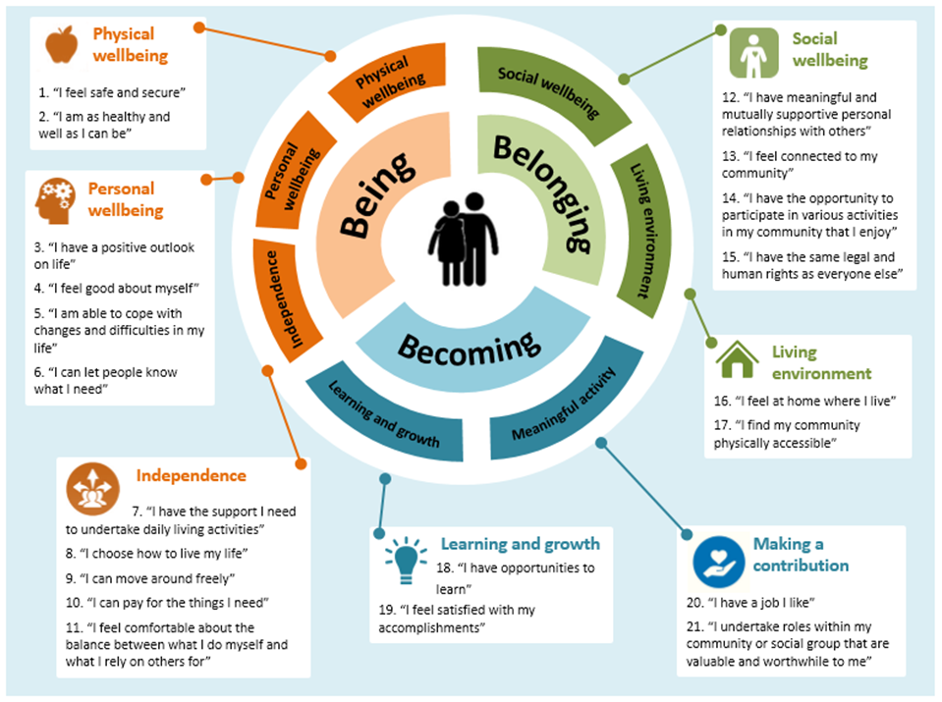
Figure B Overview of the SIM Outcomes Framework
The SIM Outcomes Framework is the product of an extensive review of existing frameworks and relevant literature, extensive stakeholder engagement, and pilot testing. The framework is organised into three levels. At the highest level are the three domains of Being, Becoming and Belonging. The domains are further broken down into seven subdomains, which are then defined by 21 outcome statements. These outcome statements are framed to capture the progress individuals are making towards achieving their goals and aspirations.
It is envisaged that clients will identify ‘focus’ or primary outcomes which are aligned with their goals and aspirations. Similarly, NGOs will align their supports and services with ‘focus’ or primary outcomes. The feedback from experts and testing has revealed value, where feasible, in collecting data on all outcomes, where progress relating to indirect outcomes is correlated with progress for the ‘focus’ outcomes.
The SIM Outcomes Framework is implemented through the Client Outcomes Tracker (COT), which NGOs use to capture data on the outcomes for individual clients, usage of supports, and satisfaction with these supports. The COT is designed to track each client’s progress towards achieving their outcomes over time through use of a six-point Likert scale which translates qualitative information in to quantitative data. The COT includes provision for capturing retrospective data on first use of the SIM Toolkit, which means that it has immediate utility for NGOs.
The COT includes provision for either the client or the NGO to identify ‘focus’ or primary outcomes and indirect outcomes. The COT includes components which allow clients to record the usage of supports, their satisfaction with these supports, and the use of additional supports provided by other NGOs and government agencies that have helped them progress towards their goals. A narrative field is also provided to capture further insights relating to each outcome.
The COT includes a reporting dashboard which collates and presents the outcomes data for each individual client in a format that can be easily interpreted.
The data assembled in the COT can then be imported into the Service Provider Outcomes Tracker (SPOT). The SPOT can provide whole-of-organisation, project, division, program and client type aggregations of the client outcomes data. The SPOT includes a reporting dashboard which presents the data in a format that can be easily interpreted (Figure D).
A Theory of Change (ToC) tool is included as an option to help NGOs deepen their understanding of how the supports they provide lead to client outcomes. The tool helps NGOs work iteratively through how their inputs, activities and outputs lead over time to intermediate and final outcomes. It helps NGOs identify ‘focus’ or primary outcomes and therefore a priority for measurement; and how focus and indirect outcomes may cluster together.
The ToC tool is particularly relevant for NGOs that have not developed their own theory of change or used similar tools such as Logic Models / Log Frames or Results Based Accountability (RBA). The ToC tool can help those NGOs that are re-orienting their activities to be customer-centric, and help all levels of staff recognise the importance of outcomes measurement.
The SIM Toolkit has been implemented using Microsoft Excel to ensure it was suitable for all NGOs with minimal demands in terms of technology and technical expertise. The toolkit is supported by guidance material to aid implementation.
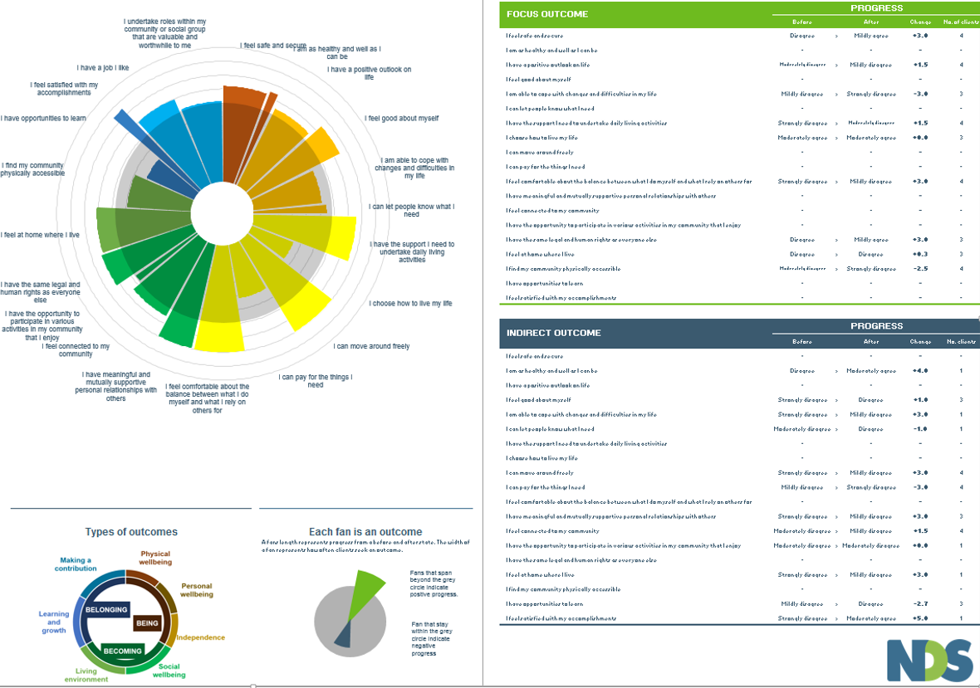
Figure D The organisational level dashboard reporting from the SPOT tool

2.5 SIM Toolkit Refinement and Piloting
The SIM Toolkit was developed iteratively and was tested and validated through the ongoing involvement of sector stakeholders including several in-depth workshops. The toolkit was then pilot with five NSW-based NGOs. The following is a summary of the main feedback received at various stages of development; a fuller description of the piloting can be found in Chapter 5.
The pre pilot-phase feedback from stakeholder engagement with sector experts and practitioners identified the following:
- The aim of the toolkit is to track a client’s quality of progress towards achieving outcomes not whether they have achieved them or not.
- Goals in client plans will not be retrofitted to the Outcomes Framework; clients will be able to select the outcomes in the SIM Outcomes Framework that are most appropriate to their context.
- The three domains cover all the anticipated goals and aspirations of people with disabilities and probably has wider applicability.
- The SIM Outcomes Statements need to be in plain language and refined to ensure they are understood by individuals.
- The contribution of multiple service providers to one client’s outcomes is an important aspect to consider.
- Progress towards outcomes in the COT needs to be based on a simple and easily comprehensible scale.
- Some organisations need considerable guidance to help them make the transition from measuring success in terms of outputs to measuring success in terms of client outcomes and social impact.
Feedback from the five pilot NGOs was captured both during implementation of the SIM Toolkit and on completion of the pilot. Outcomes data was analysed and collected from 79 clients across the five pilot NGOs. Feedback was provided by organisations’ management and operations staff who were involved in the data collection effort, and identified the following:
- There was universal recognition of the value of the toolkit, especially the use of the three outcome domains and the approach to data collection.
- There was a general need for training on outcomes measurement and, for some organisations, specific support in understanding the theory of change – how their services led to outcomes. This training and specific support is a pre-requisite for effective use of the toolkit.
- Starting to look at social impact allowed NGOs to reflect not only the change they were creating for clients but also how they could change their programme delivery to optimise the achievement of these outcomes.
- The identification of ‘focus’ and secondary outcomes allowed them to see links between various outcome areas that could inform continuous improvement and future program design.
- The implementation of the toolkit through MS Excel meant that it was easy for NGOs to use, and provided flexibility while collecting data, including customising data collection.
- The use of descriptive, numeric and image representations of the Likert Scale made the COT widely accessible.
- Participants thought that the representation of results through graphs in the dashboard provided a fair and comparable format especially over time.
- The SIM tools could be further developed and offered in a tablet or smart phone application to ease the data collection process and engage particular types of client.

2.6 Conclusions
The process of developing the SIM Toolkit and testing it has generated the following conclusions:
- There is universal recognition of the need to measure outcomes and the value of an accessible resource such as the toolkit.
- The toolkit has wide applicability across the whole disability sector, and the Client Outcomes Tracker can be adapted to be accessible for all people with a disability.
- There is a wider scope for applicability of the toolkit across the human services and community service sectors. The framework may, however, require adaptation, and such adaptation is best achieved through a mechanism that captures and embeds learning, such as a community of interest / practice.
- The toolkit is of particular relevance to organisations which are ready for outcomes measurement but have not developed their capabilities in relation to outcomes measurement nor invested in internal systems.
- General training and accessible relevant resources are required to help organisations become ready for measuring outcomes.
- The use of simple, accessible technology is essential for smaller and medium-sized organisations. There is potential to develop a tablet or smartphone application to increase the efficiency and effectiveness of the toolkit.
- Organisations which utilise case management systems would consider integrating elements of the toolkit in to their systems, especially the SIM Outcomes Framework. Organisations providing case management systems are interested in utilising the toolkit
A broader consideration of these conclusions is presented in Chapter 6.

3. Framing the development of the Social Impact Measurement Toolkit
The NSW Industry Development Fund, a partnership between NSW Ageing Disability and Home Care and National Disability Services, identified a need to support NGOs through the systemic changes in the disability services market in response to the phased implementation of NDIS. The partnership commissioned Net Balance to identify the most suitable models and develop tools for NGOs to measure, demonstrate and communicate their social impact.
A steering group comprising representatives from the partnership and a range of NGOs provided oversight to the project.
Table 1 Project Steering Group
Organisation | Contact | Stakeholder group
NDS | Gordon Duff | NDS, peak body
NDS | Garry Cronan | NDS, peak body
NDS | Deb Sazdanoff | NDS, peak body
NDS | Lee Bratel | NDS, peak body
Spinal Cord Injuries Australia | Peter Perry | Not-for-profit
House with No Steps | Lyn Ainsworth | Not-for-profit
ADHC | Eugene McGarrell | Government
ADHC | Lorraine Heywood | Government
ADHC | John Bentley | Government
Through an in-depth review of existing frameworks and relevant literature and extensive stakeholder engagement Net Balance has developed the Social Impact Measurement (SIM) Toolkit comprising an Outcomes Framework and specific tools to help NGOs develop a deep and consistent understanding of the client outcomes they achieve and how these outcomes generate social impact.

3.1 Objectives and Criteria
The objectives identified for the SIM Toolkit were that it should enable NGOs to do the following:
- Identify social indicators, quantify and measure their social impact and present the evidence in a clear way to stakeholders.
- Develop strategies and think more strategically to increase their social impact based on evidence.
- Identify areas for improvement in service delivery and business administration, and potential risks for maintaining service viability.
- Provide people with a disability, their families and carers with more choice and flexibility, and attract and retain clients by providing them with evidence of the social impact of their services.
- Understand, manage and communicate the social impact that their work creates in a clear and consistent way with customers, beneficiaries and funders.
Other objectives included to:
- Identify the cost implications for an NGO of using the toolkit.
- Identify the most suitable model for measuring social impact that recognises the diversity in size and functions, and therefore cost structures, of NGOs.
- Adopt an enablement approach that reflects the autonomy of individual NGOs, is respectful of the broader role that they play in the NSW community, and builds on their current activities for measuring social outcomes and/or impact.
The SIM Toolkit was developed using four core criteria of Relevance, Adaptability, Comprehensiveness, and Useability.
Relevance
- Focuses on outcomes, in addition to inputs, outputs and processes
- Measures outcomes identified by people with a disability rather than through ‘expert’ reporting, enabling the subjective experience of the individual to be captured
- Clearly identifies the perspectives of the person with disability, the service provider and others in the person’s life in relation to outcomes and factors influencing change
Adaptability
- Uses impact scales that enable the person with disability to rate their level of satisfaction in relation to a goal or outcome both pre- and post-service
- Is sensitive to small changes for individuals
- Can be expanded over time to include additional functionalities such as aggregation and industry-wide reporting
Comprehensiveness
- Enables a wide range of outcome types to be identified, listed and measured
- Captures outcomes that resulted from the NGO’s activities specifically, as well as from changes to the environment that facilitated these
- Identifies both barriers to and enablers of outcomes
Useability
- Requires low amounts of time allocated for data analysis through automation and standard reports
- Has supporting training documentation to encourage independent use of the tool by NGOs

3.2 Risks: Organisational readiness for outcomes measurement
Preparatory work for commissioning the Social Impact Measurement Toolkit identified that the systemic changes in the disability service market will impact differently on NGOs, which meant that the toolkit had to be developed to serve the needs of most NGOs.
The transition to the NDIS requires significant changes to service and business models, workforce, and service culture. Service providers will need to invest not only in the infrastructure and systems required to ensure their own financial sustainability, but be highly responsive to individual need and be innovative in their service offerings. They will experience significant and increasing demand to account for not only their costs (inputs), the nature of the services they provide (activities), the delivery of services (outputs) but also how they are creating positive improvements in the lives of clients, families and communities (outcomes), and generating measurable value in terms of net benefits (impact). It is important to recognise that many small organisations and some larger organisations will not have the necessary competencies and internal infrastructure to implement social impact measurement fully or immediately. These organisations will require a preparatory program of capacity building, which will provide the foundations for using the model and tools.
NGOs in the disability sector can be categorised into a pyramid of outcomes measurement readiness, as represented in Figure E below.
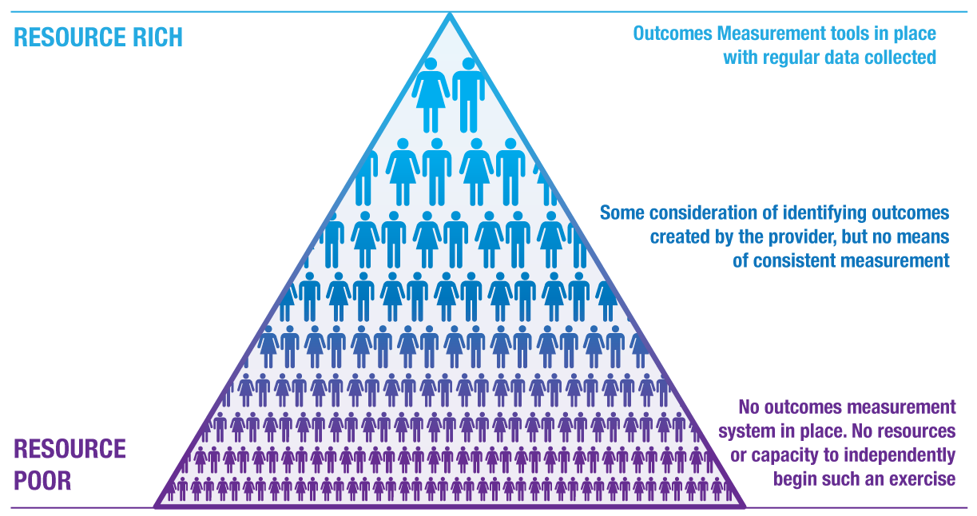
Figure E: Pyramid of outcome measurement readiness
- Very few organisations at the top of the pyramid already have outcomes measurement methodologies embedded into their internal systems. These are mainly service providers with the resources to implement such systems and who have already prioritised customer-focused services and implemented change management processes.
- At the bottom of the pyramid sit the smaller service providers who lack the resources or incentives to begin the journey towards outcomes measurement. These organisations make up the majority of the sector, many of which will require assistance in capacity building, specifically in terms of:
- General outcomes measurement training
- Determining their Theory of Change – how their activities led to long-term changes for clients
- Technical support while collecting client outcomes data.

3.3 SIM Toolkit Functionality
To achieve the stated objectives and help NGOs survive and thrive in the new market, the SIM Toolkit will need to enable NGOs to:
- Measure and improve the impact of the services they provide for individual clients and collectively as an organisation
- Demonstrate the outcomes they achieve for clients and their social impact, which provides wider choices and greater opportunities to people with a disability, their families and carers
- Communicate these outcomes and their social impact succinctly and precisely, which will help them recruit and retain clients, and attract and form partnerships with potential investors including government and private sector organisations.

4. Social Impact Measurement Outcomes Framework

4.1 Overview of the SIM Outcomes Framework
Measuring the things that really matter, such as improving people’s physical health or increasing their financial security, means that these outcomes can be included in decision making, including making choices and allocating resources. As a crucial step of the SIM Toolkit project, Net Balance developed an evidence-based Outcomes Framework that is relevant for people with disabilities.
The SIM Outcomes Framework comprises three outcome domains, seven sub-domains and 21 outcome statements. A diagrammatic overview of the framework is shown in Figure F. The process of developing the framework is described in the following sections.

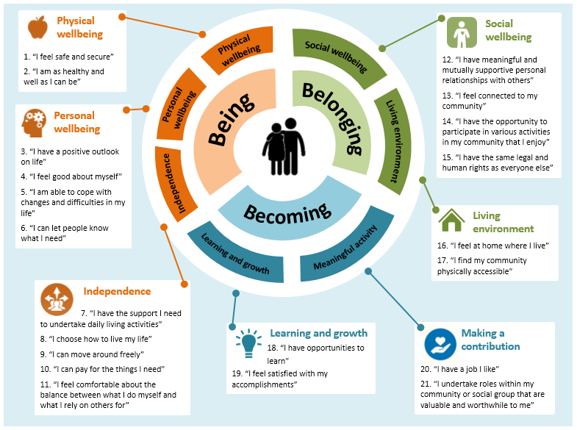
Figure F: Overview of the SIM Outcomes Framework

4.2 Overview of the methodology
Net Balance undertook the following steps to develop the SIM Outcomes Framework:
- Literature and evidence review
- Synthesis of findings from the review
- Stakeholder engagement with experts in the disability sector, disability service providers and experts in outcomes measurement
- Gap analysis, re-structuring and consolidation of outcomes through an iterative process of additional stakeholder engagement and further literature review. As part of this phase, Net Balance also mapped outcomes against the Australian National Standard for Disability Services (DSS 2013)
- Formulation of the final SIM Outcomes Framework.
The key steps in the development of the framework are presented in Figure G below.
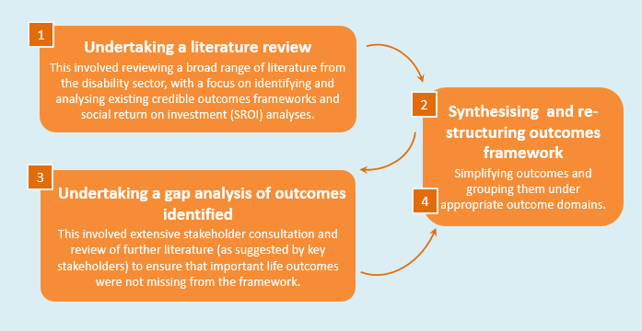
Figure G: Methodology for developing the Outcomes Framework

4.3 Literature and Evidence Review
The development of the Outcomes Framework was based upon an extensive review of literature and evidence from the disability sector and related sectors such as health, aged care and wellbeing.
When undertaking the literature and evidence review, Net Balance sought the following information:
- Outcome domains and indicators within existing frameworks and/or evaluation reports (including trends related to how existing frameworks are structured and communicated)Key concepts that underpin existing outcomes frameworks (such as quality of life, wellbeing, etc.)
These are presented in the sections below.

Existing outcomes frameworks and identified outcomes

Information sought and key references
Net Balance researched outcome domains, individual outcomes and outcome indicators within existing frameworks and/or evaluation reports. The key references found were the following:
- Twenty-four existing outcomes frameworks and ten Social Return on Investment (SROI) analyses. Refer to Appendix A for a complete list of outcomes frameworks and SROIs.
- Policy and academic research documents related to the disability sector at:
  - State level, such as Standards in action: Practice requirements and guidelines for services funded under the Disability Services Act (ADHC 2012)
  - National level, such as: Measuring Outcomes for People with Disability (NDS 2012); National Disability Strategy 2010–2020 (COAG 2011); National Standards for Disability Services (DSS 2013); SHUT OUT: The Experience of People with Disabilities and their Families in Australia (DSS 2009); Improving Sexual and Reproductive Health for People with a Disability (SH&FPA 2013)
  - International level, such as the United Nations Convention on the Rights of Persons with Disabilities (United Nations 2006)
  - State, national and international level, such as Literature Review Outcomes Measurement in Disability Services: A review of policy contexts, measurement approaches and selected measurement tools (Quilliam & Wilson 2011)

Findings
Through this extensive review of existing frameworks and available academic literature, Net Balance found that:
- There was a diverse range of outcome domains (e.g. economic security, physical health, wellbeing, etc.) within the outcomes frameworks reviewed. Examples of outcome domains are shown in Appendix B. In some frameworks the outcome domains were grouped within even broader classifications. For example, the Personal Outcomes Measures (POMs) (Council on Quality and Leadership 2012) and the University of Toronto Quality of Life Profile (QLP) (University of Toronto 2002) respectively use categories of ‘My Self’, ‘My World’, ‘My Dreams’ (POMS), and ‘Being’, ‘Belonging’, ‘Becoming’ (QLP). Whilst there were common themes amongst the domains listed, domains could be defined in numerous ways.
- Fifty-nine different but closely interrelated outcomes could be identified. They were grouped under six high level categories: ‘physical wellbeing’, ‘emotional wellbeing’, ‘social inclusion’, ‘choice’, ‘economic participation’ and ‘independence’. These are depicted in Figure H. The New Zealand Disability Strategy (New Zealand Office of Disability Issues 2009) was the only framework reviewed that uses simple, first-person language to communicate outcomes. For example, the ‘relationship’ domain is expressed as ‘I have family and friends’. This language makes the outcomes more tangible and easier to engage with.
- Many of the outcomes frameworks were provided in a range of accessible formats, including easy-read, pictorial, audio, braille and sign language versions. This highlights a requirement to use communication strategies that enable people with cognitive and/or sensory needs and diverse cultural styles to know how to access services (ADHC 2012).
The literature review also enabled us to identify the following gaps:
- None of the outcomes frameworks reviewed mentioned sexuality, sexual health or sexual and reproductive rights; although it is important to note that the CQL Personal Outcome Measures® (POMS) system does include ‘intimate relationships’. This was considered a significant gap, since people with disability are particularly vulnerable to human rights abuse, as evidenced by the recent Australian Senate inquiry into the involuntary sterilisation of people with disabilities (Commonwealth of Australia 2013). Additionally, within a ‘whole-of-life’ approach it is important that people with disability are supported to pursue their sexuality and relationship aspirations. The Improving Sexual and Reproductive Health for People with a Disability (SH&FPA 2013) report provided an appropriate evidence base to draw additional outcomes for the SIM Outcomes Framework.
- ‘Rights protection, justice and legislation’ (one of the fifty-nine outcomes listed in Figure ) only appeared in five of the outcomes frameworks and SROI analyses reviewed. However, other key references such as the SHUT OUT report (DSS 2009) and Standards in action (ADHC, 2012) suggest that this is a priority area for people with disability in Australia. The United Nations Convention on the Rights of Persons with Disabilities (United Nations, 2006) was drawn upon for definitions and outcomes related to fairness and human rights in disability service delivery.

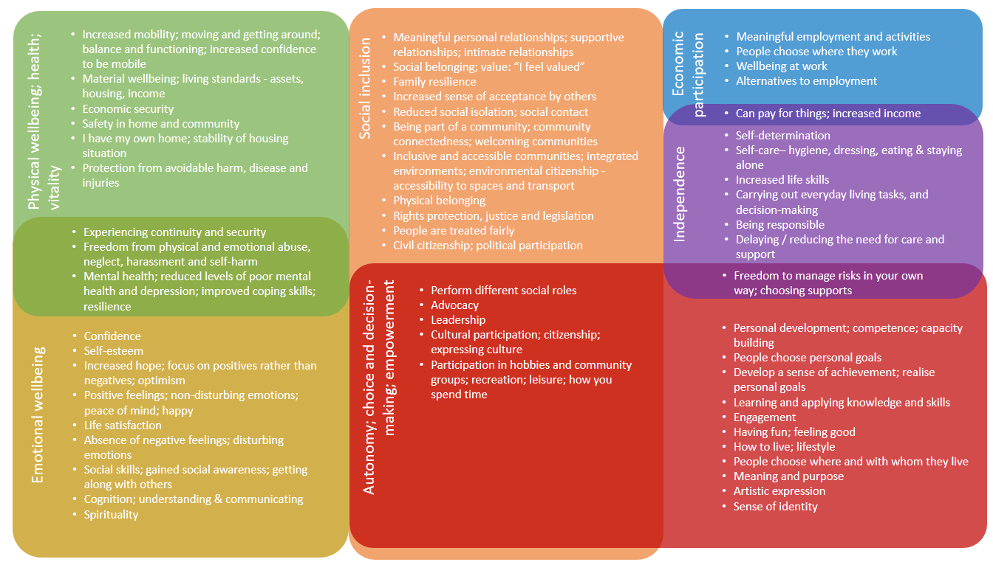
Figure H: Synthesis of outcomes

Key concepts related to individual outcomes

Information sought and key references
Through the literature review, Net Balance also sought to understand the key concepts that underpin existing outcomes framework (such as quality of life, wellbeing, etc.), both broadly and specifically within the disability services sector.
The key references found were the following:
- Measuring Outcomes for People with a Disability (NDS 2012)
- Defining and Measuring the Outcomes of Inclusive Communities (Wilson 2006)
- What makes us happy (Australian Unity 2010)
- National Accounts of Well-being: bringing real wealth onto the balance sheet (nef 2009)
- A Short Guide to Gross National Happiness Index from the Centre for Bhutan Studies (Ura et al. 2012).

Findings
The references reviewed enabled us to understand the concept of ‘quality of life’:
- ‘Quality of life’ is a complex concept that usually incorporates features of wellbeing, positive social involvement and opportunities to achieve personal potential. It includes objective measures (such as income, employment and participation), as well as subjective ones (such as satisfaction, self-determination, wellbeing, and happiness) (NDS, 2012).
- ‘Quality of life’ is often conceptualised as a product of the person’s objective life circumstances and the level of satisfaction with those circumstances. However, a key issue with quality of life measures for disability service outcomes is that people with disability tend to have high levels of satisfaction with their quality of life – a concept termed ‘the disability paradox’. Furthermore, the measurement of quality of life appears to be relatively insensitive to changes in people’s circumstances such as changes in income, material standards of living, health, education, friends, marital status and employment status. People tend to revert back to a dispositional level of subjective wellbeing less than six months after a significant change in life circumstances (NDS, 2012). This suggested that a broader conceptualisation of ‘quality of life’ that goes beyond ‘life satisfaction’ was required, and that the SIM Outcomes Framework would need to capture factors that go beyond circumstances and significantly influence the internal state of individuals.
- Wilson (2006) argued that ‘quality of life’ tools are usually limited, in that they are usually oriented towards the service delivery context, rather than encompassing whole-of-life aspirations and outcomes of people with disability. They also do not often include outcomes related to creating more inclusive communities. To address this gap, the Scope outcomes framework is underpinned by the following key concepts:
  - ‘Agency’: The ability/power to think, feel and act on this basis; and
  - ‘Citizenship’: The right to be included, have responsibility, contribute, and actively participate in the social, economic, cultural, environmental and political fabric of community.
The references reviewed also enabled us to grasp the concept of ‘wellbeing’:
- ‘Wellbeing’ is a concept that is closely related to ‘quality of life’. Similarly to ‘quality of life’, its interpretation is sometimes inaccurately limited to ‘life satisfaction’.
- The Australian Unity Wellbeing Index defines ‘wellbeing’ as different from ‘happiness’, stating that ‘happiness can come and go in a moment, whereas wellbeing is a more stable state of being well, feeling satisfied and contented’ (Australian Unity 2010). The Index measures ‘personal wellbeing’ based on the average level of satisfaction with the following aspects of life: health; personal relationships; safety; standard of living; current life achievements; community connection; future security; and spirituality/religion (Australian Unity 2010).
- The new economics foundation (nef) states that ‘wellbeing’ is most usefully thought of as ‘the dynamic process that gives people a sense of how their lives are going through the interaction between their circumstances, activities and psychological resources or ‘mental capital’’ (nef 2009).
  - nef’s approach to ‘wellbeing’ includes both the personal and social dimensions, where the social dimension relates to the strength of people’s relationships with others. Research indicates that this is a crucial factor that influences the quality of peoples’ experience of life (nef 2009). Also included are domains related to ‘functioning’ and ‘psychological resources’. The ‘functioning’ component measures how well people are doing, in terms of their functioning and the realisation of their potential. There is a growing recognition that ‘psychological resources’ or ‘mental capital’ (such as resilience) is a key component of wellbeing.
Through the literature review, we could also understand better the concept of ‘emotional wellbeing’, which is a sub-category of ‘wellbeing’:
- nef defines ‘emotional wellbeing’ as being related to positive feelings and the absence of negative feelings.
- The term used in the Gross National Happiness (GNH) Index from the Centre for Bhutan Studies (Ura et al. 2012) for ‘emotional wellbeing’ is ‘emotional balance’. This conceptualisation seems more precise than the nef framework, since it is not possible to avoid all negative feelings. Furthermore, the GNH describes positive emotions as ‘non-disturbing emotions’ and negative emotions are ‘disturbing emotions’. This reflects the Buddhist perspective that disturbing emotions decrease mental clarity and hence ‘might lead often to formation of poor intentions’ (Ura et al. 2012). This language of ‘disturbing’ and ‘non-disturbing’ avoids the dichotomy of positive and negative judgments about emotions and experiences, and instead emphasises peace of mind.
The literature review highlighted the need to reflect a broad and comprehensive conceptualization of ‘quality of life’, ‘wellbeing’ and ‘emotional wellbeing’ in the SIM Outcomes Framework.

4.4 Stakeholder engagement
Following a synthesis of findings from the extensive literature review, a broad range of stakeholders – including experts in the disability sector, disability service providers and experts in outcomes measurement – were engaged to:
- Ensure that key outcomes are not missing from the framework; and
- Provide input into how the Framework should be structured and communicated.
The Outcomes Framework was developed in close collaboration with the Steering Group, which brought together sector leaders to regularly review project progress and inform its development. Stakeholders who were consulted individually and/or as part of workshops are listed in below:
Service Providers:
- Spinal Cord Injuries Australia – Peter Perry
- House with no Steps – Lyn Ainsworth
- United Way – Michael McDade
- Interaction Disability Services – Craig Moore
- Valmar Support Services – Hugh Packard
- Ability Options – Annie Mills
- Baptistcare – Lucy Morris
- Cerebral Palsy Australia – Sharyn Gregory
- Life Without Barriers – Claire Robbs
- Life Without Barriers – Edward Birt
- Lifestart – Sue Becker
- Northcott – Kerry Stubbs
- Northcott – Rebecca Rodwell
- Radius Disability Services – Cath Macdonald
- UnitingCare Disability – Jo-Anne Hewitt
Government:
- Ageing Disability and Home Care – Eugene McGarrell
- Ageing Disability and Home Care – Lorraine Haywood
- Ageing Disability and Home Care- John Bently
- Ageing Disability and Home Care – Michael Henman
Peak Body:
- National Disability Services – Gordon Duff
- National Disability Services – Garry Cronan
- National Disability Services – Deb Sazdanoff
- National Disability Services – Lee Bratel
- National Disability Services – Deb Hoffman
Sector Expert:
- Future by Design – Valmae Rose
- Council on Quality and Leadership – Becky Hansen
Academia
- Deakin University – Lynne Adamson
- Sydney University – Gwyneth Llewellyn
- Queensland University of Technology – Michael McDade

4.5 Final synthesis, restructuring and mapping of outcomes and domains
Once all of the outcomes had been identified through the literature review, stakeholder engagement, and the iterative process of additional stakeholder engagement and further literature review to identify gaps, they were grouped under appropriate outcome domains, drawing on the structure of existing frameworks.
The final SIM Outcomes Framework is the result of numerous iterations of condensing, synthesising and prioritising outcomes, as well as restructuring the domains. The challenge was to ensure a balance between simplicity (for ease of use) and comprehensiveness (to ensure the framework encompassed all the important life outcomes for people with a disability). In order to function effectively as an outcomes measurement tool it was necessary to ensure that each outcome in the framework was unique (i.e. outcomes did not overlap). Refer to section 6 for a comprehensive explanation of the evidence base for each outcome.
In order to ensure completeness and broad applicability, Net Balance mapped the Outcomes Framework against the Australian National Standard for Disability Services (DSS 2013). This exercise and the associated findings are presented in Appendix C.

4.6 The final SIM Outcomes Framework
The Outcomes Framework forms the basis of the SIM Toolkit. As outlined above, it was developed via an iterative process involving extensive literature review and stakeholder engagement. A diagrammatic overview of the framework is shown in Figure J.
Figure J: Overview of the SIM Outcomes Framework

The framework has three layers. First, there are three high-level domains:
- Being – related to feeling safe, healthy and well.
- Belonging – related to full participation in the community.
- Becoming – related to realising potential.
The ‘Being, Belonging, Becoming’ high-level outcome domains were drawn from the University of Toronto Quality of Life Profile (University of Toronto 2002) and the Australian Early Years Learning Framework (COAG 2009). These three domains are then divided into seven sub-domains:
- Physical wellbeing
- Personal wellbeing
- Independence
- Social wellbeing
- Living environment
- Learning and growth
- Making a contribution
These sub-domains are further broken down into 21 life outcome statements, as presented in a list below and explored in detail in Appendix D, which presents the evidence base from the literature review and indicates where these outcome types have been specified.
SIM Outcomes Framework
Being
Physical Wellbeing
- I feel safe and secure
- I am as healthy and well as I can be
Personal Wellbeing
- I have a positive outlook on life
- I feel good about myself
- I am able to cope with changes and difficulties in my life
- I can let people know what I need
Independence
- I have the support I need to undertake daily living activities
- I choose how to live my life
- I can move around freely
- I can pay for the things I need
- I feel comfortable about the balance between what I do myself and what I rely on others for
Belonging
Social wellbeing
- I have meaningful and mutually supportive personal relationships with others
- I feel connected to my community
- I have the opportunity to participate in various activities in my community that I enjoy
- I have the same legal and human rights as everyone else
Living environment
- I feel at home where I live
- I find my community physically accessible
Becoming
Learning and Growth
- I have opportunities to learn
- I feel satisfied with my accomplishments
Meaningful activity
- I have a job I like
- I undertake roles within my community or social group that are valuable and worthwhile to me

5. The Social Impact Measurement Toolkit

5.1 The SIM Toolkit
The SIM Outcomes Framework is the foundation for the Social Impact Measurement (SIM) Toolkit, which are both used collectively to identify, quantify and communicate the social outcomes for individuals which are being facilitated by NGOs in the disability sector. The 21 life outcome statements identified in the framework can be collected on a client-by-client basis and aggregated together at an organisational level to assist service providers to both case manage their client’s outcomes and view the overall results of their organisation.
The tools were created using Microsoft Excel, identified as the most common platform that would be accessible to the majority of service providers and requiring the lowest level of prior knowledge and technical support.
The SIM Toolkit went through three iterations; the first was presented to a workshop of various representatives from the disability sector; the second taking on board workshop feedback and made ready for the pilot phase of the project; and a third, final version after feedback gained from the pilot phase, which engaged five NGOs.
The toolkit comprises three Excel-based tools to assist organisations to practically implement and embed outcomes measurement using the outcomes framework formulated as part of this project:
- Client Outcomes Tracker (COT)
- Service Provider Outcomes Tracker (SPOT), and
- Theory of Change (ToC) tool
The SIM Outcomes Framework is implemented through the Client Outcomes Tracker (COT) which NGOs use to capture data on the outcomes for individual clients, usage of supports, and satisfaction with these supports. The COT is designed to track each client’s progress towards achieving their outcomes over time through use of a six-point Likert scale which translates qualitative information in to quantitative data. The COT includes provision for capturing retrospective data on first use of the SIM Toolkit, which means that it has immediate utility for NGOs.
The COT includes provision for either clients or the NGO providing supports to identify ‘focus’ or primary outcomes and indirect outcomes. The COT includes components which allow clients to record the usage of supports, their satisfaction with these supports, and the use of additional supports provided by other NGOs and government agencies which have helped them progress towards their goals. A narrative field
The COT includes a reporting dashboard which collates and presents the outcomes data for each individual client in a format which can be easily interpreted.
The data assembled in the COT can then be imported in to the Service Provider Outcomes Tracker (SPOT). The SPOT can provide whole of organisation, project, division, program and client type aggregations of the client outcomes data. The SPOT includes a reporting dashboard which presents the data in a form that can be easily interpreted (Figure D).
A Theory of Change (ToC) tool is included as an option to help NGOs deepen their understanding of how the supports they provide lead to client outcomes. The tool helps NGOs work iteratively through how their inputs, activities and outputs lead over time to intermediate and final outcomes. It helps NGOs identify ‘focus’ or primary outcomes and therefore a priority for measurement; and how focus and indirect outcomes may cluster together.
The ToC tool is particularly relevant for NGOs that have not developed their own theory of change or used similar tools such as Logic Models / Log Frames and Results Based Accountability (RBA). The ToC tool can help those NGOs that are re-orienting their activities to be customer-centric and to help all levels of staff recognise the importance of outcomes measurement.
Further guidance on features and instructions on how to use the SIM Toolkit and adopting outcomes measurement in general are provided in an additional document to this report.

5.3 Development of the Toolkit
Initial scoping of the SIM Toolkit through stakeholder engagement focused on determining the best fit for the sector. A particular issue was whether the Toolkit was to serve internal and / or external purposes i.e. whether the measurement of outcomes was to drive organisational learning and continuous improvement or whether measurement was being used to send signals to the disability services market and specifically to prospective clients.
Although there was recognition that in the long term the Toolkit would serve both internal and external purposes, the preference was to focus on internal use in the first instance. This approach took into account the varying readiness of organisations to engage in outcomes reporting, and that organisations needed to gain confidence in outcome measurement before demonstrating outcomes and communicating this information to external stakeholders.

Summary of feedback during tool development and pilot phases
The aim of the SIM tool is to track a client’s quality of progress towards achieving outcomes not if they have achieved them or not.
- Concern was raised during the stakeholder engagement process regarding the tool placing scores on organisations based on quantifying number of outcomes. Due to the varying degree of care required for the range of disabilities catered for in the sector, the severity of different client and multiple geographic differences in service delivery location, it was argued that comparison of organisations based on a single metric would not be a fair indicator of the outcomes generated by service providers.
- In addition, it was acknowledged that it is not realistic for a client to be able to achieve substantial outcomes within one NDIS plan period and thus measuring change based on quantity of outcomes would be an inaccurate gauge of client progress toward outcomes.
Goals in client plans will not be retrofitted to the Outcomes Framework, as this would be service-centric rather than client-centric
- It was initially suggested that outcomes be tied to particular goals in client plans. However, feedback suggested that outcomes not be tied to any one goal as positive change in clients’ lives arise from a combination of goals suggested to them in their plans. Clients thus have the option to choose ‘Focus’ outcomes that would be directly affected by their set goals but also have the option to provide baseline responses to all the outcomes in the client based tool. This allows the organisation to identify any unintended or secondary outcomes resulting at the end of the plan period.
The contribution of multiple service providers to one client’s outcomes is an important aspect to consider
- Service providers participating in the workshop indicated that it was essential to capture the contribution of multiple factors to their clients’ achievement of outcomes. This will be captured in the tool qualitatively buy capturing a list of all providers and supports utilised in a client’s COT report. It was agreed that quantifying the contribution would be difficult and potentially misleading due the difficulty in apportioning a percentage of benefit to anyone service provider.
Progress towards outcomes in the COT needs to be based on a simple and easily comprehensible scale
- It is acknowledged that the outcome quality scales used are not based on clinical measures, rather the self-reporting of clients based on their perception of personal change in the various outcome areas over the period of their plan. There are various other clinical-based tools available and other disability specific scales, however inclusion of this level of detail would make this tool inaccessible to many organisations in the sector who have not as yet considered the prospect of outcomes measurement.
Some organisations have need for considerable guidance, resources to make the transition from ‘outputs to outcomes. ‘
- A Theory of Change brainstorming tool was created after the pilot phase of the project as a result of organisation needing guidance as to how to communicate the ways in which their activities enable clients to experience outcomes. This tool allows organisations to formulate theories of change on a program-by-program basis or on an organisational level to complement the results in the COT and SPOT tools.

Individual Tool Specifications

The Client Outcomes Tracker (COT)
The COT tool is designed to collect data on an individual client basis and can also be used as a standalone outcomes case management tool by service providers or potentially integrated into the case management system used by an organisation. The tool provides an opportunity for organisations to capture pre and post outcome data from client when they first start support services at an organisation and at the end of their plan. A function that allows the tool to save outcome data at any point in time will additionally allow service providers to capture data at shorter intervals to track progress more frequently if required.
Data Collection
- Data is captured on a 6-point Likert scale for each outcome ranging from ‘Strongly Disagree’ to ‘Strongly Agree’ with service providers having the option to capture data from their choice of from outcomes from the framework based on appropriateness and applicability to the client in question. In addition to text, each point on the scale is signified by ‘stick faces’ with expressions representing points on the scale to increase accessibility of the scale
- Data collectors have the option of highlighting ‘focus’ outcomes (ones that are the primary focus) of the client and additionally collect data on others. The intention of this is to see if attainment of focus outcomes have an unintended positive or negative effect on other outcomes on the framework. This allows organisations to establish relationships between outcome creation and start to think about program design and activities needed to improve quality.
- The tool allows service providers to select broad categories of supports offered to the client as listed by NDIA and automatically calculates cost of services based on total units consumed. There is also an option of entering customised costs if necessary. This is an optional feature of the tool and does not affect the results for an organisation. It can be added at a later date for future collection cycles.
- The notion of attribution of other service providers contributing to the clients’ outcomes can be captured in the COT. An optional section allows the client to state and/or list the number of other service providers they for various purposes. Primary service providers can use this information to ensure they are fully aware of the clients’ needs, other treatments received, complement other activities or inform other service providers of vital information regarding the client if necessary.
- The tool also provides the opportunity for service provides to gain feedback on service satisfaction in 4 areas
  - Appropriateness of clients plan
  - Responsiveness to feedback
  - Choice
  - Quality of service
Questions require before and after service responses, thus contrasting expectation with actual satisfaction in the above 4 areas.
Results
Clients’ performance are reported in the COT dashboard tab that graphically represents the change in quality of focus and secondary outcomes experienced by clients, and if complete data is entered;
- The total cost of providing supports for the client through their plan
- The client’s satisfaction rating on their plan, responsiveness to feedback, choice and quality of services
In addition, on completion of data, the tool generates a row of raw data that can be exported to the Service Provider Outcome tracker to aggregate along with the results of other clients.

The Service Provider Outcome Tracker (SPOT)
The SPOT tool is utilised to aggregate data generated from the COT tools for various clients in order to view results on an organisational level. Additionally, the SPOT tool is where an organisation has the optional opportunity to list out their theory of change for outcomes in the framework and provide organisational contact information.
Data Collection
Data required to utilise the SPOT is from data collected from clients in the COT. Complete surveys with pre and post data are required in order to view aggregated results on outcomes created at organisations in the SPOT dashboard. Other data required to be completed are basic contact and service provision information relevant to the organisation.
Results
The SPOT dashboard is the primary organisation wide reporting interface driven by client data. Metrics available on the dashboard include:
- Graphical representations of organisational performance in delivering focus, secondary and aggregated outcomes.
- The average start and end points on the scale for each outcome in the framework and the average magnitude of change along the scale.
- The top 20 supports used and total service cost of supports.
- Total number of clients who replied questions on outcomes.
- The above three metrics are filterable by disability type, gender and age.
- The average level of satisfaction on the four areas.

The Theory of Change tool (ToC)
The Theory of Change tool was added to the SIM Toolkit in response to organisations in the pilot phase of the project wanting more guidance and support with this aspect of developing their competencies in outcomes measurement. Additionally, through the stakeholder engagement and workshopping processes it was identified that the majority of disability service providers in the sector would have fallen into this category thus highlighting the need for such a tool.
The ToC tool is an optional part of the Toolkit that allows organisations to brainstorm the key activities offered and the outputs and intermediate outcomes taking place at the organisation and establish relationships between them and the outcomes in the framework. Intermediate outcomes refer to;
- Short-term changes are new knowledge, awareness and resources gained by clients as a result of activities,
- Medium term outcomes are those actions and behaviours adopted by clients as a result of new learning and awareness from activities that in the long term lead to the outcomes specified in the Outcomes Framework.
The TOC tool provides organisation with a starting point to think about their own theories of changes that can later be used to inform programme design and evaluation and communications.

6. Pilot Testing the Social Impact Measurement Toolkit

6.1 Background
The SIM Toolkit was tested on five pilot NGOs which had previously expressed interest to NDS in developing their capabilities in relation to measuring outcomes. This was a purposeful selection of cases to ensure that the full functionality of the Toolkit could be tested and does not constitute a representative sample.
One pilot NGO was a test case where an outcomes measurement system was already in place. The purpose was to assess if the SIM Toolkit could be used to complement the existing system and whether it provided sufficient added value for an NGO to adopt it.

Pilot case study organisations
The 5 pilot sites were as follows:
- CareWest in Orange,
- Lifestyle Solutions in Newcastle,
- Spinal Cord Injuries Australia (SCIA) in Sydney,
- On Focus in Casino, and
- House With No Steps (test case) in Sydney
The following sections describe the process adopted to engage with the pilot organisations and the specific engagement with each organisation.

6.2 Case study engagement
At each site, Net Balance conducted a program of training for staff from the organisation. The goal of the training was to introduce an overview of the project and train them in the use of the Toolkit in order for them to collect a sample of client data to test out the applicability and appropriateness of the tool in various settings. The sessions were typically run during the course of the day and topics discussed were as follows:
- The external and internal drivers for outcomes measurement
- An overview of the SIM Toolkit and how it was developed
  - Stakeholder driven approach to defining outcomes
  - Identification and synthesis of existing frameworks
- What outcomes measurement is and the key concepts that underpin it
  - Methodologies in use to measure social impact
  - Important things to consider
  - The external and internal drivers for undertaking outcomes measurement
- How to use the SIM Toolkit within your organisation
  - Applicability of Outcomes Framework to organisation
  - Discussion of ways to collect data
  - Potential difficulties in collecting data
  - Establishing outcomes
  - How existing data would reconcile with current model
- Common challenges with outcomes measurement and how to overcome them

Readiness for outcomes measurement
The training sessions were also an opportunity to test out the environment for outcomes measurement within the service provider and see what the obstacles would be to implementing such a tool. From feedback during the sessions and considering discussions during the workshop session earlier in the project timeline, it was possible to categorise each pilot organisation in terms of their readiness for outcomes measurement (see Figure E: Pyramid of outcomes measurement readiness).
As expected these pilot NGOs were either ready for outcomes measurement or on the pathway to readiness ranging from starting to systematically think about outcomes measurement, having developed a customised Outcomes Framework, to those that had commissioned Social return On Investment (SROI) projects or other social impact studies. However, most of the pilot organisations lacked embedded internal systems to consistently quantify, measure and report the outcomes and social impact of their services.
It is therefore important to note that these case study organisations are towards the top of the readiness pyramid whilst the majority of NGOs would fall into the bottom category where outcomes measurement was not yet a consideration within the organisation. It is also assumed that only a small number of NGO service providers have invested in embedding established social impact measurement systems into their regular databases to monitor social impact at their organisations consistently.

6.3 Care West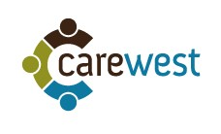

Background
CareWest is a disability provider headquartered in Orange, NSW employing over 220 staff with offices located in Parkes, Wagga Wagga, Dubbo, Wellington, Condobolin and Nyngan. CareWest is one of the largest regional-based providers of community services in regional NSW remains focused on ensuring programs and services are tailored to the individual needs of local communities. The organisation offers programmes across five areas:
- Aged Services,
- Disability services,
- Carer services,
- Child & Family services, and
- Aboriginal services

Current approaches to outcome measurement
At present CareWest has a robust client management system to track basic information on clients in terms of personal information and progress of personal plans through the VisiCase case management system. The current system however does not deal with the tracking of social outcomes resulting from clients’ progress through their plans. The CareWest strategy team has however, recently been working on formulating an Outcomes Framework based on case management staff’s experience with clients and selected frameworks found in the literature of disability services. CareWest’s vision is to incorporate the aspects of the framework into their current data collection process in order to better track outcomes for clients.

Issues discussed during training
The CareWest team does not have outcome reporting requirements for compliance purposes but realise the importance of recording outcome data in order to more effectively create long term positive change for their clients and their families. This has been the driving force behind them putting resources into creating an Outcomes Framework internally.
CareWest have not used a formal methodology such as SROI or logic models to determine a theory of change or to think about outcomes. They have rather depended on the field experience of case workers and their research and strategy team.
It was noted that CareWest’s Outcomes Framework was similar to the SIM Outcomes Framework in the outcome areas covered. Their framework had 19 outcomes when compared to 21 in the SIM Outcomes Framework. On closer inspection, this difference was due to the combining of certain outcome categories. These similarities were a positive sign as they validated the research done in formulating the NDS outcome research and vice versa in terms of the literature being reflective of the work being done at CareWest’s various operations
CareWest are looking for a way to consolidate an Outcomes Framework with a data capture system in order to track outcomes across their organisation on a client by client basis to use as a reporting and case management tool. This would ideally be incorporated into VisyCase and captured within embedded into their present data collection systems.
The concept of bias while collecting data during the pilot was discussed and an option was considered where a clinical psychologist who was part of the CareWest team would take the lead in interviewing and data collection supported by case workers of specific clients in order to maintain objectivity while recording results.

Data collection summary
- Surveys collected from 15 clients
- Ranged from 4 program areas;
  - Intensive Family support
  - Community Packages
  - Older parent carers (outcomes for carers)
  - Early Start Diagnosis supports (outcomes for carers)
- Data on costs of services and service satisfaction levels were not provided
- Data collected primarily through 1 on 1 interviews with case manager
  - CareWest were only able to utilise the clinical psychologist for a few interviews due to resource constraints
  - An attempt was made to collect data over the phone but this proved to be an inappropriate and inefficient method to do so due to miscommunication and the limited abilities of a lot of client groups
  - Certain questions were ignored by the interviewer during the surveying process due to inappropriateness for the client’s situation
- Data collection ranged from 30 minutes to an hour per client

Feedback on the SIM tool

Dashboard reporting format
- The feedback on the visual presentation of results in a dashboard format with large graphs representing areas of change was very beneficial to operational and management staff.
- It allowed the organisation to verify the change they were creating in the lives of clients and demonstrated it clearly. In addition, the tool allowed them to see connections between the achievement levels of different outcomes and thus address activities that could lead to an increase in quality of these outcomes in the future. For example, in programmes where activities were based on ‘pairing strategies,’ related work would have to be done on community based activities to increase the quality of outcomes as revealed by the clients’ performance on the community outcomes.

Data collection and User Interface
- Certain outcome questions were not asked of some clients as they might have led to negative emotional effects especially when discussing outcomes such as ‘positive outlook on life’ especially with people with MH issues. It was recommended that there needs to be an avenue for debriefing clients such as the Lifeline service. CareWest staff had to stop the interview in one instance after they had an uncomfortable conversation with one client.
- The tool was effective both as an organisational reporting tool and a case management device as it allowed for the viewing of results on an individual and aggregated basis.
- One of the biggest positives was that the team was allowed to use the outcomes as a starting point to have conversations with clients on aspects of the area that were most relevant to them, thus allowing them to customise the survey for every client.
- With respect to future data collection, the team suggested a few options and recommendations:
  - Delivering it to individuals in paper format and asking them to fill it out themselves where appropriate.
  - Use it as a conversation guide while collecting data from each client in a one-on-one interview format.
  - Providing a guidance document with further information on areas the assessor needs to consider for each outcome.
  - Using a statement such as ‘did the score go up, go down or stay the same?’ as a starting point to eliciting an indication of change along the scale provided in the tool.
  - A little more work is required in providing safeguards while delivering the survey in the future once finalised.

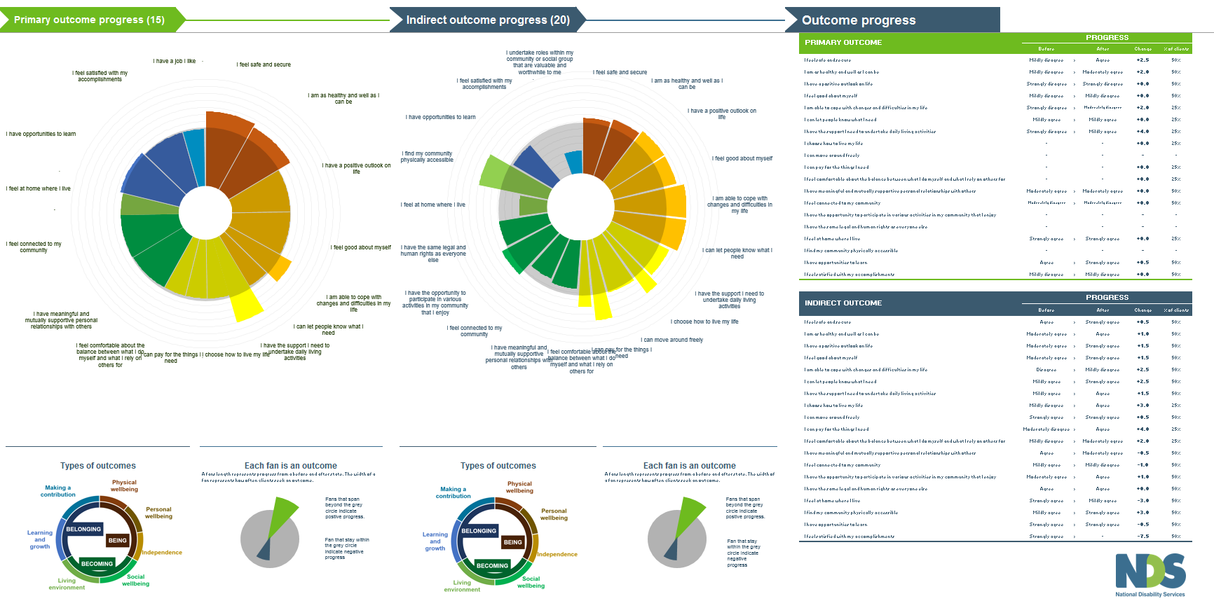
Figure 10: SPOT dashboard pilot results for CareWest

Interpretation of data collection results
Outcomes reported
Clients surveyed reported on 16 focus (primary) outcomes and data was gathered on 20 indirect outcomes
Key findings
- There were no negative impacts on any Focus outcomes indicated by clients.
- Most of the clients experienced maintenance of outcome levels especially in the domains of belonging and becoming.
  - This can be explained by the fact that many of the clients surveyed had only recently started activities in their respective programs and/or were older clients for whom maintaining their current state across their chosen domains was a positive outcome
- Clients fared particularly well on the Being domain outcomes with at least a two scale point change increase in outcome magnitude in the physical wellbeing outcomes, ability to cope with changes and having the support to undertake daily activities
- This is echoed by the fact that clients indirectly experienced a positive change in outcome magnitude across the Being domain outcomes as indicated in the Indirect outcome graph.
- The indirect outcome graph also reinforces the primary outcome graph by indicating that clients indirectly experienced positive change in the Being domain outcomes.
- The indirect outcome graph shows some negative outcome change for a few outcomes, especially in being able to undertake roles within the community, feeling at home where clients live, being connected to the community and having supporting relationships with other.
  - This can be explained by the fact that residents were fairly new to the activities offered. Given that the majority of clients surveyed were housing support users, the new changes in their lives had potentially led to the indicated results. It is likely that after their initial adjustment period, they are likely to experience positive change or maintenance in these outcomes.
Insights
- The greatest changes as indicated by clients were in the areas of having the support to undertake daily living activities and finding the community physically accessible. These two outcomes are vital to supported housing programs and thus can help CareWest demonstrate their ability to deliver outcomes for clients in need of assistance in these areas.
- Interestingly, a connection can be drawn between the provision of appropriate supported housing for clients and positive changes in finding the community physically accessible and their ability to participate in activities that they enjoy as indicated in the indirect outcome graph.

6.4 Lifestyle Solutions

Background
Lifestyle Solutions is a not for profit organisation, founded in Newcastle in 2001 with a vision to provide person centred, flexible and responsive support services to people with disability. Lifestyle solutions conducts operations throughout in the disability sector across Australia providing services for children, young people and adults. Additionally, Lifestyle Solutions in Newcastle is currently participating in the NSW NDIS pilot in the Hunter region in NSW
Specific service streams with respect to disability care offered by Lifestyle Solutions are:
- Self-managed and Community Based services
- Housing and Support, and
- Community Justice Programs

Current approaches to outcome measurement
At present, data collection at Life Solutions in Newcastle is restricted to basic personal and demographic client data along with Disability plan management. The organisation is stretched in terms of resources with respect to program delivery and the lack of outcomes reporting or a sector wide tool has meant that such measurement has not been able to be undertaken. The organisation however is open to beginning a journey of outcomes measurement and incorporating it into their systems given the right guidance and tools from the sector.

Issues discussed during training
Lifestyle Solutions staff attending the training were from a range of departments; management, strategy, research and service delivery. For many it was their first foray into learning about social outcomes measurement principles and methodologies. However, they were instantly in tune with how utilising such frameworks would be beneficial from a program design, delivery and communications perspective.
The concept of formulating a theory of change was very appealing to the group. However they required additional guidance in order to start thinking about this and would prefer to do it on a program by program basis as opposed to an organisational level, due to the diversity of activities offered
Concerns were initially raised as to the amount of organisational resources required to conduct surveys and the complexity of the tool, however on demonstration of the functionality, it was decided that it would be beneficial to collect survey data from one site of service delivery to understand the effort required to complete such a task.
In order to start thinking about outcomes measurement in the future, they saw the tool as a great starting point to assess where they stood and how far they needed to go in order to make substantial progress in this space. Much like the data collection issue, it was decided that they would need to trial a process of outcomes measurement in one service offering and learn from the findings before embarking on a large scale project. In addition, it was stated that it would highly useful for there to be a sector wide framework that they could follow in order to maintain consistency in reporting and communication.

Data collection summary
- Surveys were trialled on clients in Supported housing programmes
- 14 surveys were completed during the pilot period
- Data on costs of services and service satisfaction levels were not provided
- Data was collected by support workers conducting 1 on 1 interviews with clients
  - Forms were printed out and data was initially collected manually before being entered into the electronic tool format
  - For the majority of clients, the interview process was not all completed in one sitting. Rather they were conducted over several days, depending on how the person being supported was feeling on the particular day. The total average time to complete the surveys took varied from between a half hour to an hour

Feedback on the SIM tool

Dashboard reporting format
- Through the pilot period, staff had gotten used to the dashboard style reporting and found it a very useful way to summarise and report progress on both an organisational and client level.
- Upon viewing of complete data, staff has started to think about issues such as program access, and in general, back of house operations.
- The results have also enabled staff to think about how they gain feedback, which Lifestyle Solutions have not done well in the past and how this feedback should be driving the organisation strategy and mission with the NDIS rolling out.
- Lifestyle Solutions have done a lot of work around quantitative data related to outputs in the past and this exercise has shown them the need to improve the qualitative data they gather and how it can be used in outcomes measurement.

Data collection and user interface feedback
- During the data collection process, certain clients found parts of the survey too complicated and in depth when aspects of higher level outcomes such as community, relationships and participation were broken down into many sub-outcomes. In such cases, data was only gathered on a limited number of outcomes.
- Lifestyle Solutions staff also did not gather data on secondary outcomes due to clients not understanding why they were being asked questions on certain areas when they were irrelevant to them. It was posited that potentially simplifying the outcomes and having fewer would allow data being collected on unintended outcomes a possibility in the future.
- Staff liked that fact that both positive and negative responses were able to be collected on outcome progress as this gave them a good indication on where improvements could be made in the future.
- One of the biggest positives was that the team was allowed to use the outcomes as a starting point to have conversations with clients on aspects of the area that were most relevant to them, thus allowing them to customise the survey for every client. The general feedback was that structured questions would make the tool too rigid and not applicable to a people with a wide range of needs.
- Certain clients could not articulate a change on the scale and thus only a one point positive or negative movement was recorded.
- With respect to future data collection, the team suggested a few options and recommendations:
  - Providing a comments box in the electronic tool to capture client specific comments that could provide further insight into survey responses.
  - Providing a guidance document with further information on areas the assessor needs to consider for each outcome.
  - Potentially using a smaller scale to rate outcome quality.
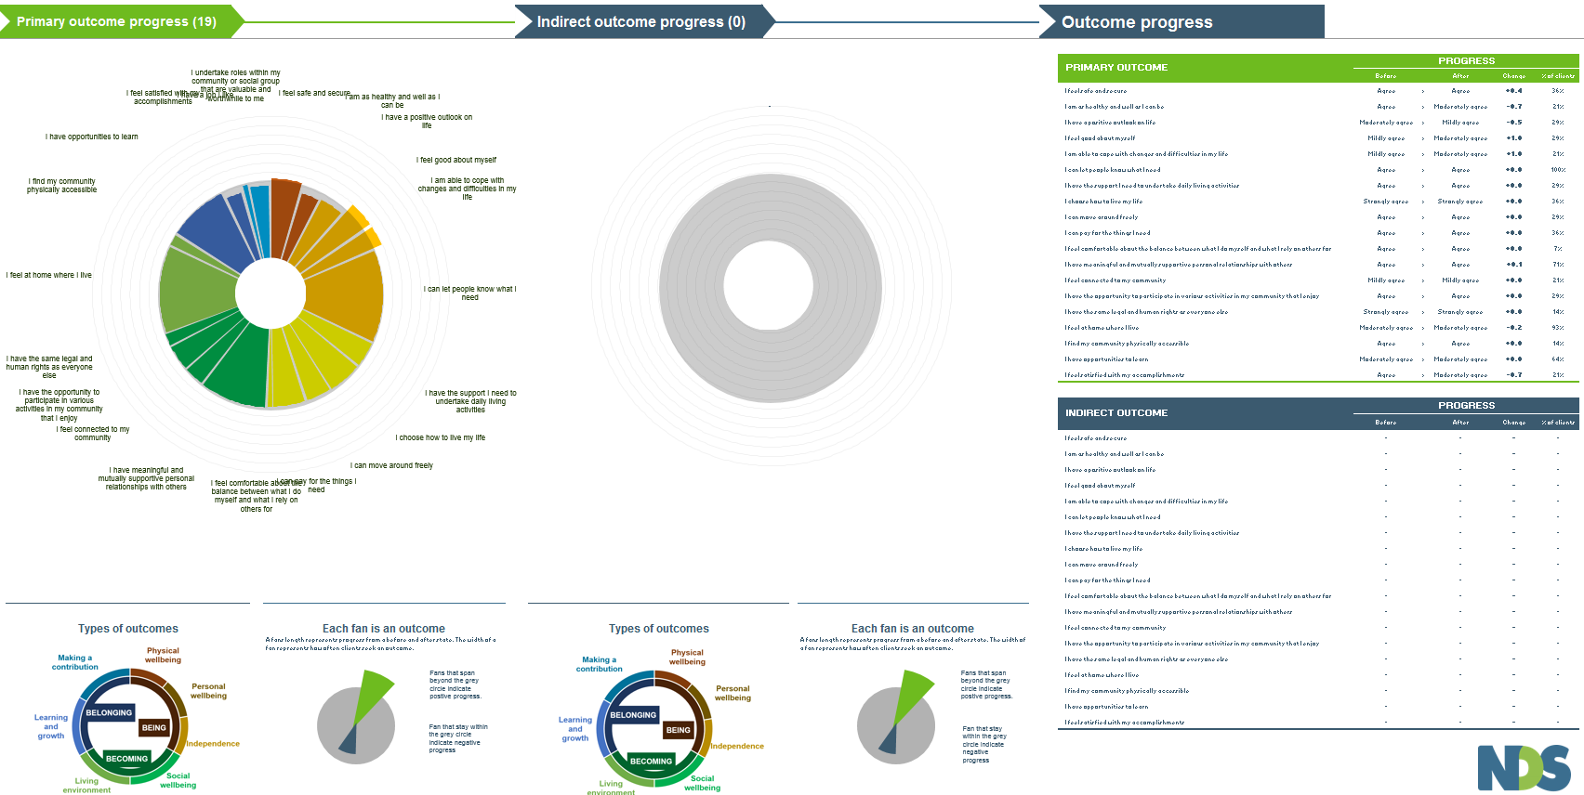
Figure 11: SPOT dashboard pilot results for Lifestyle Solutions

Interpretation of data collection results
Outcomes reported
Clients across the survey group reported across all three domains and outcome areas. Clients did not indicate any indirect outcomes during data collection.
Key Findings
- All data collected for becoming domain outcomes indicated that clients had been able to maintain their initial outcome levels prior to starting supports at the organisation.
- With respect to outcomes in the Being domain, clients experienced positive change in outcomes relating to feeling good about themselves and being able to cope with changes and difficulties in life. The only outcome where clients indicated a small negative change was in being as healthy as they could’ve been. However, respondents didn’t disagree with this statement rather their level of satisfaction has decreased by one scale point
- Outcomes in the belonging domain stayed level with what clients started with and saw small decreases in their ability to undertake roles within their community and feeling satisfied with accomplishments
Insights
- As data was collected from client accessing housing and living support it is great to see clients experiencing positive change in the outcomes related to feeling secure, ability to cope with changes and feeling good about themselves.
- It is likely that there is a decrease in outcome magnitude in the belonging domain outcomes as clients surveyed were new to the service and had just moved into a new living arrangement thus not having completely adjusted and integrated into the community. This could explain the negative movement across the outcomes relating to undertaking roles within the community and being satisfied with accomplishments.
- The two most common outcomes reported on were feeling at home where I live and I can let people know what I need which is a good indication that the primary aim of supported housing clients were met by the supports offered.
- Maintenance of outcome levels can be seen as a positive sign as clients are able to manage their needs without experiencing a drop in any key outcome areas.

6.5 Spinal Cord Injuries Australia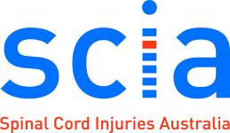

Background
Spinal Cord Injuries Australia (SCIA) provides advice, referral and other services that support people with a spinal cord injury to be independent, maintain their dignity and have access to opportunities. SCIA offer a broad range of services, aiming to be a national leader and one-stop-shop for all matters relating to spinal cord injuries. Some of the services offered by SCIA are as follows:
- Accommodation and care
- Peer support
- Employment
- Community based rehabilitation
- Injury prevention

Current approach to outcomes measurement
SCIA have progressed further along the journey towards outcomes measurement than most disability service providers. They have commissioned a number of Social Return on Investment (SROI) analyses for individual programs. One example of such research that is publicly available is the Walk On program SROI. These studies have been useful in shifting to an outcomes-based approach to service delivery, and in building the capacity of staff members to undertake outcomes measurement. Staff members involved in the SROI analyses have built a strong understanding of key concepts, such as theory of change and outcome indicators. This will be invaluable as the SCIA moves towards implementing an organisation-wide approach to measuring outcomes for clients.

Issues discussed during training
The pilot commenced with training on the SIM Toolkit and the key concepts underpinning outcomes measurement. SCIA staff who attended the training were highly enthusiastic about potential utility of the Outcomes Frameworks, excel tools, and about the philosophical shift to an outcomes-based approach in the sector. Many staff members could already envisage how the information gathered via the Toolkit could be used, for example:
- An understanding of how different services complement one another to create client outcomes. In the future this could lead to better integration of services delivered.
- Enabling clients to visually see the changes they have experienced.
- Use of stories of change for marketing purposes.
SCIA staff member commented that the SIM Toolkit appeared to be simple enough to understand and implement, whilst still being robust and evidence-based. Another benefit was that it lacked the level of complexity associated with an SROI analyses, but still provided useful information about client outcomes.

Data collection summary
- SCIA undertook surveys with 30 clients based in a hospital setting.
- Each survey took approximately 20-30 minutes to complete.
- Data was collected primarily through one on one interviews with social workers.
- Very limited data was collected on service costs and no data was collected on client service satisfaction.
- SCIA staff found it useful to show the client a printed and laminated a copy of the Outcomes Framework and outcomes descriptions whilst undertaking the survey.
  - The colours were helpful in differentiating outcomes domains.

Feedback on the SIM tool

Dashboard reporting format
SCIA staff thought that the representation of client progress via the dashboard was visually appealing and also a valuable communication tool. It could be used internally for case conferences, and also used to communicate directly with the clients about their progress. Some staff commented that this would not be possible for all clients (e.g. such as those who suffer from acquired brain injury). One suggestion to further improve the dashboard diagram was to have markers clearly showing before and after, rather than plotting the distance travelled.

Outcomes Framework
SCIA staff felt that the Outcomes Framework provided a comprehensive set of life outcomes that would be extremely useful in tracking client progress. SCIA staff stated that the outcome descriptions were really useful in providing more depth and clarity about each outcome. Some staff member felt that perhaps the outcome descriptions could be used in place of the outcomes statements, as some of the outcome statements were difficult to intuitively understand.

Usefulness of data
- Track feedback on client satisfaction
- Visually show how their services are impacting on clients
- To help direct clients to additional services in line with their desired outcomes
- To integrate in to current goal setting conversations clients have with social workers
- To identify organisational priorities and to inform redesign of services

Data collection and user interface feedback

Level of engagement in survey
SCIA staff found that some clients were not fully engaged in survey, mainly due to the length of time it took to complete. In the hospital setting, other comparable procedures take approximately 5-10 minutes. Another factor influencing the level of client engagement was how the tool was introduced. Some staff expressed the need for more detailed guidance on how to describe the tool and its purpose. One suggestion was to develop a survey introduction script, emphasising the value the tool provides for clients. This would ensure that the survey was being administered and communicated consistently. The lack of privacy in the hospital setting also may have impacted on the level of client engagement.

Appropriateness of questions
- Some survey questions had to be avoided due to inappropriateness for the clients’ situation. For example, it was not appropriate to ask a newly injured client about employment opportunities. Another factor to consider is that some clients may not be mentally prepared to answer the questions, particularly if they have recently experienced trauma.
- SCIA staff found that the tool was also quite difficult to administer with clients from culturally and linguistically diverse backgrounds who were involved in the pilot. Further work needs to be undertaken to ensure that the tool is culturally inclusive for all clients.
- Some clients found it difficult to understand the pictures of the faces related to the Likert scales. Other clients expressed that there were too many options. SCIA staff suggested that rather than reduce the number of options, clients would find it easier to rate outcomes on a scale from 1 to 10. This approach is consistent with other scales that clients may be familiar with (e.g. the pain scale).
- SCIA staff commented that it would be useful for future iterations of the tool to be available on a tablet or phone based app. This would make it much easier to transport when travelling to see clients, especially those who are community or hospital based.

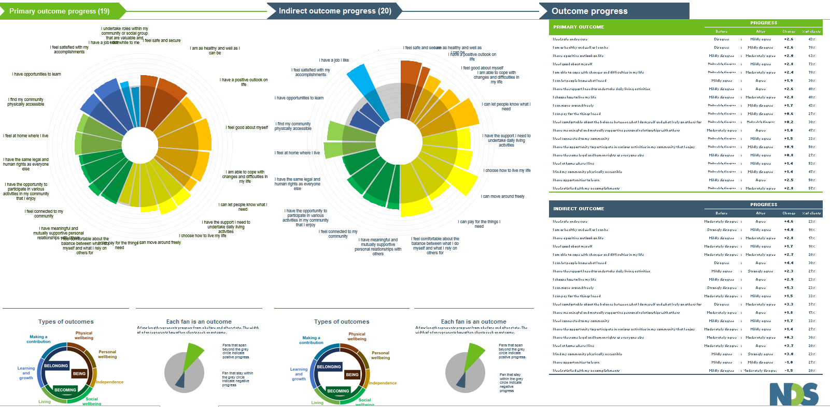
Figure 12: SPOT dashboard pilot results for SCIA

Interpretation of data collection results
Outcomes reported
Clients surveyed reported on all 21 focus (primary) outcomes and data was gathered on 20 indirect outcomes
Key findings
- Clients surveyed experienced a positive change on nearly all outcomes data was collected on with maintenance of outcomes achieved on undertaking roles within their community, being able to pay for things they need and being comfortable with the balance between self- reliance and getting help from others
- Being domain outcomes demonstrated the strongest positive change with many of the clients experiencing a 2-point increase across the measurement scale.
- Positive change in outcome achievement was even stronger across recorded indirect outcomes. Being domain outcomes were again demonstrated the areas with the most positive change. Feeling safe, letting people know when they needed help and ability to move around outcomes had clients experiencing a 4 point upward movement on the outcome scale.
- The largest positive change was in the ‘I have a job that I like’ outcome where there was a 5 point change.
- Clients only experienced a small negative (1 point) change in the opportunities to learn and satisfaction with accomplishments outcomes.
Insights
- The positive progress made across the all the outcomes in the framework is a good indicator of results give that data was collected from clients accessing a wide range of supports
- The large positive movement in the employment satisfaction outcome indicates that SCIA provides an effective employment assistance service offering.
- The two outcomes that experienced negative change in the indirect outcome graph seem to experience a large positive change in the focus outcome graph. This could potentially mean that where there was a focus on learning and personal goal setting activities, SCIA was able to deliver strong outcomes, however where this wasn’t the case, positive movement in other outcome areas due to particular activities potentially unintentionally caused a halt in learning opportunities. This is something that SCIA could look into while designing future support activities

6.6 On Focus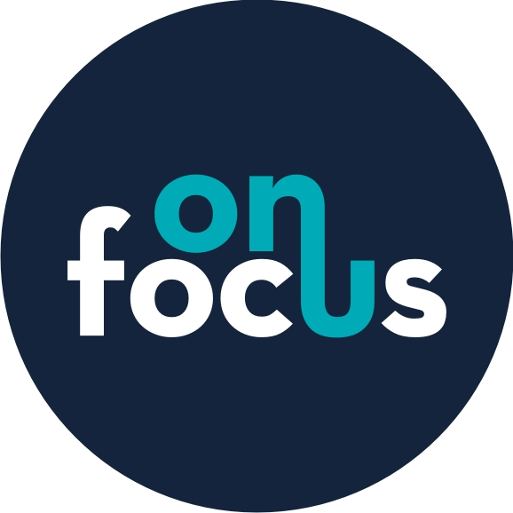

Background
On Focus is a multi-functional disability service provider with its head office in Casino, NSW. On Focus provides a range of accommodation and day services plus it is also a Registered Training Organisation (RTO). The accommodation services are available across the Far North Coast and include accommodation support, attendant care and skills development for people with disabilities seeking to live independently. The day service seeks to ‘assist people with a disability who require an alternative to paid employment or further education’ and is available in Casino, Lismore and Ballina. On Focus also offers ‘high quality training to its staff and clients and the staff and clients of Community Service Organisations’. The RTO is based in Casino but learning and development programs are offered across the region.

Current approaches to outcome measurement
At present On Focus does not have a method of measuring and reporting outcomes for its clients. Current measurement activities are limited to those related to funding mechanisms and basic tracking of inputs, activities and outputs. On Focus has a clearly articulated mission statement, values, and aims and objectives and a focus on strategy in a very dynamic operating environment. Operationally On Focus is well structured around its key service areas. This suggests that On Focus has the sound foundations necessary for moving to measuring outcomes.

Issues discussed during training
The external and internal drivers for developing a systematic approach to outcome measurement were discussed in depth. There was a strong desire for On Focus to measure outcomes across all services but recognition that currently they had limited relevant expertise and little capacity. They were also concerned about outcomes measurement systems might be time consuming and complex which would mean that they were not feasible given existing resource constraints. It was unclear where ultimately the responsibility for measuring outcomes would sit – either within each On Focus service area or centrally. There was also recognition that adoption of the Toolkit would help On Focus become more customer centric.
The relevance of all 21 outcome questions to most of their clients was recognised, as was the inter-relationship between the different outcome domains and ultimately it was their responsibility to ensure services were provided holistically.
There was also concern regarding the technology and level of expertise required to use SIM, and strong support for the use of Excel and the provision of accessible guidance.

Data collection summary
- Surveys collected from 20 clients
- The time taken was approximately one hour per client however this could have been a lot shorter but provided an opportunity to productively engage with clients
- The majority of clients were from day services plus a small number from home care services
- Very limited data was collected on service costs and client service satisfaction.
- Data was collected by the senior management who wanted to understand how data was captured and whether it would be suitable for using in the future.
- The survey was conducted through one on one interviews.
- All 21 outcome questions were used with all deemed to be Primary. They provide ‘a great overview of where the client feels they fit in the community’ and the basis for thinking ‘about the goal setting’.
- Some of the questions were challenging for some clients and further refinements might need to be done to ensure that the questions work for all clients.
- For many clients, it was difficult to capture retrospective data at the same time of current data which will not be a problem when fully implemented.

Feedback on the SIM tool

Data collection and User Interface
The data collection process and method of interfacing with clients was seen as both simple and effective. The capturing of information from individuals was straight forward, as was the process of collating data in the spreadsheet system. The direct engagement with clients around the 21 outcomes provided a real opportunity to understand how they are progressing. They expressed a desire to use the SIMS tool in the future and that they would embed it into the individual planning process.

Dashboard reporting format
The reporting dashboard was considered an effective tool for interpreting the data captured. It was considered visually attractive and informative. The interpretation of the data was summarised as confirming what they thought rather than generating new insights. On Focus concluded that the system had great potential and would consider implementing it across all their services.

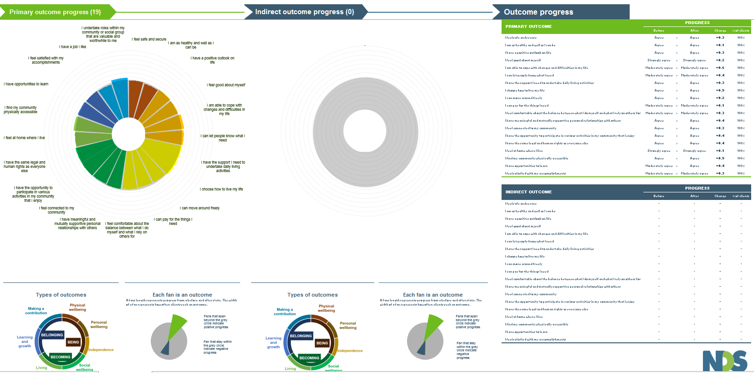
Figure 13: SPOT Dashboard pilot results for On Focus

Interpretation of data collection results
Outcomes reported
Clients surveyed reported on all 21 focus (primary) outcomes. No indirect outcomes were indicated.
Key findings
- Clients surveyed experienced maintenance of outcomes across the majority of areas. 1 point positive movement across the scales were experienced by clients in being able to cope with changes and difficulties, letting people know what they needed, undertaking roles within the community and finding the community physically accessible.
- All clients started off their outcomes at a positive point in the scale and thus none experienced any negative outcomes.
Insights
- Given that On Focus’ primary supports offered relate to accommodation and day services, all 4 outcomes where a positive change was recorded indicate an accomplishment of the core goals of the service.
- Additionally, these four outcomes represented all three domains in the framework providing evidence that clients were able to experience positive change in all key life areas.

6.7 House With No Steps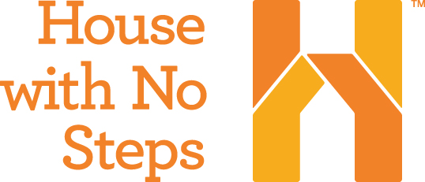

Background
House with No Steps (HWNS) provides a range of services including disability support, children services, respite care, recreation programs, community living and self-directed support (‘your life your choice’). HWNS also has a number of businesses which provide employment opportunities for people with disabilities.
HWNS is already a very person centric organisation focusing on recognising and achieving individuals’ aspirations.

Current approaches to outcome measurement
Over the past two years HWNS has invested in internal systems to support its person centric focus including the adoption of an outcomes measurement system developed by CQL called Personal Outcome Measures® (POMS). POMS ‘is a method for evaluating the quality of services from the points of view of a person with a disability’ and ‘CQL’s approach to measurement looks at personal quality of life and addresses questions of priority and relevance for the person, based individual life priorities’
The POMS system includes a range of outcome domains which have some commonality with the SIM Outcomes Framework. POMS captures two important pieces of information for each client. Firstly, it identifies whether an outcome is present for the individual. Secondly, it identifies whether supports are in place to enable the person to achieve the outcome or make progress towards it. POMS can also be utilised to engage wider stakeholders such as family members and carers.
Through this system HWNS is accredited for Person Centred Excellence and they have staff accredited to administer and analyse the POMS data. HWNS implementation of POMS includes a bespoke spreadsheet system for capturing, analysing and reporting data. HWNS uses POMS to not only track and report outcomes but also to develop service strategies and achieve continuous improvement.

Case study
HWNS was chosen to assess how the SIM Toolkit could interface with existing systems such as CQL POMS and whether the SIM Toolkit could potentially add value to existing systems.

Interface with CQL POMS
The 21 SIM Outcome Statements were mapped against the POMs domain descriptions (see Appendix E). The mapping showed a lot of overlap between the two frameworks but with some notable differences:
- The high level domains share a similar focus i.e.
  - SIM - Being, Belonging, Becoming
  - POMS - My Self, My World, My Dreams.
- The majority of indicators in the two frameworks are shared – see the cross-tabulation in the spreadsheet.
- The SIM Outcomes Framework has a stronger focus on independence:
  - Indicators 5, 10 and 11, respectively ‘I am able to cope with changes and difficulties when they arise’, ‘I can pay for the things I need’ and ‘I am reducing my reliance on outside support over time’, are not specifically included in the POMs.
- The SIM Outcomes Framework includes the concept of positivity which POMs lacks:
  - Indicators 3 and 4 respectively ‘I generally have a positive outlook on life’ and ‘I generally feel good about myself’ (in SIM Outcomes Framework).
- The POMs framework has a stronger emphasis on the concept of human rights:
  - Only expressed in the SIM Outcomes Framework through indicator 15 ‘I am able to exercise the same legal and human rights as others’.
  - POMs expands on this through four indicators: 1.e, 1.f, 1.g and 1.i, respectively ‘People exercise rights’, ‘People are treated fairly’, ‘People are free from abuse and neglect’, and ‘People decide when to share personal information’.
- Although there is a good overlap between the outcome domains and questions in SIM and POMS, there is a fundamentally different approach to measuring outcomes with SIM adopting a more quantitative approach and POMS a more qualitative approach. In terms of ‘data’, POMS records whether an outcome is present (0 or 1) and whether a supports are in plane to achieve that outcome (0 or 1). In addition, information is captured on priority or ‘focus’ outcomes and whether there are any barriers. POMS does not include any Likert scale data such as that captured in SIM which measures the progress towards achieving an outcome. However, POMS does capture a significant amount of rich qualitative information on each person which drives person centred care and service quality improvements.

Data collection and User Interface
Given the considerable level of overlap of outcome domains it was possible to export data from CQL POMS in to the SIM Client Outcome Tracker – albeit with clearly stated limitations in terms of the differences in the exact questions used and the different methods of data capture (see Appendix E).
The actual data exported for each person is limited in two ways. Firstly, the sample data provided was only for one point in time. Secondly, the sample data only provided whether an outcome is present and whether supports are in place. There are therefore three possible combinations. For the purposes of the pilot the following SIM Likert scale scores were imputed for each person where a comparable outcome existed:
- An outcome is present and supports are in place = SIM Likert 4 and this outcome is identified as Focus outcome in SIM
- An outcome is present but no supports are in place = SIM Likert 2 and this outcome is identified as Focus outcome in SIM
- An outcome is not present but a support is in place = SIM Likert 3
A hypothetical second series of random SIM Likert scores was then created for this sample to test the SIM reporting dashboards.

Dashboard reporting format
Acknowledging the limitations noted above, it has been possible to import broadly comparable data from POMS for most of the 21 questions featured in SIM and then impute hypothetical data for a further point in time, and use this data to generate both the client and organisation level dashboards (Figure 14 below).
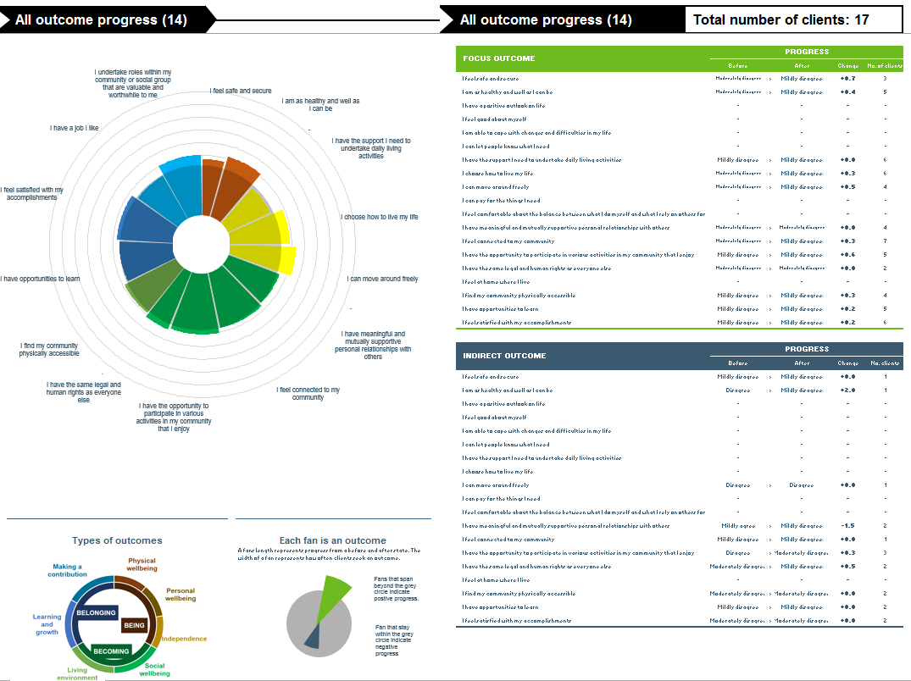
Figure 14: SPOT Dashboard pilot results for HWNS

Interpretation of data collection results
Outcomes reported
The HNWS Client data imported into the SIM was limited to 14 focus outcomes and the second set of data was randomly generated was used to generate an illustration of how the SIM Toolkit could be used in tandem with an existing outcomes measurement system such as POMS. If this has been real data then the following would be identified as key findings and insights:
Key findings
- On average, clients surveyed experienced maintenance and positive movement of outcomes across all outcomes indicated.
- The strongest positive changes were experienced in clients being able to move around freely, contributing to the community and being as healthy as they could
- Where clients started off at negative points in the scale there were no further decreases in outcome magnitude. Most clients either maintained similar levels or progressed up the scale
Insights
- Outcomes experienced represented all three domains in the framework providing evidence that clients were able to make positive changes in all key life areas identified.
The added value of using the SIM Toolkit
The importing of POMS data and generation of client and organisation reporting dashboards confirmed that it is possible to integrate the SIM Toolkit in to existing systems such as POMS. The SIM reporting dashboard was recognised as a clear value add as the CQL POMS has no such reporting facility. There are however two further questions for HWNS to consider in assessing whether the SIM Toolkit can add value to their existing CQL POMS system.
Firstly, whether it is desirable and feasible to add the missing SIM outcome statement questions – especially relating to independence and positivity - to their existing POMS data collection process – and thus be able to provide a complete set of data for the SIM 21 outcome statements. This may raise issues regarding the amendment of a proprietary tool such as CQL POMS and their accredited use of that tool. This will require further investigation by HWNS.
Secondly, whether it is desirable and feasible to utilise the SIM Likert scale for the POMS outcome questions in addition to the binary measures currently used. HWNS are currently considering the development of an additional module which relates to the planning stage of the NDIS. This may provide an opportunity for them to systematically assess the added value of adopting elements of SIM Toolkit.

6.8 Pilot feedback summary
The five pilot sites included NGO service providers that were towards the top of the outcomes-measurement readiness pyramid. The feedback received on the SIM Outcomes Framework and SIM Toolkit were broadly consistent across all sites
- All the service providers realised the importance of measuring outcomes and saw the SIM Toolkit and Outcomes Framework as an ideal starting point to embark on this endeavour. There was universal recognition of the value of the SIM Toolkit and support for the three SIM outcome domains and method of data collection.
- On review of the SPOT dashboards for the core four pilot organisations, two organisations (On Focus and Lifestyle Solutions) seem to have generated results which appear to be as not effective as the other two. However, on further investigation, it was revealed that the cause for this was the retrospective data collection. Clients could not recall their position with respect to certain outcomes from more than a few months ago or had only just started accessing supports related to their plans.
- The retrospective data collection may therefore not suit all clients and all outcome statements However, this is not a problem once the SIM Toolkit has been implemented as data is collected on a longitudinal basis for example: When clients start to access a service, during a plan period (say every 12 months), and when they finish their plan period (2 years).
- Starting to look at social impact allowed organisations to reflect not only the change they were creating for clients but also how they could change their program delivery to optimise outcome creation. The identification of focus and secondary outcomes allowed them to see links between various outcome areas that could further inform future program design.
- The excel-format of the SIM Toolkit was relatively easy to use to collect data and the flexibility it provided them while collecting data allowed them to customise the way they implemented the survey across clients of varying disability types and geographic areas.
- Each pilot organisation used different ways of collecting data involving various stakeholders in the process such as senior managers, case workers, administrative staff and clients’ families.
  - Further guidance may be required to ensure that the data collection process is robust and biases are not introduced.
- Organisations also suggested including possible safeguards and processes for interviews to follow in instances where asking clients for responses on certain outcome areas (such as safety) might put them in distress or indicate greater issues that may trigger further investigation of concerns.
- There was a request for an introductory script or document for clients when they first start data collection to emphasise the role of the SIM Toolkit and what would be required of them.
- Some of the organisations with lower levels of outcomes measurement readiness required capacity building assistance on:
  - General outcomes measurement,
  - Theory of Change (This has been addressed by the design of the Theory of Change tool now included with the SIM Toolkit),
  - Technical support while collecting data.
- It was suggested that the SIM Toolkit be offered as a tablet or smartphone application to ease the data collection process. This would help organisations collect data more frequently and across a wide geographical range.
- Organisations were supportive of the fact that the SIM Toolkit measured quality of progress towards achieving an outcome rather than an absolute quantity of an outcome. On this basis, participants thought that the representation of results through graphs in the dashboard provided a fair and comparable format especially over time.
- The only area of data which was mostly incomplete was in providing the costs of services utilised by clients surveyed. The causes for this were that such information was already being captured through other data collection systems and would require a manual process to extract. This could be resolved by matching SIM data with internal systems through unique identifiers and an automated data import / export process.
- There was support for the Likert Scale used for the outcome statements in terms of both the scale length and the use of graphical representation. However further work is required to explore alternatives to the current representation of the outcome scales such as demonstrative human facial expressions that would be culturally appropriate. It was suggested that organisations and individual clients have a choice of what sort of scale representation us used in the tool.
- Other feedback gained through the pilot phase and subsequent testing identified minor functionality issues and small errors in the detail of the Toolkit including:
- missing categories
- non-functioning calculations
- language used, and
- Where feasible and within the confines of this project, all of the feedback has been taken on board and incorporated into the final version of the SIM Toolkit.

7. Conclusions
The process of developing and testing the SIM Toolkit has generated a number of conclusions and key findings which may inform the future development of SIM Toolkit.

7.1 Widening use of the SIM Toolkit
There is universal recognition of the need to measure outcomes and recognition of the value of an accessible resource such as the SIM Toolkit. The feedback suggests that the SIM Toolkit can be effectively used across human services and the community sector more broadly. The SIM Toolkit is of particular relevance to organisations which are ready for outcomes measurement but have not developed their capabilities in relation to outcomes measurement and have not invested in the development of internal systems.
The pilot testing was broadly successful suggesting that organisations ready for outcomes measurement could effectively utilise the Toolkit. However, the feedback suggests that organisations will require support and the successful roll out of use of the Toolkit will require a strategy based on a staged implementation to ensure organisations are supported. Wider usage may also reveal that the Toolkit will require adaptation to suit different client types and services. The roll out and continued refinement of the Sim Toolkit could be achieved through building a community of interest or practice.

7.2 Organisational readiness for measuring outcomes
The piloting of SIM Toolkit was conducted with organisations which had already expressed an interest in outcomes measurement and are not representative of the disability sector as a whole where it is assumed that many smaller and medium sized organisations have not yet recognised the importance of outcomes measurement. However, even within this ‘engaged’ subset there is a considerable variation of readiness for outcomes measurement. For some there will need to be a considerable amount of capacity building before embarking on the systematic measurement of outcomes. The pilot organisations recognised the desirability for measuring outcomes and the challenges in implementing the Toolkit. It was noted that some organisations will need to implement a program of change management including changing organisational culture to ensure they are ‘customer-centric’.
For the organisations which are not engaged – especially the smaller and medium sized organisations – it may be necessary to utilise a diagnostic tool to identify their readiness for measuring outcomes and what types of capacity building are required to help organisations become ready. It would be counter-productive to make the SIMS Toolkit available without the preparatory capacity building.

7.3 Evolving use of the SIM Toolkit by organisations
Net Balance has identified three levels of use of the SIM Toolkit by organisations.
Firstly, for many organisations they can use the SIM Toolkit to help build their own capabilities to measure outcomes and discover how measurement can be used to inform organisational learning. This foundation level allows organisations to become confident in measuring outcomes.
Secondly, once organisations become confident in measuring outcomes they will consider how this information can be used to demonstrate their impact to key stakeholders including clients and funders. Confident organisations may also consider participating in anonymous peer benchmarking initiatives.
Thirdly, positive feedback from key stakeholders will encourage organisations to openly report and communicate this data. At this level it may be necessary for organisations to use independent data collection or data auditing / assurance processes. As more organisations report their outcomes using the SIM Toolkit, there will become a critical mass which would justify the development of a web portal to collate organisational data and reporting dashboards.

7.4 A Developing the technology of the SIM Toolkit
The use of simple accessible technology has been widely appreciated through the development and testing process and is acknowledged as essential for smaller and medium sized organisations. The SIM Toolkit has wide applicability across the disability sector and key elements such as the data capture process and representation of the Likert Scale for outcomes statements can be adapted to ensure that it is accessible for all people with a disability. However, the feedback suggests that there are opportunities to enhance the technology of the SIM Toolkit.
The development of a tablet or smartphone application was identified as one method for improving the efficiency and effectiveness of the data collection process. Such an application could speed up data collection with clients and provide an opportunity for different representations of the SIM outcome statements and the Likert Scales including use of innovative representation that are suited to particular client segments.
- Some of the pilot organisations were also keen to integrate the SIM Toolkit in to their embedded case management systems, whilst others were keen to consider the SIM Toolkit as part of their future investments in case management systems. Organisations providing case management systems have also expressed interest in utilising the SIM Toolkit.
- The feedback also suggested that there is potential to hold the SIM Toolkit and supporting resources on the Cloud which could serve to both promote and control usage.

8. Limitations
Net Balance Management Group Pty Ltd (Net Balance) has prepared this report in accordance with the usual care and thoroughness of the consulting profession. This report has been prepared for use by National Disability Services NSW, and only those third parties who have been authorised in writing by Net Balance.
The Report is based on generally accepted practices and standards at the time it was prepared. No other warranty, expressed or implied, is made as to the professional advice included in this report. It is prepared in accordance with the scope of work and for the purpose outlined in the project brief. The methodology adopted and sources of information used by Net Balance are outlined in this report.
Please note that all results have been reported as recorded. Any percentages that do not add up to exactly one hundred percent are the result of rounding errors. This report was prepared and finalised in August 2014 and finalised. It is based on the conditions encountered and information reviewed at the time of preparation. Net Balance disclaims responsibility for any changes that may have occurred after this time.
This report should be read in full. No responsibility is accepted for use of any part of this report in any other context or for any other purpose or by third parties. This report does not purport to give legal advice. Legal advice can only be given by qualified legal practitioner.

References
ADHC 2012, Standards in action: Practice requirements and guidelines for services funded under the Disability Services Act, Ageing Disability and Home Care, NSW Department of Family and Community Services.
Atkinson, D, Boulter P, Hebron, C, Moulster, G, Giraud-Saunders, A & Turner S 2013, The Health Equalities Framework, National Development Team for Inclusion, UK learning Disability Consultant Nurse Network, United Kingdom.
Australian Unity 2010, What makes us happy – Ten years of the Australian Unity Wellbeing Index, Australian Unity, Deakin University, Melbourne.
Bonham Research 2011, Ask ME! Quality of Life Questionnaire, United States, accessed 08/08/14, http://www.bonhamresearch.com/Level%201/AskMe.htm
Commonwealth of Australia 2013, Involuntary or coerced sterilisation of people with disabilities in Australia, Senate Standing Committees on Community Affairs.
COAG 2009, The Early Years Learning Framework for Australia, Commonwealth of Australia 2009
COAG 2011, National Disability Strategy 2010-2020, Council of Australian Governments, Commonwealth of Australia.
Council on Quality and Leadership 2012, Personal Outcome Measures, Council on Quality and Leadership.
Department of Health 2013, Adult Social Care Outcomes Framework 2013 to 2014, Department of Health, United Kingdom.
DHHS 2009, Operational Framework for Disability Services, Department of Health and Human Services, Tasmania.
DHS 2007, Quality Framework for Disability Services in Victoria, Department of Human Services, Victoria.
DLGC 2013, National Quality Framework, Department of Local Government and Communities, Western Australia.
DSS 2009, SHUT OUT: The Experience of People with Disabilities and their Families in Australia, a National Disability Services consultation report prepared by the National People with Disabilities and Carer Council, Department of Social Services, Australian Government.
DSS 2013, National Standards for Disability Services, Department of Social Services, Australian Government.
HSRI & NASDDS 2014, National Core Indicators - Individual outcomes domains, Human Services Research Institute, The National Association of State Directors of Developmental Disabilities Services, United States.
International Wellbeing Group 2013, Personal Wellbeing Index: 5th Edition, Australian Centre on Quality of Life, Deakin University, Melbourne.
National MWIA Collaborative 2011, Mental Well-being Impact Assessment Toolkit, National MWIA Collaborative, England.
nef 2009, National Accounts of Well-being: bringing real wealth onto the balance sheet, new economics foundation, United Kingdom.
New Zealand Office of Disability Issues 2009, New Zealand Disability Strategy, New Zealand Office of Disability Issues, Ministry of Social Development.
NDS 2012, Measuring Outcomes for People with Disability, National Disability Services.
Public Health Agency of Canada 2013, Community Capacity Building Tool, Public Health Agency of Canada.
Quilliam, C & Wilson, E 2011, Literature Review Outcomes Measurement in Disability Services: A review of policy contexts, measurement approaches and selected measurement tools, SCOPE, Deakin University, Melbourne.
Schalock, RL & Keith, KD 1993, The Quality of Life Questionnaire Manual, IDS Publishing Corporation.
SH&FPA 2013, Improving Sexual and Reproductive Health for People with a Disability, Sexual Health and Family Planning Australia.
Triangle Consulting 2012, The Outcomes Star – a tried and tested tool for supporting and measuring change, Triangle Consulting, United Kingdom, accessed 15/08/2014, http://www.outcomesstar.org.uk/
United Nations 2006, United Nations Convention on the Rights of Persons with Disabilities, United Nations.
University of Toronto 2002, Quality of Life Profile, Quality of Life Research Unit, Canada.
Ura, K, Alkire, S, Zangmo, T & Wangdi, K 2012, A Short Guide to Gross National Happiness Index, The Centre for Bhutan Studies.
Wilson, E 2006, Defining and Measuring the Outcomes of Inclusive Communities, SCOPE, Deakin University, Melbourne.
WHO 2004, International Classification of Functioning, Disability and Health (ICF), World Health Organisation, United Nations.
WHO 2010, Measuring Health and Disability: Manual for WHO Disability Assessment Schedule – WHODAS 2.0, World Health Organisation, United Nations.

Appendix A: Existing frameworks and SROI analyses drawn upon
Outcomes Frameworks
- New Zealand Disability Strategy - ten life outcome areas (New Zealand Office of Disability Issues 2009)
- International Classification of Functioning, Disability and Health (ICF) - nine ‘activities and participation’ domains (WHO 2004)
- National Disability Strategy - six outcomes (COAG 2011)
- UN Convention on Rights of Persons with Disabilities - eight guiding principles (United Nations 2006)
- Victorian Quality Framework life areas (DHS 2007)
- SCOPE Outcomes Framework - seven outcome domains (Wilson 2006)
- UK Health Equalities Framework (HEF) (Atkinson et al. 2013)
- Tasmanian Operational Framework for Disability Services (DHHS 2009)
- UK Adult Social Care Outcomes Framework 2013 to 2014 (Department of Health 2013)
- National Core Indicators (NCI), United States - Individual outcomes domains (HSRI & NASDDS 2014)
- Personal Outcomes Measures (POMs) (Council on Quality and Leadership 2012)
- University of Toronto Quality of Life Profile (QLP) (University of Toronto 2002)
- The Quality of Life Questionnaire (Schalock & Keith 1993)
- Ask ME! Quality of Life Questionnaire, United States (Bonham Research 2011)
- Personal Wellbeing Index (International Wellbeing Group 2013)
- WA Quality Framework – outcomes (DLGC 2013)
- National Accounts of Wellbeing (nef 2009)
- Community Capacity Building Tool (Public Health Agency of Canada 2013)
- Australian Unity Wellbeing Index (Australian Unity 2010)
- Mental Wellbeing Impact Assessment Toolkit (National MWIA Collaborative 2011)
- Gross National Happiness Index (Ura et al. 2012)
- The Outcomes Star (Triangle Consulting 2012)
- Measuring Health and Disability: Manual for WHO Disability Assessment Schedule – WHODAS 2.0 (WHO 2010)
- National Standards for Disability Services (DSS 2013)

SROI analyses
- SROI of Action for Kids' Work Related Learning (WRL) Program, United Kingdom
- SROI of Saskatchewan Abilities Council Employment Services Pilot Program, Canada
- SROI of Saskatchewan Abilities Council Becoming Clubhouse Program, Canada
- SROI of Saskatchewan Abilities Council Becoming Clubhouse Program, Canada
- SROI of Industrial Maintenance Engineers (IME) Program, United States
- SROI of Vision Australia (VA) Program, Independence in the Home and Community (aged 60+)
- SROI of Vision Australia Program, Employment Services.
- SROI of Vision Australia Program, Low Vision Clinics (aged 60+)
- SROI of Vision Australia Program, Children and Family Services
- SROI of Spinal Cord Injury Australia program - Walk On ProgramAppendix B: Example outcomes domains from selected frameworks
National Disability Strategy 2010-2020
- Inclusive and accessible communities
- Rights protection, justice and legislation
- Economic security
- Personal and community support
- Learning and skills
- Health and wellbeing
New Zealand Disability Strategy
- Health: ‘I feel healthy and well’
- Transport: ‘I can move around’
- Income: ‘I can pay for things’
- Housing: ‘I have my own home’
- Relationship: ‘I have friends and family’
- Value: ‘I feel valued’
- Citizenship: ‘I participate in my community’
- Employment: ‘I have meaningful employment’
- Recreation: ‘I have fun’
- Education: ‘I am learning new things’
Quality Framework for Disability Services in Victoria
- Always learning
- Being part of community
- Being independent
- Being safe
- Building relationships
- Choosing supports
- Communicating
- Doing valued work
- Exercising rights and responsibilities
- Expressing culture
- Having fun
- How to live
- Looking after self
- Moving around
- Paying for things
- Where to live
Scope Framework
- Personal wellbeing and civil citizenship
- Social citizenship
- Political citizenship
- Cultural citizenship
- Economic citizenship
- Environmental citizenship
- Spiritual citizenship.
Personal Outcomes Measures (POMS)
- My Self:
  - People are connected to natural support networks
  - People have intimate relationships
  - People are safe
  - People have the best possible health
  - People exercise rights
  - People are treated fairly
  - People are free from abuse and neglect
  - People experience continuity and security
  - People decide when to share personal information
- My World:
  - People choose where and with whom they live
  - People choose where they work
  - People use their environments
  - People live in integrated environments
  - People interact with other members of the community
  - People perform different social roles
  - People choose services
- My Dreams
  - People choose personal goals
  - People realise personal goals
  - People participate in the life of the community
  - People have friends
  - People are respected
University of Toronto Quality of Life Profile (QLP)
- Being: who one is
- Physical Being
- Psychological Being
- Spiritual Being
- Belonging: connections with one's environments
- Physical Belonging
- Social Belonging
- Community Belonging
- Becoming: achieving personal goals, hopes, and aspirations
- Practical Becoming
- Leisure Becoming
- Growth becoming
The International Classification of Functioning (ICF)
- ‘Activities and participation’ domains:
- Communication
- Mobility
- Self-care
- Domestic life
- Interpersonal interactions and relationships
- Learning and applying knowledge
- Community, social and civic life
- General tasks and demands
- Major life areas

Appendix C: Mapping the SIM Outcomes Framework to the National Standard for Disability Services
SIM Outcome 1 ‘I feel safe and secure’ relates to the following National Disability Services Standards:
Standard One: Rights
Emphasis on safe service delivery and feeling ‘respected and safe’ and,
Services should ‘actively prevent abuse, harm, neglect and violence.’
Standard Four: Feedback and Complaints
People need to feel safe to make a complaint.
Standard Six: Service Management
Services delivered in a safe environment by appropriately qualified and supervised personnel.
SIM Outcome 2 ‘I feel healthy and well’ relates to the following National Disability Services Standards:
Not explicitly stated in National Standard. This is a more specific example of an individual outcome (Individual outcomes are outlined in Standard Three).
SIM Outcome 3 ‘I generally have a positive outlook on life’ relates to the following National Disability Services Standards:
Not explicitly stated in National Standard. This is a more specific example of an individual outcome (Individual outcomes are outlined in Standard Three).
SIM Outcome 4 ‘I generally feel good about myself’ relates to the following National Disability Services Standards:
Not explicitly stated in National Standard. This is a more specific example of an individual outcome (Individual outcomes are outlined in Standard Three).
SIM Outcome 5 ‘I am able to cope with changes and difficulties when they arise’ relates to the following National Disability Services Standards:
Not explicitly stated in National Standard. This is a more specific example of an individual outcome (Individual outcomes are outlined in Standard Three).
SIM Outcome 6 ‘I can communicate my needs to people around me’ relates to the following National Disability Services Standards:
Standard Four: Feedback and Complaints
‘I have a range of ways to speak up about my supports and services.’
Standard Five: Service Access
‘I understand what the service offers.’
SIM Outcome 7 ‘I have the support I need to take care of myself’ relates to the following National Disability Services Standards:
Human Rights Principles:
Independence of persons and individual autonomy.
SIM Outcome 8 ‘I have the freedom to choose how to live my life’ relates to the following National Disability Services Standards:
Standard One: Rights
‘I have the right to exercise control and choice when I use service or supports’ and,
‘I have the right to dignity of risk’ and,
The service promotes individual rights to freedom of expression, self-determination and decision-making.
Standard Three: Individual Outcomes
‘I have the right to lead and direct decisions about my life and how services I use support me.’
SIM Outcome 9 ‘I can move around freely’ relates to the following National Disability Services Standards:
Not explicitly stated in National Standard. This is a more specific example of an individual outcome (Individual outcomes are outlined in Standard Three).
SIM Outcome 10 ‘I can pay for the things I need’ relates to the following National Disability Services Standards:
Not explicitly stated in National Standard. This is a more specific example of an individual outcome (Individual outcomes are outlined in Standard Three).
SIM Outcome 11 ‘I am reducing my reliance on outside support over time’ relates to the following National Disability Services Standards:
Independence of persons and individual autonomy.
SIM Outcome 12 ‘I am generally satisfied with the quality of relationships I have with others’ relates to the following National Disability Services Standards:
Standard Two: Participation and Inclusion
‘I have the right to decide how I have contact with family, friends and community.’
SIM Outcome 13 ‘I feel valued and respected in my community’ relates to the following National Disability Services Standards:
Standard Two: Participation and Inclusion
Emphasises the importance of participation based on an individual’s interests, identity, heritage, preferences, goals and aspirations (which may change over time).
Standard Three: Individual Outcomes:
Service providers to competently recognise and respond to issues related to age, gender, culture, heritage, language, faith, sexual identity, relationship status and other relevant factors.
Responsiveness to diversity.
Human Rights Principles:
Respect for difference and acceptance of persons with disabilities as part of human diversity and humanity.
SIM Outcome 14 ‘I have the opportunity to participate in various activities in my community that I enjoy’ relates to the following National Disability Services Standards:
Standard Two: Participation and Inclusion
‘I follow my interests, with the support of my services, family, friends, carers or advocates’ and,
‘I have the right to participate in my chosen community.’
SIM Outcome 15 ‘I am able to exercise the same legal and human rights as others’ relates to the following National Disability Services Standards:
Standard One: Rights
‘I have the right to exercise control and choice when I use services or supports’ and,
‘I have the right to dignity of risk and to be free from discrimination and harm.’
Standard Five: Service Access
‘I have the right to access services based on fair and equal and transparent criteria, and support for a referral when a service is not available.’
SIM Outcome 16 ‘I feel at home in my current living arrangement’ relates to the following National Disability Services Standards:
Not explicitly stated in National Standard. This is a more specific example of an individual outcome (Individual outcomes are outlined in Standard Three).
SIM Outcome 17 ‘I am able to access physical spaces and infrastructure in my neighbourhood’ relates to the following National Disability Services Standards:
Not explicitly stated in National Standard. This is a more specific example of an individual outcome (Individual outcomes are outlined in Standard Three).
SIM Outcome 18 ‘I have the opportunity to learn new knowledge and skills’ relates to the following National Disability Services Standards:
Not explicitly stated in National Standard. This is a more specific example of an individual outcome (Individual outcomes are outlined in Standard Three).
SIM Outcome 19 ‘I generally feel satisfied with my accomplishments’ relates to the following National Disability Services Standards:
Standard Three: Individual Outcomes
‘I use services and support which build on my strengths and support me to reach my life goals’
SIM Outcome 20 ‘I have a meaningful job’ relates to the following National Disability Services Standards:
Standard Two: Participation and Inclusion
Emphasises the importance of promoting a valued role for people with disability in public and private life
Standard Three: Individual Outcomes
‘I use services and support which build on my strengths and support me to reach my life goals’
SIM Outcome 21 ‘I undertake roles within my community or social group that are valuable and worthwhile’ relates to the following National Disability Services Standards:
Standard Two: Participation and Inclusion
Emphasises the importance of promoting a valued role for people with disability in public and private life
Standard Three: Individual Outcomes
‘I use services and support which build on my strengths and support me to reach my life goals’

Appendix D: Evidence base for the SIM Outcome Framework
‘Being’ Domain outcomes evidence base
- Sub-Domain: Physical Wellbeing, ‘I feel safe and secure’
This outcome relates to: Feeling safe and secure at home and in the neighbourhood.
Evidence base:
Housing has a significant impact on mental health and wellbeing. There is consistent evidence for improved mental health after housing and neighbourhood improvement interventions.
- Safety at home and in the community/neighbourhood are addressed in the following references:
- National Standards for Disability Services (DSS 2013)
- Australian Unity Wellbeing Index (Australian Unity 2010)
- Personal Outcomes Measures (POMs) (Council on Quality and Leadership 2012)
- WA Quality Framework (DLGC 2013)
- Mental Wellbeing Impact Assessment Toolkit (National MWIA Collaborative 2011)
- Personal Wellbeing Index (International Wellbeing Group 2013)
- UK Health Equalities Framework (HEF) (Atkinson et al. 2013)
- Adult Social Care Outcomes Framework 2013 to 2014 (Department of Health 2013)
- Community Capacity Building Tool (Public Health Agency of Canada 2013)
- Ask ME! Quality of Life Questionnaire, United States (Bonham Research 2011) - ‘How safe do you feel in your neighbourhood?’
- SROI of Vision Australia Program, Independence in the Home and Community

- Sub-Domain: Physical wellbeing, ‘I am as healthy and well as I can be’
This outcome relates to: Feeling well-rested, having energy, and experiencing a general sense of wellbeing. This can be influenced by factors such as quality of sleep, access to affordable and nutritious food, access to health services and doing exercise that is appropriate to my needs.
Evidence base:
The concepts of health and vitality are addressed in the following references:
- Australian Unity Wellbeing Index (Australian Unity 2010)
- New Zealand Disability Strategy (New Zealand Office of Disability Issues 2009)
- National Disability Strategy (COAG 2011)
- National Accounts of Well-being (nef 2009)
- Personal Outcomes Measures (POMs) (Council on Quality and Leadership 2012)
- Mental Wellbeing Impact Assessment Toolkit (National MWIA Collaborative 2011)
- Ask ME! Quality of Life Questionnaire, United States (Bonham Research 2011) - ‘Do you get the sleep you need to without being sturbed?’
- University of Toronto Quality of Life Profile (QLP) (University of Toronto 2002) - ‘I am able to participate in exercise appropriate to my needs’
- The Outcomes Star (Triangle Consulting 2012)- Spectrum star of autism and Asperger’s syndrome

- Sub-Domain: Personal Wellbeing, ‘I have a positive outlook on life’
This outcome relates to: Being resilient, i.e. having the psychological resources and skills to cope with changes or challenges.
Evidence base:
'The concepts of happiness and optimism are addressed in the following references:
- SROI of Spinal Cord Injury Australia program - Walk On Program - The outcomes are: ‘increased happiness’; ‘focus on the positives, rather than the negatives’; ‘participants feel better about their lives’; and ‘positive outlook on life’.
- National Accounts of Wellbeing (nef 2009) - ‘Feeling optimistic about the future’
The ideas of having positive feelings, non-disturbing emotions and peace of mind are addressed in the following references:
- SROI of Action for Kids' Work Related Learning (WRL) Program UK
- SROI of Spinal Cord Injury Australia program - Walk On Program - ‘emotional stability’
- National Accounts of Wellbeing (nef 2009) - nef defines emotional wellbeing as being related to positive feelings and the absence of negative feelings.
- Gross National Happiness Index (Ura et al. 2012) - Includes ‘emotional balance’ and ‘peace of mind’.

- Sub-Domain: Personal Wellbeing, ‘I feel good about myself’
This outcome relates to: Having self-esteem and confidence, for instance in the choices made.
Evidence base:
'Self-esteem is addressed in the following references:
- National Accounts of Wellbeing (nef 2009)
- SROI of Industrial Maintenance Engineers (IME) Program, US
- Ask ME! Quality of Life Questionnaire, United States (Bonham Research 2011) - ‘Do you like yourself?’
- Confidence is addressed in the following references:
- National Accounts of Wellbeing (nef 2009)
- SROI of Action for Kids' Work Related Learning (WRL) Program, UK
- SROI of Vision Australia Program, Employment Services
- SROI of Vision Australia Program, Children and Family Services
- SROI of Spinal Cord Injury Australia Program - Walk on Program

- Sub-Domain: Personal Wellbeing, ‘I am able to cope with changes or difficulties in my life’
This outcome relates to: Being resilient, i.e. having the psychological resources and skills to cope with changes or challenges.
Evidence base:
The concept of resilience was highlighted by disability experts and service providers at several instances during the stakeholder engagement. It is also addressed in the following references:
- SROI of Saskatchewan Abilities Council Becoming Clubhouse Program, Canada - ‘Increased awareness of mental health triggers leads to Improved coping skills’
- National Accounts of wellbeing (nef 2009) - Resilience is defined as ‘being able to deal with life's difficulties.’ It is a measure of one's psychological resources.

- Sub-Domain: Personal wellbeing, ‘I can let people know what I need’
This outcome relates to: Understanding others and being well-enough understood to get a message across and communicate needs.
Communication may occur via language, signs and symbols, conversations, and/or using communication devices.
Evidence base:
The importance and different aspects of communication are addressed in the following references:
- National Standards for Disability Services (DSS 2013)
- International Classification of Functioning, Disability and Health (ICF) (WHO 2004) - ‘Communication’ is one of ICF's nine activity domains
- WHODAS 2.0 (WHO 2010) - The ‘Cognition’ domain relates understanding and communicating: ‘In the past 30 days, how much difficulty did you have in (1) remembering to do important things? (2) analysing and finding solutions to problems in day-to-day life? (3) Generally understanding what people say? (4) Starting and maintaining a conversation?’
- Ask ME! Quality of Life Questionnaire, United States (Bonham Research 2011) - ‘Can you say ‘no’ when you are asked to do something that you don't want to do?’
- Victorian Quality Framework (DHS 2007)
- UK Health Equalities Framework (HEF) (Atkinson et al. 2013)
- The Outcomes Star (Triangle Consulting 2012) - Life star for learning disability
- The Outcomes Star (Triangle Consulting 2012) - Spectrum star for autism/Asperger’s - ‘social skills’
- Sub-Domain: Independence, ‘I have the support I need to undertake daily living activities’
This outcome relates to: Having the support and life skills necessary to maintain personal hygiene, physical appearance, and other day-to-day activities such as cooking, eating, cleaning, laundry, and shopping that are important to me.
Evidence base:
The concept of self-care is addressed in the following references:
- National Standards for Disability Services (DSS 2013)
- International Classification of Functioning, Disability and Health (ICF) (WHO 2004)
- WHODAS 2.0 (WHO 2010)
- Victorian Quality Framework (DHS 2007)
- The Outcomes Star (Triangle Consulting 2012) - Spectrum star for autism/Asperger’s
- University of Toronto Quality of Life Profile (QLP) (University of Toronto 2002)

- Sub-Domain: Independence, ‘I choose how to live my life’
This outcome relates to: Having the freedom to choose your lifestyle, personal goals, where you live, who you live with, daily routines, activities, relationships, and supports. This also relates to being able to manage risks and try new things.
Evidence base:
Self-determination, choice, decision-making, autonomy, and empowerment are addressed in the following references:
- Ask ME! Quality of Life Questionnaire, United States (Bonham Research 2011) - ‘Did you pick who you live with? Do you choose the food that you eat? Do you choose how you spend your own money? Can you have a girlfriend or boyfriend if you want?’
- Victorian Quality Framework (DHS 2007)
- Tasmanian Operational Framework for Disability Services (DHHS 2009)
- WA Quality Framework (DLGC 2013)
- National Core Indicators (NCI) (HSRI & NASDDS 2014)
- The Quality of Life Questionnaire (Schalock & Keith 1993)
- National Accounts of Wellbeing (nef 2009)
- SCOPE Outcomes Framework (Wilson 2006) - key ideas under the ‘Personal wellbeing and civil citizenship’ outcome domain include: ‘autonomy’, ‘control and choice over identity’, and ‘self-determination’
Freedom to manage risks and choosing supports are addressed in the following references:
- Victorian Quality Framework (DHS 2007)
- SCOPE Outcomes Framework (Wilson 2006)
- UK Adult Social Care Outcomes Framework (Department of Health 2013)
- The Outcomes Star (Triangle Consulting 2012) - Life star for learning disability

- Sub-Domain: Independence, ‘I can move around freely’
This outcome relates to: Having the ability and confidence to move around freely. This relates to one's general mobility, balance, and functioning.
Evidence base:
The concept of mobility (moving and getting around) - both ability and confidence to be mobile - is addressed in the following references:
- New Zealand Disability Strategy (NZ Office of Disability Issues 2009)
- International Classification of Functioning, Disability and Health (ICF) (WHO 2004)
- WHODAS 2.0 (WHO 2010)
- Victorian Quality Framework (DHS 2007)
- SROI of Vision Australia's Program - Independence in the Home and Community
- SROI of Spinal Cord Injury Australia's Walk On Program

- Sub-Domain: Independence, ‘I can pay for the things I need’
This outcome relates to: Having sufficient income or access to money.
Evidence base:
This is also described as:
- ‘Material wellbeing’ in the Ask ME! Quality of Life Questionnaire (Bonham Research 2011) - ‘On money, do you feel that you are... (Well off / Have some money problems / Poor)
- ‘Standard of living’ in the National Accounts of Wellbeing (nef 2009) - ‘How satisfied are you with your present standard of living?’ - and the Australian Unity Wellbeing Index (Australian Unity 2010) - ‘On a scale of 0 to 10, with 0 being very dissatisfied, rate how satisfied you are with your standard of living’
- The idea of being able to ‘pay for things’ is addressed in the following references:
- New Zealand Disability Strategy (New Zealand Office of Disability Issues 2009)
- Victorian Quality Framework (DHS 2007)
- SROI of Action for Kids' Work Related Learning Program, UK
- SROI of Industrial Maintenance Engineers Program, US
- SROI of Visions Australia's Employment Services Program

- Sub-Domain: Independence, ‘I feel comfortable about the balance between what I do myself and what I rely on others for’
This outcome relates to: Having a comfortable balance between being independent and receiving outside support. This may include being able to delay and/or reduce reliance on outside support over time.
Evidence base:
The idea of reducing the need for care and support over time is addressed in the following references:
- National Standards for Disability Services (DSS 2013)
- UK Health Equalities Framework (HEF) (Atkinson et al. 2013)
- UK Adult Social Care Outcomes Framework 2013 to 2014 (Department of Health 2013) - ‘Delaying and reducing the needs for care and support’
- SROI of Saskatchewan Abilities Council Becoming Clubhouse Program, Canada
- SROI of Industrial Maintenance Engineers Program, US
‘Belonging’ Domain outcomes evidence base
- Sub-Domain: Social Wellbeing, ‘I have meaningful and mutually supportive personal relationships with others’
This outcome relates to: Having meaningful and supportive personal relationships with friends, family, a partner and colleagues.
Being able to spend time with people one cares about in order to maintain relationships and social connections, as well as establish new connections.
Evidence base:
The concept of meaningful and supportive personal relationships is included in 19 of the 24 frameworks reviewed. Key references include:
- National Accounts of Wellbeing (nef 2009) - ‘There are people in my life who really care about me’. Indicators for supportive relationships are: How much of the time spent with your immediate family is enjoyable? How much of the time spent with your immediate family is stressful? How often do you meet socially with friends, relatives or colleagues? Do you have anyone whom you can discuss intimate personal and personal matters? How much of the time during the past week have you felt lonely?
- New Zealand Disability Strategy (NZ Office of Disability Issues 2009) - ‘interdependence is recognised and valued, especially the important relationships between disabled people and their families, friends, wha¯nau and other people who provide support’
- Ask ME! Quality of Life Questionnaire, United States (Bonham Research 2011) - ‘How often do you see friends on weekends? How often do you see, talk with, or email your family? Do you have family or friends who you trust and can ask for help and support if you want?’
- WA Quality Framework (DLGC 2013) - performance indicators:
  - Opportunities to establish new relationships.
  - Range of relationships with emphasis on family, friends and intimate relationships.
  - Maintenance of relationships and social connections.
  - Satisfaction with relationships and social connections.
The idea of reduced social isolation was addressed in the following references:
- UK Health Equalities Framework (HEF) (Atkinson et al. 2013)
- UK Adult Social Care Outcomes Framework 2013 to 2014 (Department of Health 2013)
- SROI of Action for Kids' Work Related Learning Program, UK
- SROI of Saskatchewan Abilities Council Becoming Clubhouse Program, Canada

- Sub-Domain: Social Wellbeing, ‘I feel connected to my community’
This outcome relates to: Feeling included within the community, having a sense of connectedness and belonging. Feeling that cultural beliefs, sexuality and other aspects of one's identity are welcomed and respected in the community that they live in.
Evidence base:
The idea of feeling valued is addressed in the following references:
- New Zealand Disability Strategy (NZ Office of Disability Issues 2009)
- SROI of Saskatchewan Abilities Council Becoming Clubhouse Program - ‘Increased sense of acceptance by others’ (relates specifically to LGBT people)
Social belonging is addressed in:
- University of Toronto Quality of Life Profile (QLP) (University of Toronto 2002)
- The Quality of Life Questionnaire (Schalock & Keith 1993)
- The Outcomes Star (Triangle Consulting 2012) - Life star for learning disability
Being part of a community / community participation and belonging / community inclusion / community connectedness are expressed in 17 frameworks. Key references include:
- National Standards for Disability Services (DSS 2013) - ‘It is expected that service providers will maximise opportunities to assist people with a disability to participate fully in the community according to their individual and cultural needs and preferences’ - ‘actively included and participating in general community life’ - ‘in a way that meets their own interests and needs’ - ‘connect in a meaningful way with the community’
- Victorian Quality Framework (DHS 2007) - ‘Expressing culture - experience a sense of cultural identity and belonging’ & ‘Being part of a community - participate in the life of the community’
- SCOPE Outcomes Framework (Wilson 2006) - ‘community connectedness and belonging, community inclusion’

- Sub-Domain: Social Wellbeing, ‘I have the opportunity to participate in various activities in my community that I enjoy’
This outcome relates to: Having the ability and opportunity to take part in leisure activities in the spheres of arts and creativity, sport and/or culture.
Evidence base:
Participation in hobbies and community groups / Recreation / Leisure are addressed in the following references:
- University of Toronto Quality of Life Profile (QLP) (University of Toronto 2002)
- WA Quality Framework (DLGC 2013)
- The Outcomes Star (Triangle Consulting 2012) - Life star for learning disability
- The Outcomes Star (Triangle Consulting 2012) - Spectrum star for autism/Asperger’s
- SROI of Vision Australia Program, Low Vision Clinics

Having fun is included in the following references:
- New Zealand Disability Strategy (NZ Office of Disability Issues 2009)
- Victorian Quality Framework (DHS 2007)
- The Outcomes Star (Triangle Consulting 2012) - Life star for learning disability

Cultural participation / citizenship / expressing culture are addressed in the following references:
- Victorian Quality Framework (DHS 2007)
- SCOPE Outcomes Framework (Wilson 2006) - ‘The quality of life in the cultural citizenship domain includes a person's agency (to make meaning, act, influence and contribute) in the areas of cultural production and participation, broader attitude change and development, and recreational activities’
- Gross National Happiness Index (Ura et al. 2012) - ‘artistic expression’

- Sub-Domain: Social Wellbeing, ‘I have the same legal and human rights as everyone else’
This outcome relates to: Having access to legal and human rights on a full and equal basis with others. This includes: political rights (i.e. voting); privacy rights; advocacy; and making decisions and medical treatments/interventions
Evidence base:
The concepts of rights protection, justice, and legislation are addressed in the following references:
- National Disability Strategy (COAG 2011) (key reference for this outcome)
- National Standards for Disability Services (DSS 2013)
- Victorian Quality Framework (DHS 2007)
- Personal Outcomes Measures (POMs) (Council on Quality and Leadership 2012)
- Ask ME! Quality of Life Questionnaire (Bonham Research 2011)
- Gross National Happiness Index (Ura et al. 2012)

- Sub-Domain: Living Environment, ‘I feel at home where I live’
This outcome relates to: Having a place to live that you like and meets your needs; somewhere you feel comfortable and feel that you can be yourself.
Evidence base:
There a several concepts related to 'home', including access to affordable, quality housing, providing a 'homely' environment, increasing stability of the housing, feeling safe, feeling comfortable and being able to be yourself.

The importance of having a stable housing situation is addressed in the following references:
- New Zealand Disability Strategy (NZ Office of Disability Issues 2009) (‘I have my own home’) - relates to supporting quality living in the community for disabled people, relate to the need to increase the availability of affordable, good quality housing which enables access to services.
- Tasmanian Operational Framework for Disability Services (DHHS 2009) - ‘a home’ is listed an outcome - relates to establishing a home in a setting that is appropriate to individuals' needs and wishes; provide a home environment for individuals.
- SROI of Industrial Maintenance Engineers (IME) Program (US) - outcome ‘increased stability of housing situation’
- WA Quality Framework (DLGC 2013) - Outcome under ‘home’: ‘the place where a person lives is safe, secure and comfortable, and they can be themselves’
- Mental Wellbeing Impact Assessment Toolkit (National MWIA Collaborative 2011) - impact of housing on wellbeing, i.e. the quality of the built environment
- WA Quality Framework (DLGC 2013) - performance indicators:
  - Individuals identify where they live as their home.
  - Individuals have a sense of ownership and dominion.
  - Individuals have their own space.
  - Individuals are safe, secure and comfortable.
  - Individuals are able to make informed choices and be themselves.
  - Individual’s satisfaction with their home.

- Sub-Domain: Living Environment, ‘I find my community physically accessible’
This outcome relates to: Having access to products, services, facilities and spaces, both public and private, in the local community. This includes access to public infrastructure (e.g. transport), and information and communications technologies and systems, in both urban and rural areas.
Evidence base:
Environmental citizenship and accessibility to spaces and transport are addressed in the following references:
- UN Convention on Rights of Persons with Disabilities (United Nations 2006) - ‘take appropriate measures to ensure to persons with disabilities access, on an equal basis with others, to the physical environment, to transportation, to information and communications, including information and communications technologies and systems, and to other facilities and services open or provided to the public, both in urban and in rural areas’ (Article 9 - Accessibility, http://www.un.org/disabilities/default.asp?id=269)
- SCOPE Outcomes Framework (Wilson 2006) - ‘Environmental citizenship’ - ‘The quality of life in the environmental domain including a person’s agency (to make meaning, act, influence and contribute) in relation to their environment including constructed environments, public and private space.’
- Personal Outcomes Measures (POMs) (Council on Quality and Leadership 2012) - ‘people use their environments’
‘Becoming’ Domain outcomes evidence base
- Sub-Domain: Learning and growth, ‘I have opportunities to learn’
This outcome relates to: Having the ability and opportunity to build knowledge, skills and experience for lifelong learning. This relates to building capabilities through formal and informal training or education that is responsive to one's needs.
Evidence base:
The concept of lifelong learning is addressed in the following references:
- Mental Wellbeing Impact Assessment Toolkit (National MWIA Collaborative 2011)
- Victorian Quality Framework (DHS 2007)
- WA Quality Framework (DLGC 2013)
- SCOPE Outcomes Framework (Wilson 2006)
Education (i.e. learning and applying knowledge and skills) is addressed in the following references:
- New Zealand Disability Strategy (NZ Office of Disability Issues 2009) - ‘provide opportunities in employment and economic development’ - ‘planning and training for entering employment’ - ‘training, employment and development opportunities’ - ‘Enable disabled people to lead the development of their own training and employment goals, and to participate in the development of support options to achieve those goals.
- International Classification of Functioning, Disability and Health (ICF) - (WHO 2004)
- UN Convention on Rights of Persons with Disabilities (United Nations 2006)
- Victorian Quality Framework (DHS 2007)
- SROI of action for Kids' Work Related Learning Program, UK
- SROI of Saskatchewan Abilities Council Employment Services Pilot Program, Canada
- WA Quality Framework (DLGC 2013)
- Community Capacity Building Tool (Public Health Agency of Canada 2013)
- Gross National Happiness Index (Ura et al. 2012)
- National Accounts of Wellbeing (nef 2009) - ‘To what extent do you get to learn new things’
Personal development and competence are addressed in the following references:
- Tasmanian Operational Framework for Disability Services (DHHS 2009)
- University of Toronto Quality of Life Profile (QLP) (University of Toronto 2002)
- The Quality of Life Questionnaire (Schalock & Keith 1993)
- Ask ME! Quality of Life Questionnaire (Bonham Research 2011)
- National Accounts of Wellbeing (nef 2009) - ‘competence’ - ‘feeling accomplished from what you do and being able to make use of your abilities’ - ‘in my daily life I get very little chance to show how capable I am’ - ‘Most days I feel a sense of accomplishment from what I do’

- Sub-Domain: Learning and growth, ‘I feel satisfied with my accomplishments’
This outcome relates to: Feeling a sense of achievement or satisfaction as a result of realising personal goals
Evidence base:
Develop a sense of achievement / realise personal goals is addressed in the following references:
- SROI of Spinal Cord Injury Australia's Walk On Program
- Personal Outcomes Measures (POMs) (Council on Quality and Leadership 2012)
- Australian Unity Wellbeing Index (Australian Unity 2010)
- National Account of Wellbeing (nef 2009)

- Sub-Domain: Meaningful Activity, ‘I have a job I like’
This outcome relates to: Having the ability and opportunity to find employment that promotes a sense of meaning and purpose.
Evidence base:
Having a meaningful employment is addressed in the following references:
- New Zealand Disability Strategy (NZ Office of Disability Issues 2009)
- Victorian Quality Framework (DHS 2007)
- SROI of Action for Kids' Work Related Learning Program, UK
- SROI of Saskatchewan Abilities Council Employment Services Pilot Program, CA
- SROI of Industrial Maintenance Engineers Program, US
- National Core Indicators (NCI), United States (HSRI & NASDDS 2014)

- Sub-Domain: Meaningful Activity, ‘I undertake roles within my community or social group that are valuable and worthwhile to me’
This outcome relates to: Having the ability and opportunity to take on a range of social roles in the community (big or small), or to participate in activities that are meaningful and make a contribution. These roles may include volunteering and/or leadership roles on committees or in organisations, or helping others.
Evidence base:
The importance of being able to take on social roles in the community is included in the following references:
- Personal Outcomes Measures (POMs) (Council on Quality and Leadership 2012) - ‘performing different social roles’
- National Accounts of Wellbeing (nef 2009) - ‘I generally feel that what I do in my life is valuable and worthwhile’
- Mental Wellbeing Impact Assessment Toolkit (National MWIA Collaborative 2011) - ‘Unpaid work such as volunteering can also promote well-being as well as a sense of meaning and purpose within the context of community activity. Different studies demonstrate a correlation between well-being and activities involving participation and volunteering. Both work and volunteering are among a number of intentional activities which can have significant impact on well-being.’
- New Zealand Disability Strategy (NZ Office of Disability Issues 2009) - ‘Foster leadership by disabled people’ - ‘Acknowledge the experience of disability as a form of specialised knowledge and strengthen the leadership of disabled people.

Appendix E: Outcome Mapping between SIM tool and CQL POMs outcomes
The following section provides a mapping between the outcomes in the SIM and Council for Quality Leadership, Personal Outcome Measures tools. The table lists the SIM toll outcomes in the first column and the comparable POMs measures in the second column. There are two outcomes from the CQL POMS (1h. People experience continuity and security and 1i. People decide when to share personal information) that do not have a direct mapping to the SIM framework.
Table 2 SIM outcomes mapped with POMs
SIM tool outcomes | CQL Personal Outcome Measures
- I feel safe and secure | 1c. People are safe
- I feel healthy and well | 1d. People have the best possible health
- I generally have a positive outlook on life
- I generally feel good about myself
- I am able to cope with changes and difficulties when they arise
- I can communicate my needs to people around me | 1a. People are connected to natural support networks
- I have the support I need to take care of myself | 1a. People are connected to natural support networks
- I have the freedom to choose how to live my life | 2a. People choose where and with whom they live  2g. People choose services
- I can move around freely | 2c. People use their environments
- I can pay for the things I need
- I am reducing my reliance on outside support over time
- I am generally satisfied with the quality of relationships I have with others | 1b. People have intimate relationships  3d. People have friends
- I feel valued and respected by my community | 3e. People are respected
- I have the opportunity to participate in various activities in my community that I enjoy | 3c. People participate in the life of the community
- I have the same legal and human rights as everyone else | 1e. People exercise rights  1f. People are treated fairly  1g. People are free from abuse and neglect
- I feel at home in my current living arrangement | 2d. People live in integrated environments
- I am able to access physical spaces and infrastructure in my neighbourhood | 2d. People live in integrated environments
- I have the opportunity to learn new knowledge and skills | 3a. People choose personal goals
- I generally feel satisfied with my accomplishments | 3b. People realise personal goals
- I have a meaningful job | 2b. People choose where they work
- I undertake roles within my community or social group that are valuable and worthwhile | 2e. People interact with other members of the community  2f. People perform different social roles

Ageing, Disability and Home Care, NSW Department of Family & Community Services
Scope is one of the largest providers of services to people with a disability in Victoria.
http://www.ndis.gov.au/sites/default/files/documents/price_list_nsw_20may20142.pdf
Note that results are shown in the 2nd iteration of the SPOT with Primary (now Focus) outcomes and Secondary outcomes separated. The latest version of the tracker aggregates the outcome results into one consolidated graph. CareWest did not provide financial information for clients surveyed or service satisfaction survey questions.
Note that results are shown in the 2nd iteration of the SPOT with Primary (now Focus) outcomes and Secondary outcomes separated. The latest version of the tracker aggregates the outcome results into one consolidated graph. Lifestyle Solutions did not provide financial information for clients surveyed or service satisfaction survey questions.
http://scia.org.au/walk-on/research/sroi
Note that results are shown in the 2nd iteration of the SPOT with Primary (now Focus) outcomes and Secondary outcomes separated. The latest version of the tracker aggregates the outcome results into one consolidated graph. SCIA only provided limited information on costs of services and no data on satisfaction survey questions.
Note that results are shown in the 2nd iteration of the SPOT with Primary (now Focus) outcomes and Secondary outcomes separated. The latest version of the tracker aggregates the outcome results into one consolidated graph. On Focus only provided limited data on costs of services and satisfaction results section.
Note that results are shown in the final iteration of the SPOT with Primary (now Focus) outcomes and Secondary outcomes aggregated. HWNS provided no data on costs of services and satisfaction results section.

