EVERYONE COUNTS
WHY LANGUAGE SERVICES
MATTER
National Disability Services (NDS)
May 2015
May 2015

Developed for National Disability Services by Barbel Winter, Managing Director, futures Upfront and Maria Katrivesis, Consultant and Trainer.
For more information and for permission to reproduce please contact:
futures Upfront
info@futuresupfront.com.au
www.futuresupfront.com.au
Thank you
We would like to thank the following for their support and contribution to this project:
- The members of the NDS People, Culture and Communication Steering Group
- Everyone who has participated in the surveys and follow up consultations
- Sylvana Mahmic, Isabel Le and the Vietnamese mums from Plumtree
- Deb McEvoy - Herbert and her team and consumers from One Village, Allevia
- Meni Tsambouniaris from Ethnic Community Services Coop
- Cathy Lovelock and the team at SGSCC disAbility
- Maria Cassaniti and Nadia Garan from Transcultural Mental Health Centre
- Ann Lehmann from MS
- Celine Mok and the team at Royal Institute for Deaf and Blind Children
- Our colleagues Pino Migliorino and the ‘Natalies’ (Juresic and Jurisic) from DiverseWerks
Special thanks to Katherine Orr, who started us all off so well.
Contact
Dion Beverakis
PCA Project Manager – NSW
02 9256 3164
0448 212 083
dion.beverakis@nds.org.au
About National Disability Services
National Disability Services is the peak body for non-government disability services. Its purpose is to promote quality service provision and life opportunities for people with disability. NDS’s Australia-wide membership includes more than 1000 non-government organisations, which support people with all forms of disability. NDS provides information and networking opportunities to its members and policy advice to state, territory and federal governments.

Table of Contents
1. Purpose 2
2. Summary and Recommendations 3
3. Project Introduction and Outline 6
4. Making the Business Case 7
5. Methodology 8
6. Whole of Sector Concerns 8
7. Workforce Development 11
8. Working with Interpreters 18
9. Organisational Issues 22
Appendices 25
10. Results from surveys, consultations and in-depth engagements 25
Resources 34
11. How to work out the numbers of people from CALD backgrounds with disability for your geographic area 34
12. Recruiting for language and cultural skills 38
13. Working with Interpreters and Translators 40
14. Bilingual worker, family member or interpreter? 42
15. Language Allowance Guide 44

How to read this report
Because everybody reads reports differently – each of us may have a different purpose or focus or amount of time – this quick guide directs readers to the section/s they are most interested in.
My interest is | Where to find it
Why does this all matter to my organisation? | Read Making the Business Case (Page 7)
I am interested in the results only | Read Summary and Recommendations (page 3)
I want to know what I can do now | Read ‘What services can do now’ (pages 5-6)
I am interested in what other organisations are doing | Read the five case studies (pages 12, 14, 15, 16 and 20)
I want to know more what we can do as an industry | Read the ‘What the sector can do’ (pages 4-5)
I want to know more about why and how this project was undertaken | Read more about the Purpose (page 2); Project Introduction and Outline (page 6) and Methodology (page 8)
I want to know more about the numbers of people from CALD backgrounds with disability | Read ‘How to work out the numbers of people from CALD backgrounds with disability in your geographic area’ (page 34)
I am interested in more resources | Read the Resources sections (start from page 34)

Purpose
The Use of Language Services Project is one of a series of projects of National Disability Services (NDS) managed as People, Culture and Communication, with funding from Family and Community Services (FACS), Department of Ageing, Disability and Home Care.
The People, Culture and Communication Project addresses the importance of culturally appropriate service delivery, as well as disability sector development needs specifically relating to communication.
The Use of Language Services Project purpose is to gain greater understanding of the current policies, practices, knowledge and skills of disability service providers in NSW in relation to meeting the language needs of people from CALD backgrounds with disability and their families.
This report:
- Identifies the issues as presented by the industry
- Showcases good practice within organisations which others may find helpful
- Provides resources for organisations that want to meet the language needs of CALD communities, and
- Makes recommendations for the industry as a whole as well as for individual services.

Summary and Recommendations
Around 25,000 people in NSW have a disability and do not speak English at all or not well. 25% of all people with disability are from culturally and linguistically diverse (CALD) backgrounds. Over many years, access and equity provisions and appeals to social justice principles have done little to improve access to disability services for this group of people.
The introduction of the National Disability Insurance Scheme (NDIS) and individually funded, person centred supports provides a great opportunity for existing providers and new entrants to the disability services sector to understand and proactively meet the needs of this group of people.
This report is the end result of a process that aimed to investigate how disability services in NSW currently support people from CALD backgrounds with disability, in particular those who do not speak English at all or not well.
Through surveys, consultations and in-depth conversations, we explored issues of practices and policies, of enablers and barriers, knowledge and skills.
To make sense of all the information and share it with the sector so that we can build on and further develop good practice and identify what needs to be done, we divided the results into 4 key areas:
- Whole of sector concerns
- Issues relating to the workforce
- Concerns in relation to the use of interpreters, and
- Issues relation to organisation policies, procedures and practices.
Many of the issues and concerns identified are not ‘new’ or ‘surprising’. The good news is: there are already plenty of resources and knowledge available in the sector that organisations can use to make changes. Organisations and staff can also start now by implementing the recommendations in this report. The resources added to this project (in the Resources sections below) assist any organisation that wants to get into action now.
We have also included a number of recommendations that need a whole of sector approach. With many current industry development projects coming to an end, and the focus shifting to a national system (and with the disappearance of a NSW funded disability system), one of the key unanswered questions remains: Who will coordinate, support and maintain industry level initiatives? The answer to this question is beyond the scope of this paper; however, it is an essential missing element.

What the sector can do:
- NDS to map opportunities to include CALD perspectives in all current NDS projects and initiatives
- NDS to identify opportunities to invest in CALD related initiatives and projects
- NDS to lead the implementation of the recommendations identified in this report
- Explore opportunities for the development of a bilingual workers pool that can be ‘shared’ across agencies
- Develop a guide / enable the sector to recruit bilingual/bicultural staff
- Develop model policies for the sector including language allowance policy, use of bilingual/bicultural staff and language skills assessment
- Develop a guide on how to match customers with staff based on terms of language / culture
- Review existing person centred tools and incorporate linguistic and cultural components; and develop additional linguistic and culturally responsive person centred tools and thinking
- Develop model policies for language services, including working effectively with interpreters
- Develop and coordinate interpreter training for the disability sector that can be delivered in a variety of modes (such as on-line training, self-paced, as part of induction)
- Develop resources on how to learn more and link with the diversity of the community
- Explore the possibility of establishing a freelance interpreter pool specifically for the disability sector
- Develop and coordinate training for interpreters wanting to work with people with disability and their families (this training should include modules on Human Rights, choice and control, different communication modes and behaviours)
- Develop a guide for the allocation of interpreter budgets
- Develop a guide on how to create a CALD action plan, including setting up an advisory group
- Develop a guide on what data to collect, how to interpret the data and how to use it effectively in planning for services, projects, workforce, and other aspects of your organisation

What services can do now:
- Apply the ‘How to work out the numbers of people from CALD backgrounds with disability for your geographic area’ guide (Page 34) to your organisation
- Connect with, and learn from, one or two of the communities identified in your geographic profile
- Try out something new. Start a small project – focus on one community. Apply an action learning approach and make sure that learning is shared across the organisation
- Recruit staff with bilingual/bicultural skills relevant to the demographics in your community
- Identify bilingual/bicultural skills in your current workforce
- Identify the willingness of staff to use their bilingual/bicultural skills in the workplace
- Assess the language skills of staff and acknowledge through a language allowance
- Use bilingual/bicultural staff and assess them for their language skills
- Ensure that linguistic and cultural needs are part of customer/staff matching processes
- Implement linguistic and cultural awareness and responsiveness training as a core part of training in person centred thinking and practices
- Embed language competency as a core skill into relevant job descriptions
- Develop a language services policy for your organisation and make sure it is implemented across the organisation
- Train staff on your language services policy and how to work effectively with interpreters
- Go out and connect. Link up with one of cultural groups in your geographic area
- Develop your own freelance interpreter pool
- Educate the interpreters you use regularly
- Have a budget for interpreters
- Monitor the use of interpreters in your organisation
- Use demographic and client data to inform planning and other processes
- Undertake a cultural competency audit of your organisation and develop and implement a CALD action plan in line with your strategic goals
- Create a CALD Working Group to guide and oversee the implementation of your CALD action plan
- Become culturally competent in everything you do

Project Introduction and Outline
futures Upfront was contracted by NDS to undertake the Language Services Project in October 2014. Barbel Winter and Maria Katrivesis, both with extensive experience in the intersection of diversity and disability, led the project.
Initially the project consisted of 5 stages:
- The development of an evidence base
- A survey and methodology to identify current practice regarding the use of language services in disability service organisations and to identify organisations with good practices
- Consultations with up to 30 organisations that were identified through the survey findings as having in place good practices
- Provision of results and assistance to individual organisations to further develop good practice initiatives
- Final report to NDS.
However, stages 3 and 4 were revised once the survey findings revealed a general low level of understanding and a lack of innovative practices or policies in regards to language services. It was agreed by the Project Steering Group that the provision of and assistance to individual organisations was of little benefit to the industry as a whole (as many organisations identified similar issues, needs and barriers).
Instead, project stages 3, 4 and 5 were modified to focus on:
- Consultations to explore further the issues identified in the surveys
- Strategic partnerships with a number of organisations to focus on and strengthen current practices in relation to language services
- Highlighting good practice initiatives that may be useful to the sector as a whole
- The development of resources that can be immediately implemented by individual organisations to strengthen their language services approaches
- A detailed report outlining project findings, recommendations and resources, available to the sector as a whole.

Other Concurrent Projects
Alongside this project, another project was undertaken, focusing on supporting interpreters to work effectively in the disability sector undertaken by DiverseWerks.

Making the Business Case

Who are we talking about?
Between 20-25% of all people with a disability are from a culturally and linguistically diverse (CALD) background.
In NSW about 25,000 people who do not speak English well, or not at all, have a disability. At least 10% of these individuals are expected to be eligible for funded supports under the NDIS.
In addition, there are significant numbers of people from CALD backgrounds with disability who speak English, but their close family members, such as their parents, may not speak English well or not at all.
The geographic distribution of people from CALD backgrounds with disability is uneven across NSW, with the Sydney region being home to the largest number of people.
With the diversity of Australia’s population rising, the proportion of people from CALD backgrounds settling in rural and regional areas of NSW is also increasing.

What does this mean for disability service providers in NSW?
Data available of people from CALD backgrounds with disability accessing services is at best poor and needs to be improved significantly to accurately capture service utilisation rates.
The available, limited data suggests disability services access rates for people from CALD with disability to be between 5-10%. This means that between 50 - 80% of people from CALD backgrounds with disability are missing out on services
While the data is poor it nevertheless suggests that there is a large untapped market among people from CALD communities with disability. Using the available data, futures Upfront estimates that there is potential for disability services to support at least twice as many people as at present.
Service providers that are able to meet the cultural and linguistic needs of individuals from CALD communities will be well placed to benefit from this largely untapped ‘market’.
In targeting people from CALD backgrounds with disability, services can:
- Meet their organisational social justice agenda
- Contribute to all people with disability in the attainment of their human rights
- Support people to exercise more choice and control in the context of a person-centred, individually funded disability sector, and
- Expand their services and attract new business, thus not only contributing to the sustainability of their organisation, but also substantial growth.
Attached in the Appendix you will find:
- How to work out the numbers of people from CALD backgrounds with disability for your geographic area (Page 34).

Methodology
For this project futures Upfront engaged with services, service users and their families in a range of ways, including:
- On-line surveys (one for frontline staff and one for service managers to capture information about practices and knowledge, as well as policies and procedures)
- Group and individual consultations (with service providers who had identified through the survey that they were interested in follow-up; and with people with disability and their families who we met during the follow-up sessions with organisations
- In-depth engagement with seven services (that were identified as having practices or policies that, if shared, may contribute to other agencies).
Attached in the Appendix you will find:
- For more details on each of the above methodologies see ‘Results from surveys, consultations and in-depth engagements’ (Page 25).

Whole of Sector Concerns
The responses to this project from the sector clearly indicate that there is interest and engagement in this issue.
- 300 people opened the survey, with over 240 completing it
- 40 people (people with disability, family members and service providers) participated in facilitated group and individual consultations, and
- 7 organisations participated in more
in-depth conversations.
“Organisations need to understand and value culture and embed cultural competence into everything they do.” (Consultation Participant)

Areas for support identified
In both the surveys and the consultations we asked participants in which areas they required assistance to better support the language and cultural needs of the people they supported.
In order (of number of times identified) the responses were:
- Cultural competency support/information
- Support with policies and procedures
- Everything to do with language services (policies, working with interpreters, accessing interpreters, the role of bilingual staff and bi lingual family friends)
- Support with data collection
- Organisational development
- Workforce development (induction, bilingual staff, face to face training, resources).
One of the critical issues that this project highlighted was the overall lack of skills, knowledge and capacity within the disability services sector to effectively meet the needs and aspirations of people from CALD backgrounds with disability.
There is a need for sector wide capacity building, including the need to develop resources, training and opportunities to develop sector thinking and practices in this area. However, organisations do not have to wait to improve their capacity, knowledge, practices and processes: they can start implementing some, or all of the ideas presented in this report using the case studies and resources provided in the appendices.

Services do not reflect the diversity of the community
In the managers survey, 3 out of 4 (75%) respondents said ‘the people we support reflect the cultural diversity of the geographic areas in which we work’.
In the frontline staff survey, over 70% of the respondents said ‘No’ or ‘I am unsure’ to the question of whether there were any issues or barriers for people from CALD backgrounds with disability to accessing their organisation.
“We don’t have any CALD people here.”
(Survey Respondent)
As identified in section 5 above (pages 9-10), the numbers from this survey do not reflect the service utilisation rates of people from CALD communities. Addressing this discrepancy between perception and reality may prove to be a critical first step in addressing current inequities.
There are also a number of other factors contributing to this significant inequity, including:
- A lack of knowledge about what may be available;
- The complexities in navigating the disability services maze;
- Culturally shaped notions of disability – to name a few.

There is little innovation
Originally this project was designed so that the consultants could work collaboratively with a broad range of services already engaged in innovative work around language services, and that these could be shared with the sector at large.
However, the surveys revealed that while there was interest (expressed in the number of people participating and the variety of areas for further support identified), there was little innovation.
This does not mean the case studies presented in this report are not excellent examples of good practice, but none of them are ‘new’. They have been ‘done’ in other sectors for many years, although perhaps without a specific focus on service delivery to people from CALD backgrounds with disability.
In line with the new funding environment, organisations must rethink the ways in which they work with all people with disability, in particular those from CALD backgrounds, to ensure that all service delivery is presented from a culturally responsive, person centred framework.

Lack of accountability through accreditation, verification and other quality assurance and NDIS-readiness mechanisms
One of the issues raised through many of the consultations was that current accreditation processes have a have a distinct lack of focus on linguistic and cultural issues. Participants reported that their organisations achieved accreditation, for example the NSW Third Party Verification (TPV) process, without having any diversity policies in place.
“TPV and other accreditation processes need to be able to assess the cultural competence of organisations”
(Consultation Participant)
The four issues identified above suggest the need for the development of broad based supports and initiatives for the sector as a whole. There is also a range of recommendations to individual services that can be implemented now.

What the sector can do:
- NDS to map opportunities to include CALD perspectives in all current NDS projects and initiatives
- NDS to identify opportunities to invest in CALD related initiatives and projects
- NDS to lead the implementation of the recommendations identified in this report

What services can do now:
- Apply the ‘How to work out the numbers of people from CALD backgrounds with disability for your geographic area’ guide (Page 34) to your organisation
- Connect with, and learn from, one or two of the communities identified in your geographic profile
- Try out something new. Start a small project – focus on one community. Apply an action learning approach and make sure that learning is shared across the organisation

Workforce Development

Workers with bilingual/bicultural skills
Both surveys asked respondents a range of questions relating to workers with bilingual/bicultural skills and how their language skills are used in the workplace. In this context, workers with bilingual/bicultural skills are those whose cultural and linguistic skills are an ‘added’ bonus to the skills and competencies required for a position – that is, their linguistic/cultural skills and knowledge do not form part of the essential criteria for fulfilling that role.
“I use my language skills to communicate with the people I support.”
(Survey Respondent)
In the frontline workers survey, 33% of frontline workers identified as bilingual. However, it does not necessarily follow that 33% of frontline staff across the industry are in fact from CALD backgrounds. Our result might simply reflect the interest of those respondents in this issue, rather than being a true representation of the number of workers from CALD backgrounds in disability services.
More than half of those who said they were bilingual also said they used their language skills in their current role.
“The CALD client population of RIDBC has increased because we actively recruit workers with bilingual/bicultural skills. They have helped build trust within those communities.”
(Celine Mok, RIDBC)
The issue of workers with bilingual / bicultural skills was explored further in the face-to-face and telephone consultations. Four of the organisations consulted actively recruited workers with bilingual/ bicultural skills and they appear to have significant engagement with CALD communities.
We asked participants to identify the positive impact of workers with bilingual/bicultural skills and to identify what can be done to strengthen this impact. The general consensus was that these workers were important in building long term relationships with CALD communities. Other feedback included that workers with bilingual/bicultural skills:
- Are well connected in their communities
- Help build long term relationships with communities
- Aid communication and facilitate cross cultural understanding
- Help break down barriers
- Make people feel welcome and engender trust in the organisation.
Case Study 1:
More than an interpreter
Plumtree, formerly known as Pathways Early Intervention Services, knew it needed to do more to connect with CALD communities, but what needed to be done was not clear.
One day, a woman came along to a parents and children’s group. She came to assist and interpret for her sister. Before long this woman, Isabel, was interpreting for other families, helping out and explaining things.
It just grew from there. However, Plumtree didn’t just want another interpreter. They wanted someone the families could trust. Over time Isabel learned more about early intervention and how the system works in Australia. As her knowledge and her confidence grew, so did her ability to assist families.
Now Isabel works as a family support worker and runs one of the groups. Many of the families who come are Vietnamese, but not all. Isabel supports families from all backgrounds, and maybe because people know she works so well with Vietnamese families, other families from different CALD backgrounds also seem to come here more.
Isabel also acts as an advocate for families. Sometimes that confuses other people in the system who think of her as only an interpreter, but to the families she works with, she is so much more.
When we talked to some of the families who are supported by Isabel they talked about how critical it was for them to have Isabel there. Isabel is not only a link for families to Plumtree, she is a link into the Australian system, which at the best of times is confusing for many people.
Several of the family members said
“An interpreter is a language expert but they can’t bring me closer to issues the way Isabel does. Isabel is a family support worker and she can bring my understanding closer to the issues – she explains and helps me understand. Interpreters interpret words only.”
Isabel Le says
”As a bilingual worker it is very rewarding to work with families and help them with diverse needs and in different areas of support. Cultural awareness, sensitivity and competent practices show that we are valuing our clients and are respectful of their way of meeting their child's needs.”
Completing the survey, and participating in the consultations run by futures Upfront, has encouraged Plumtree to develop a policy on paying a language allowance for staff like Isabel, who are using their language skills at work.
“Plumtree welcomes the opportunity to work with families from diverse backgrounds and in striving to do this, we have recognised the need to plan for this. Over the past 8 years we have worked with two cultural groups to raise our capacity and our profile in supporting families and children from those communities. We have learnt that this is an ongoing process but the results demonstrate that this is worthwhile.” (Sylvana Mahmic, Director)

Bilingual/bicultural workers
Even though the surveys identified some organisations that use the language skills and cultural knowledge of their staff, very few services activity recruit bilingual/ bicultural workers.
In this context, bilingual/ bicultural workers are referred to as those workers whose linguistic/ cultural skills are a core component in meeting the essential criteria of a position.
“We employ staff that can speak another language.”
(Survey Respondent)
25% of managers who responded to the survey stated that they actively recruit workers for their language skills. However, this relatively high percentage was not reflected in the front line workers survey. This may suggest a differing understanding of the role of bilingual workers.
The face-to-face consultations explored the benefits of bilingual / bicultural workers and how the sector could make better use of their language skills and cultural knowledge:
- A flexible bilingual workforce may facilitate access to language services in rural and regional areas
- Bilingual workers should be able to work across a number of services. They should be allowed to ‘follow the money’. They need flexible working conditions to enable this.
“Bilingual workers tend to be isolated in organisations.”
(Consultation Participant
The idea of a shared pool of skilled bilingual / bicultural workers has been implemented for many years in other sectors, as the example below shows.
Case Study 2:
Using the bilingual / bicultural skills of the workforce
The Bicultural Support Program of Ethnic Community Services Cooperative has been in operation since 1981. It works with early childhood services to promote and assist the inclusion of children from CALD and Indigenous backgrounds in early childhood settings.
Bicultural Support provides eligible education and care services with time-limited access to a bilingual/bicultural person to support the service to enrol and settle a child from a CALD, Indigenous, refugee or humanitarian intervention background.
The strategies include:
- Facilitating communication between education and care services and families
- Facilitating cultural awareness
- Supporting curricula or programming development, and
- Providing resources and linkages.
“It is good that you can understand me, because it is very funny that the other staff can't understand, and I have to talk very simply to them.” (Feedback from a child to their Bicultural Support Worker)
Bicultural Support in NSW places approximately 120 Bicultural Support Workers in the field monthly, each working an average 12 hours per allocated visit. This means that 120 children receiving support and 120 Children’s Services receiving bilingual/bicultural input.
“Bicultural Support acts as a communication bridge between our families, children and the staff. The Program helps build relationships & partnerships between all parties and assists everyone to participate and become better included on all levels by ensuring that our program is culturally & linguistically appropriate.” (Maha, Bankstown Multicultural Children’s Centre)
“The model of the Program is transferrable to Aged Care, Preschools and Disability Services. In fact, until 10 years ago, Bicultural Support (formerly known as the Casual Ethnic Workers Pool (CEWP)) had a special sub-program for children with disabilities. Unfortunately, this was disbanded, however Ethnic Community Services Co-operative advocates for the re-institution of a program in which child care workers are trained and up-skilled to work across a variety of settings with people with disability from CALD backgrounds.” (Meni Tsambouniaris, Co-ordinator)

Customer – Staff matching
We found many references to organisations preparing for a more consumer driven, individually funded future in the consultations. One of the ways some organisations are preparing for that future is by matching the people they support to staff who share similar interests and attributes.
The consultations identified one organisation already doing some work with staff matching. To explore how staff matching could benefit people from CALD backgrounds with disability, in particular their communication needs, the consultants met senior staff and discussed the policies and practices already in place. This was then followed up with a workshop with both senior staff and frontline workers to exploring how to embed cultural and linguistic similarities in the customer – staff matching process. See Case Study 3 below.
Case Study 3:
Cultural and linguistic Matching
At Allevia, within the One Village program, moves are already under way to match staff with clients and thus provide clients with more choice in who they are working with. Allevia is a small service. Much of what happens is based on conversations and relationships and people knowing each other. So matching on the basis of language and culture happens, but it’s haphazard.
In a workshop with senior managers and futures Upfront, we worked through the issues of matching staff on the basis of language and culture.
One of the areas we discussed was in relation to staff. The workshop identified that Allevia needed to become more intentional about:
- Collecting data on language/s spoken, language competency and willingness to use language skills in the work context for all staff
- Identifying the cultural background of all staff
- Including language skills and cultural background in all one page staff profiles available to clients.
While everyone agreed that language/s spoken and culture are an integral part of a person’s identity, we discussed how infrequently the issues are actually raised by clients. This maybe because these issues have not been raised before, or because staff are not as skilled at having conversations that actively ‘look for’ and identify linguistic and cultural needs.
We discussed the need for being more intentional in the conversations when working on identifying the clients’ linguistic and cultural needs and aspirations. It was agreed that this may require additional training and up-skilling of staff in having conversations about language and culture.
“Within One Village programs we are committed to taking the time to build a trusting relationship, we understand the value of seeing the whole person, whilst acknowledging that each of us view the world in our own unique way. We are working closely with our cultural communities and the broader community to create connections that will make life easier.” (Deb McEvoy-Herbert, One Village Director)

Culturally responsive person centred planning
One of the assumptions we have come across over and over again in our conversations with service providers is that person centred thinking and planning is automatically culturally responsive and takes into account the linguistic and cultural needs and aspirations of the person with disability. When we explored this further it became apparent that there was little or no understanding of what this actually meant.
The case study below highlights the need for planners, person centred practitioners and workers generally to become more culturally aware and responsive.
Case Study 4:
Culturally Responsive Planning
SGSCC disAbility is part of St George & Sutherland Community College and delivers services and day programs for people with a wide range of disabilities and with diverse needs, goals and cultures. The management and staff are acutely aware of diversity within the community and were hoping to complement person centred planning with a greater understanding of the culture of each participant and what role it plays in planning.
futures Upfront met with senior management. Having identified that SGSCC disAbility already have detailed policies in place, the conversations quickly shifted to SGSCC disAbility’s planning processes and the importance of responding to the needs and wishes of their clients. The assumption that person centred thinking and planning is automatically culturally responsive and only requires a planner to work in a person centred way to meet a client’s cultural and linguistic needs was discussed and challenged.
This conversation was followed up with a workshop between the futures Upfront and SGSCC disAbility’s planners. The workshop explored:
- How our cultural assumptions and blind spots affect work practice
- The focus on the individual in person centred planning vs. cultures who value the collective
- How the idea of ‘choice’ works cross culturally
- How to look out for diversity and build it into the planning process
“SGSCC disAbility now realises that being culturally responsive and competent in facilitating planning for the people we support means more than being ‘person centred’. It is also important to see each person within their cultural context and really listen closely to what people want and need without imposing our own cultural expectations and lens” (Cathy Lovelock, Manager Disability Services)

What the sector can do:
- Explore opportunities for the development of a bilingual workers pool that can be ‘shared’ across agencies
- Develop a guide / enable the sector to recruit bilingual / bicultural staff
- Develop model policies for the sector including language allowance policy, use of bilingual/bicultural staff and language skills assessment
- Develop a guide on how to match customers with staff based on terms of language / culture
- Review existing person centred tools and incorporate linguistic and cultural components; develop additional linguistic and culturally responsive person centred tools and thinking

What services can do now:
- Recruit staff with bilingual / bicultural skills relevant to the demographics in your community
- Identify bilingual / bicultural skills in your current workforce
- Identify the willingness of staff to use their bilingual/bicultural skills in the workplace
- Assess the language skills of staff and acknowledge through a language allowance
- Use bilingual / bicultural staff and assess them for their language skills
- Ensure that linguistic and cultural needs are part of customer/staff matching processes
- Implement linguistic and cultural awareness and responsiveness training as a core part of training in person centred thinking and practices
- Embed language competency as a core skill into relevant job descriptions
Attached in the Appendix you will find:
- Recruiting for language and cultural skills (Page 38)
- Language Allowance Guide (Page 44)

Working with Interpreters
One of the key elements of this project was to look at and investigate if and how disability services are utilising (professional) interpreters.
Unlike workers who use their bilingual skills, interpreters are first and foremost engaged with a service because of their language skills.
A Professional Interpreter should be accredited by the National Accreditation Authority for Translators and Interpreters (NAATI). There are different levels of NAATI credentials ranging from Language Aide to Senior Conference Interpreter. Generally, the interpreters used in disability services are Professional Interpreters (formerly known as Level 3 interpreters).
“Professional Interpreters are capable of interpreting across a wide range of semi-specialised situations and of using the consecutive mode to interpret speeches or presentations.”
NAATI (2010): Outlines of NAATI Credentials

General information about the use of interpreters in disability services
Both surveys asked a range of questions relating to interpreter usage.
In the managers survey, 25% said their organisation has a specific budget for language services. However, only 15% stated that they collect data about the usage of that budget. Those that did collect data reported that they spent about half of their budget on interpreters and half on translations.
In response to the question “which interpreting services does your organisation use?”, 1 in 4 services said they do not use interpreting services at all and 60% stated that they use the Translating and Interpreting Service (TIS). However those organisations that do use professional interpreting services use more than one service.
The frontline staff survey identified that 82% of frontline staff have either never used interpreters (48%) or only used them a few times a year (34%). Less than 10% of front line staff stated that they use interpreters regularly. Approximately 1 in 5 workers said that they have used their own language skills or the language skills of bilingual workers.

Training on how to use interpreters
There was a significant discrepancy between how respondents to the frontline survey rated their own skills and abilities to work with a professional interpreter and how they rated the professionalism of the interpreters they have used. Respondents rated their own skills and abilities in working with interpreters much higher than the rating given for the professionalism of interpreters. This is despite the fact that over 70% of respondents to the frontline staff survey said they had never been trained in using professional interpreters and over 60% of respondents to the managers survey said they do not provide training to their staff.
“We are using training provided by TIS (Telephone Interpreter Service)”
(Survey Respondent)
For those frontline staff who had received training, 80% said that they have applied the training to their work practice.
Overall, 75% of frontline staff said they would benefit from interpreter training and from guidelines on how to access interpreters. However only about one quarter of the responding managers said their organisation offered interpreter training for staff. Of these, 50% stated that training was only provided when requested.
The practice of only providing interpreter training when requested by staff is akin to providing WHS training only when requested by staff. Just as organisations have a duty of care to ensure all staff understand their WHS obligations, they also have a duty of care to ensure that any information is provided to the people they support in a form they understand. For those individuals who do not speak English well or not at all, access to an interpreter is key to making information accessible. Organisations who do not provide relevant staff with interpreter training are at risk of breaching their duty of care and seriously risk the quality of information provided to the people they support.

Experiences of working with interpreters
The face-to-face consultations explored further the perceived reluctance of staff to use interpreters.
Participants identified that a previous bad experience with an interpreter made workers reluctant to use them in the future. When this issue was explored further participants identified that the bad experiences were often due to staff not being trained adequately and/or that the use of interpreters is not embedded in the work practices of organisations.
“My recommendation to get an interpreter was not supported by my organisation”
(Survey Respondent)
In addition, participants raised issues about the inability of interpreters to:
- Understand and operate within a human rights framework when it comes to people with disability
- Understand particular (disability specific) terms
- ‘Be with’ people with complex communication and people whose behaviours may be challenging.
In response to some of these complexities, one organisation we spoke to have developed their own ‘Freelance Interpreter Pool’. This pool of interpreters is made up of professional interpreters that have worked with the service over time and who, the service felt, were working well with the community they were supporting.
Case Study 5:
Create your own freelance interpreter pool
The Royal Institute for Deaf and Blind Children (RIDBC) has a long history of supporting CALD communities. Over the years they have had specific programs for children and their families from particular ethnic communities, they have had recruitment programs targeting the training and development of staff from ethnic communities and they have policies and practices, including clear policies on the use of interpreters.
The results are enviable, with CALD access rates to their services reflecting the rates of CALD people in the community.
One of the areas that Celine Mok, the Manager of Community Support Services, has helped develop is a pool of freelance interpreters.
This means that for most of the 10 or so main ethnic languages, the service can access freelance interpreters from a list that has been developed over time. There are benefits for everyone:
- Children and families get to work (wherever possible) with the same interpreter and thus build trust and ease of communication
- The interpreter gets more confident with: working with people with disability; the content for interpretation; and more confident in working in a particular setting
- The worker builds trust, and over time, a relationship with the interpreter, learning to work together to make communication easier
- The service has an available pool of interpreters at a set rate that they know do the work well.
RIDBC values and acknowledges the issues of culture and diversity in the delivery of their programs and services. Open, trusting and collaborative relationships are key to supporting children and families to adapt to the changes and challenges they face on a daily basis.
RIDBC is committed to developing cultural responsive practices in supporting children and families from CALD communities; ongoing professional development is provided to staff to enhance their knowledge and responsibility to implement culturally appropriate services.
Communication and follow-through are key issues for these families, offering and using interpreters skilfully are crucial elements to gaining an accurate understanding of families’ context, needs and choices.
“RIDBC’s current arrangement of having its own pool of reliable freelance trained interpreters creates the balance of continuity and flexibility, which has proved to be valuable for both our staff and families. We would recommend any service providers who use communication support on a regular basis to consider doing the same.” (Celine Mok, Manager of Community Support)

What the sector can do:
- Develop model policies for language services, including working effectively with interpreters
- Develop and coordinate interpreter training for the disability sector that can be delivered in a variety of modes (such as on-line training, self- paced, part of induction)
- Develop resources on how to learn more and link with the diversity of the community
- Explore the possibility of establishing a freelance interpreter pool specifically for the disability sector
- Develop and coordinate training for interpreters wanting to work with people with disability and their families (this training should in modules on Human Rights, choice and control, different communication modes and behaviours)
- Develop a guide for the allocation of interpreter budgets

What services can do now:
- Develop and implement a language services policy for your organisation and make sure it is implemented across the organisation
- Train staff on your language services policy and how to work effectively with interpreters
- Go out and connect. Link up with one of cultural groups in your geographic area
- Develop your own freelance interpreter pool
- Educate the interpreters you use regularly
- Have a budget for interpreters
- Monitor the use of interpreters in your organisation
Attached in the Appendix you will find:
- Working with Interpreters and Translators (Page 40).

Organisational Issues
Many of the issues identified through this project highlight the importance of sound organisational strategies, initiatives, policies and processes that enable organisations and their workers to do a good job for people with disability who do not speak English well or not at all.
There are no written policies, however all the Staff know what is expected when working with CALD communities.
(Survey Respondent)

Lack of Language Services Policies
The surveys showed that:
- 81 managers (of the 130 that completed the survey) said that service users are informed about their right to an interpreter, yet
- Only 45 managers said their organisations have a policy on interpreter usage. (37 have a policy on promoting to networking with CALD communities; 26 have a policy on translating materials)
- 90% of frontline workers said that they were either familiar with their organisations’ language services or interpreter policies or were at least aware of those policies.
Workers also said that they use:
- Bilingual workers from their own and other organisations
- Family and friends of the person they support
- Translated materials
- Audio/visual/online resources in languages other than English.
Given that only about 25% of staff operate in organisations with relevant policies, this means that staff make decisions about how to communicate with people who speak little or no English without any guidance from policies or procedures and without training.

Lack of planning
About 75% of respondents to the managers survey collect information from the people they support (such as language spoken at home, country of birth, need for interpreter). However, less than 20% use this information for planning or promotion purposes.
The case study below shows an agency that has been working on the issues for some time and has chunked the work into smaller parts to ensure things get done.
Case Study 6:
Having a plan and committed people is critical
Over the past two years MS has been actively working towards increasing its capacity to work more effectively with culturally and linguistically diverse communities in NSW, Victoria and the ACT. With support from Maria Katrivesis through the Multicultural Disability Advocacy Association of NSW (MDAA) Cultural Competency Support Project, MS Australia has conducted a cultural competency audit looking at every aspect of its operations.
Now there is a CALD plan in place that includes policies and processes, service delivery and structures, HR processes, training and allocations of funding. Language services and access to interpreters is one of the components of the plan.
A pre-existing working group including staff from various parts of the organisation was instrumental in this process. The group was able to liaise with Maria throughout the audit process and facilitated access to key executives, managers and staff. The group also presented the outcomes of the audit to the Executive and secured support for the strategies identified. The ongoing role of the group is to oversee and keep track of progress against the strategies set out in the plan, and really keep the pressure on the organisation.
All of this has enabled MS Australia to begin to think critically about how it works with the diversity of the community and develop and implement strategies to address the gaps and barriers identified.
“We still have a long way to go with improving cultural competency, but Maria Katrivesis and the MDAA Cultural Competency Support Project has been a watershed in identifying the areas where we need to make changes, and giving us guidance about how to go about it.” (Ann Lehmann, Chair of the MS Cultural and Linguistic Diversity Committee)

What the sector can do:
- Develop a guide on how to create a CALD action plan, including setting up an advisory group
- Develop a guide on what data to collect, how to interpret the data and how to use it effectively in planning for services, projects, workforce, and other aspects of your organisation

What services can do now:
- Use demographic and client data to inform planning and other processes
- Undertake a cultural competency audit of your organisation and develop and implement a CALD action plan in line with your strategic goals.
- Create a CALD Working Group to guide and oversee the implementation of your CALD action plan.
- Become culturally competent in everything you do.

Appendices

Results from surveys, consultations and in-depth engagements

The surveys, consultations and in-depth engagements
futures Upfront engaged with services, service users and their families in a range of ways, including:
- Two online surveys
- A number of group and individual consultations and conversations
- In-depth engagement with seven identified services.
Online surveys
All ADHC funded services were invited to participate in two surveys. An email was sent by NDS to all NDS members and ADHC notified all its funded services through the Provider Portal.
futures Upfront developed two surveys, one targeting managers focusing on organisational issues and one targeting frontline staff and their direct managers focusing on work practices and skills. In total 300 people opened the survey. 130 managers opened the link to the managers survey with 85 participants answering all 25 questions.
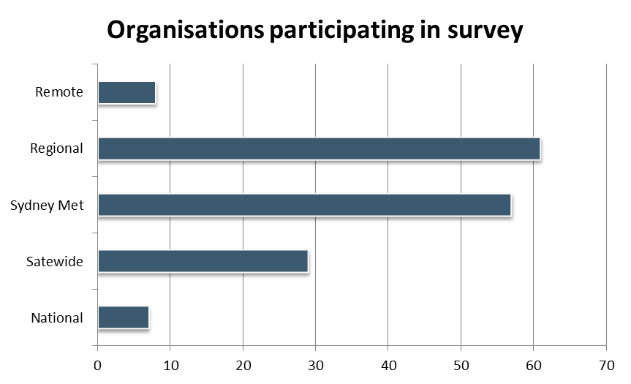
85% stated that the main source of funding for their organisation was from the state and there was a good mix of metro and regional/ remote services.
In terms of the frontline workers survey, 170 frontline staff and direct managers opened their survey and 130 people completed the questions. The people participating in this survey described their role as follows:
Possible Answers | Responses
My work role involves working with or supporting people with disability, their families and friends | 52.35% or 89 people
I directly manage workers who have contact with people with disability, their families and friends | 40.59% or 69 people
In my current role I do not have contact with people with disability, their families and friends | 7.06% or 12 people
52% had worked in the same organisation for 5 years or more and only 14% had been there for less than 1 year.
Group & individual consultations and conversations
Following the surveys, we held 4 consultations with service providers or service users and their families, as well as about 10 individual phone and face to face consultations with people unable to attend the consultations. A total of about 30 individuals representing 25 organisations participated in these consultations. This enabled us to ‘drill’ down further and explore the issues in more depth. It also provided an opportunity for participants in the groups to share and learn from each other.
In-depth engagement with seven identified services
The conversations through the above consultations enabled us to work a little more in–depth with seven organisations, as well as some of their service users and family members involved in these organisations. Those organisations were chosen for the diversity of initiatives and approaches that they have taken to address the issues in how to better meet the language needs of people from CALD backgrounds with disability and their families.
In keeping with the survey structure, the results from all of the engagements above were organised across the following three focus areas:
- Workforce
- Interpreters
- Organisational development.

Workforce
Both surveys asked a range of questions in relation to recruitment, utilisation of language skills, assessment of and reimbursement for the use of those skills.

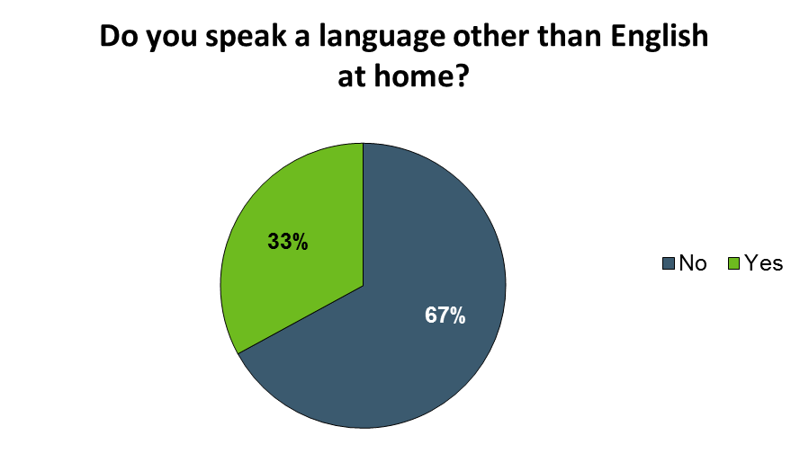
In the frontline survey we found:
Of the 56 people who spoke a language other than English at home (LOTE), more than half (45 people) used their language skills in their current role.
In the managers survey we asked a number of questions in relation to workforce, including: Does your organisation collect any of the following data about the people you support?
Possible Answers | Responses
Country of birth | 68.48% or 63 people
Language/s spoken at home | 63.04% or 58 people
Willingness or capacity to use language skills in the workplace | 34.78% or 32 people
None of the above | 16.30% or 15 people
Of the 92 people who responded to the question: “Does your organisation actively recruit workers for their language skills”, only 25% or 23 people said yes, and 75% said no or unsure.
When asked: Does the organisation assess the language skills of workers? The responses were as follows:

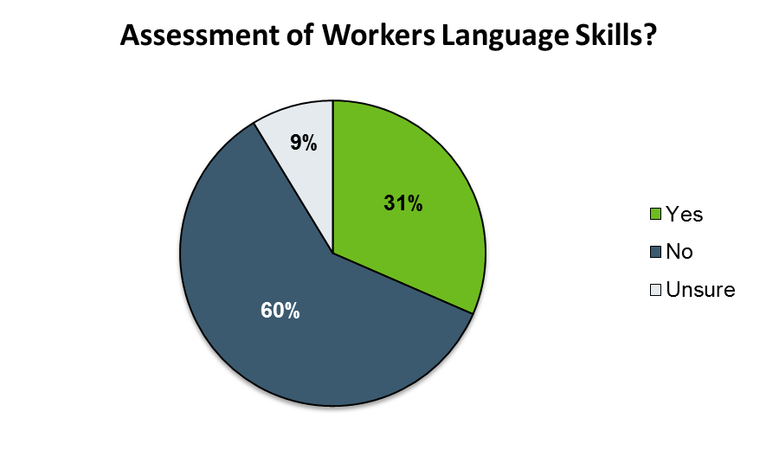
The issue of bilingual workers was explored further in the face-to-face and telephone consultations: “What is the positive impact of bilingual workers and what can be done to strengthen this impact?”
There was a general consensus that bilingual workers were important in building long term relationships with CALD communities. Those organisations that actively recruited bilingual workers (4 of the organisations interviewed) stated a much larger CALD engagement than those organisations without bilingual workers.
The RIDBC have used their bilingual/bicultural staff to build a strong reputation and strong networks in the Korean, Vietnamese, Chinese and Arabic communities. Now the organisation can demonstrate high numbers of consumers from those communities.
When asked what strategies should organisations implement to maximise the effectiveness of their bilingual workforce, the following were identified:
- Formally acknowledge staff’s language skills
- Provide a small monetary allowance to staff in acknowledgement of their language skills, especially if the language skill has been assessed
- If Language competency is a core skill it needs to be embedded in job descriptions
- Bilingual workers should be able to work across a number of services. They should be allowed to “follow the money”. They need flexible working conditions to enable this
- A flexible bilingual workforce may facilitate access to language services in rural/regional areas
- Bilingual workers need to be provided with ongoing skills development and training to ensure currency, etc.
In the in-depth conversation with seven organisations, the issue of workforce was talked about at length. Workforce was clearly an issue on everybody’s mind and given the diversity of the workforce, results could be achieved relatively easily.
In our in-depth engagement we worked with four organisations. They were either already working in this area and wanted to share their work with us, or they could see that if their workforce could be ‘stretched’ and new skills and thinking could be added, this could make a difference in how the service as a whole interacts with consumers. From there, the key areas were:
- Using bi-lingual/ workers
- Developing culturally responsive person centred planning thinking, skills and knowledge
- Implementing staff- client matching that takes into account language and culture.

Working with Interpreters
We asked both managers and frontline staff a range of questions relating to interpreters.
25% of managers responded positively to the question of having a specific budget for language services. However only 15% collect any data on the usage of that budget. Those that did collect data reported that they spent about half of their budget on interpreters and half on translations.
Asked about what professional interpreting services they use, 1 in 4 services said they do not use professional interpreting services at all. 60% said they used the Translating and Interpreting Service (TIS).

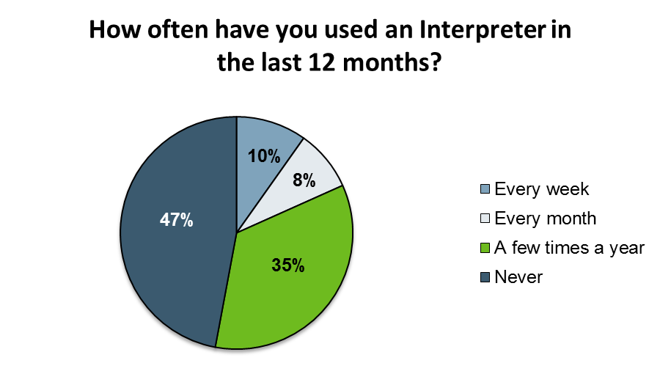
In relation to the use of interpreters, frontline staff were asked:

The reasons staff gave for not using interpreters more often were as follows (in descending order)
- None of the people I support have had difficulties communicating in English (over 50%)
- None of the people I support requested or required an interpreter (40%)
- Family and/or friends of the people I support have been able to provide all of the help needed (over 25%)
Approximately 1 in 5 workers said that they have used their own language skills or the language skills of bilingual workers.
Frontline staff were asked to rate (from very poor to very high, 6 categories):
- Their skills and ability to work with professional interpreters (the average rating was 3.49, with over 80% rating their skills and abilities as good or higher than good)
- The professionalism of interpreters and the effectiveness of communication provided through interpreters (the average rating was 3.21, with almost 25% rating interpreters and the effectiveness of communication as adequate or below).
In contrast to their (high rating) self-perception of their skills and ability, 50% of the staff reported that they have never received any training on language services and overall 75% of staff said they would benefit from training on how to use interpreters effectively and on guidelines on how to access interpreters.
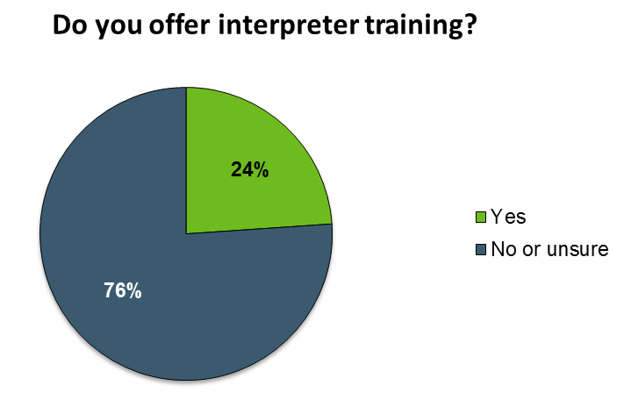
In relation to whether there is any training to use interpreters effectively, managers were asked:
A further 50% of those few services that offered interpreter training said this was done when requested by staff.
Frontline staff who reported that they have received some training in using interpreters found that training moderately useful (3.63 on a 6 category scale), it was mostly delivered face to face and almost 80% of those trained said that they did apply the training.
When discussing the perceived reluctance of staff to use interpreters during the face to face consultations, participants identified that this may be because:
- Staff have had previous bad experiences when utilising interpreters, or
- Staff have not been adequately trained, or
- The use of interpreters is not embedded in the work practices of the organisation.
Participants agreed that interpreter training should be embedded into staff induction processes and that the training should include how (in what instances) an interpreter should be used.
When discussing interpreters, participants identified the following:
- Good practice for briefing an interpreter. This may include language or terminology to be used in the session
- Skills for working with interpreters
- How to access interpreters
- How to ask questions
- How to set up a room to facilitate communication between interviewer and interviewee. Where to physically place telephone in the room
- ‘Script’ or tools for what to say and how to say it
- Use of role-plays and scenarios.
In the in–depth conversations, one strategy we found interesting and worthwhile highlighting was the establishment of a freelance interpreter pool.

Organisational development
81 managers (of the 130 who clicked on) said that service users are informed about their right to an interpreter, yet only 45 managers said that they had a policy on interpreter use. Over 90% of frontline workers said that they were either familiar with their organisations’ language services or interpreter policies or were at least aware of those policies. About 120 workers said they also use:
- Bilingual workers of their own and from other organisations
- Family and friends of the person they support
- Translated materials
- Audio-visual / online resources in languages other than English.
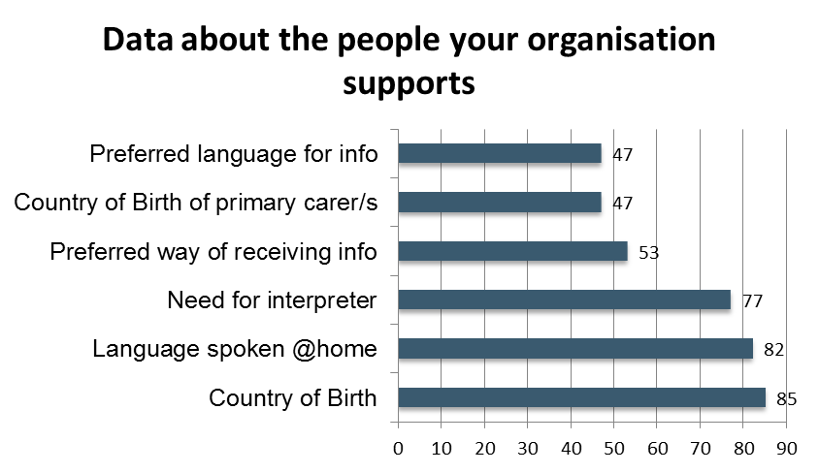
About 75 managers said that their services reflected the cultural diversity of the geographic areas the services operated in. About the same number of managers either did not answer this question of or were unsure or said no to this question.
In relation to the following question: “Does your organisation collect any of the following data about the people you support (select all that apply)?” 100 Managers provided the following answers:
In relation to using demographic information (language spoken, country of birth, need for interpreter etc.) to inform strategic planning, 43 of the 100 managers answered yes and the rest were unsure or said no.
In relation to promoting their services to CALD communities, managers replied:
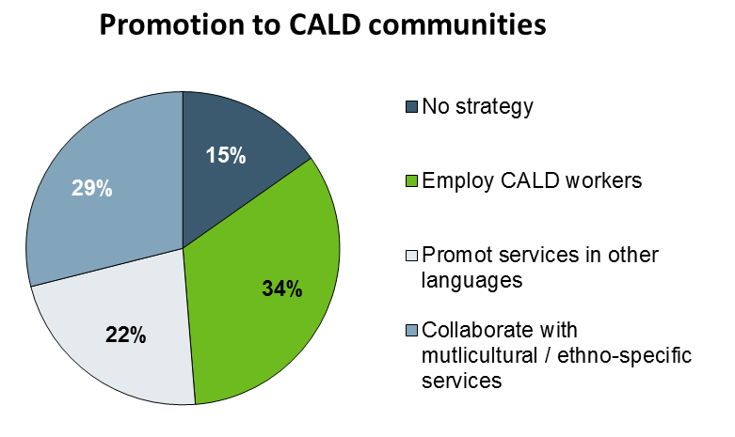
Finally, the question about what policies were in place was answered by less than half of the total participants in the managers survey. Of those,
- 45 have a policy on interpreter use,
- 37 have a policy on promoting to CALD communities
- 35 have a policy on networking with CALD communities
- 26 have a policy on translating materials
Many of the issues we identified through our work with organisations highlight the importance of sound organisational strategies, initiatives, policies and processes that enable workers to do a good job for those clients who do not speak English or who do not speak English well. The organisations we worked with in this in-depth process talked about having support ‘from the top down’.
All of the examples here are examples of initiatives supported by the organisations. The area we highlight is the importance of a CALD plan and working group.

Resources

How to work out the numbers of people from CALD backgrounds with disability for your geographic area
The following is a resources developed for the disability services sector. The aim is to enable the sector to work out the likely number of people from CALD backgrounds with disability in specific geographic location.

Who lives in the community?
The data used here is based on the most recent Australian Census data (2011). This data may be complemented with information available through your local council or your local ethnic community organisation.
- Put ‘Census Australia’ into your search engine and follow the link to the official ABS census website (http://www.abs.gov.au/census).
- From there, under Census data, click on the Community Profiles icon.
- From that webpage you can search specific geographic areas with the Community Profiles Search (make sure you search the most recent census data).
Examples of Community Profiles Searches:
- Enter 2204 into the community profile search engine and you get the data for Marrickville NSW,
- Enter Wagga Wagga and you get to choose between 15 slightly different geographical areas, ranging from Local Government Area to State Electoral boundaries
- Enter Sydney and again you get to choose from a whole range of different geographic areas pertaining to Sydney (ranging from City of Sydney to Significant Urban Area)
You might have to play with this a bit and look at the map that opens up in the new page. This part may actually be the most time consuming part of working out who lives in the community. For many people whose service covers a range of locations, you might have to repeat the process several times to ensure you capture all the data.
- Once you have the geography right for you, download and then open the excel spreadsheet called “Basic Community Profile”. Click on to ‘List of Tables’ at the bottom of the first page.
For our purpose here, the following tables are of particular interest:
- Ancestry (B08)
- Country of Birth (B09 and B10)
- Proficiency in Spoken English (B11 and B12)
- Language spoken at Home (B13).
While all of those tables provide useful information, neither one of those tables provide an answer to the key question (How many people from CALD backgrounds with disability are there?).
To arrive at that answer, we really need to understand what we are looking at.

Understanding what to look out for
To come to an understanding of the available data so that it provides useful information for your organisation to plan and prepare, we have to understand what the data actually means.
Disability Data and the NDIS
Generally speaking the data provided by the Census on disability is not particularly useful (B18 provides some information on people who need assistance with core activities). The ABS Survey on Disability, Ageing and Carers identifies that 18.5% people have a disability (or approx. 4.2 million nationally). The Productivity Commission report identified that about 10% people will be eligible for funded supports under the NDIS (or 410,000 nationally).
CALD Data
When looking at CALD data it is generally agreed that the term CALD is made up of:
- People who were born overseas in a non- English speaking country.
This group is generally referred to as 1st generation migrants/ refugees. Based on the 2011 ABS Census 6.9 million people in NSW. About 700,000 (approx. 10% of all people) were born in a non-English speaking country (about 500,000 were born overseas in an English speaking country).
- A group generally referred to as second-generation migrants/ refugees.
This group is made up of children whose parent/s (either one or both) were born overseas in a non- English speaking country. The rate of children born to overseas born mothers (2.0) is slightly lower than the rate of children born to Australian born mothers (2.1). There are some notable exceptions with Chinese mothers having an even lower rate (1.5) and Lebanese mothers having children at a significantly higher rate (3.3). Using this data we could simply add another 700,000 people who are identified as second generation.
- There are others who identify as being from CALD background, whose grandparents or even more distant family members come to Australia from other non-English speaking countries.
Census data collected on ancestry (BO8 in the census) identifies that there are over 1.5 million people who say that either both or one of their parents are from a non-English speaking country.
Based on the data above, it can be safely assumed that between 20 - 25% of people living in NSW are from a CALD background.
Language data
1.5 million people in NSW speak another language than English at home. (Census table B13).
Further details are captured in data about English proficiency (in tables B11 and B12) with 1.7 million people answering the question about English proficiency and 218,000 or about 13% people saying they do not speak English well or not at all.
Disability, CALD and Language spoken
For the purpose here, we assume that the incidence of disability among CALD communities in Australia is approximately the same as it is for the general population (1 in 5 people). However, NEDA using a range of data sets argues that:
”There is a higher prevalence of impairment for people born in a non-English speaking country aged over 45 years of age, especially for ‘first wave’ non English speaking migrants, up to 3 times that of the Australian born population.”

Making the data work
The easiest way to understand and learn how to apply the knowledge above to the data available is to work through an example:
Data for Wagga Wagga, Postcode (2650):
53,973 people live in Wagga Wagga,
Disability Data for Wagga Wagga:
10,795 people have a disability, and of those 1079 people of those may be eligible for the NDIS
CALD Data for Wagga Wagga:
9,882 people who live in postcode 2650 are from CALD background (4,941 people were born in overseas in a country where English was not the dominant language. A further 4,941 people are second generation CALD.)
Language Data for Wagga Wagga:
2,527 people say they speak a language other than English at home, (with a further 1738 people not stating what language they speak at home).
340 people said they do not speak English or do not speak English well.
Disability, CALD and Language spoken for Wagga Wagga:
1976 people with disability from CALD background, with 197 likely to be eligible for NDIS funding
505 people with disability speak another language at home, with 50 likely to be eligible for NDIS funding
60 people with disability speak little or no English, with 6 likely to be eligible for NDIS funding
At the average funding allocation of $34,600 this group therefore may attract NDIS funding to the value of anywhere between $207,000 and $6.8 million.
There are other sources of demographic data that organisations can use. These include:
- The People of NSW 2011
This resource uses data from the Australian Bureau of Statistics. Published by The Department of Immigration and Border Protection (DIBP) and available on the Multicultural NSW’s (formerly the Community Relation Commission) website (http://www.crc.nsw.gov.au/community_engagement/communities/the_people_of_nsw_2011).
This contains four-page profiles for every NSW local government area. It also contains comparative data for whole of NSW and whole of Australia.
The table in the four-page summaries on English Language Proficiency by Age: Selected Language Groups, is especially useful if you are interested in which languages groups in your area do not speak English well or not at all.
- ID population experts
Using 2011 ABS and other data, they create community profiles for local governments and other agencies to inform organisational decision making and planning. Many local councils now use “.id’s” database platform to create accessible and easy to understand demographic data.
The easiest way to access this information on the web is to do a Google search using the following words: “community profile” “id” and the local government area you are interested in (eg. ”Marrickville”).
Once you have located the relevant community profile use the “Who are We?” tab in the “Area Profile” menu located on the left hand side of the web page to explore the diversity data.

Recruiting for language and cultural skills
The following is a brief guide on how to recruit for language and or cultural skills:
To decide whether the organisation wants to recruit someone with language and cultural skills and what the role might look like, organisations will have to think about the following questions:
- Do we want more staff that are linguistically and culturally diverse or do we want staff for a particular client or for a program that requires specific language/cultural skills?
- Do we want to target CALD communities more generally or do we want to target a specific cultural community?
- Do we think the language/ cultural skills we are looking for are in addition to the specific skills of the role or are the language skills central to that role?

Workforce diversification and enhancing profile
If an organisation simply wants to diversify its workforce and generally increase its profile within CALD communities, there are basically two strategies:
- Encourage people from diverse background to apply to the role advertise. For most organisations this means adding something lie the following to the Job Advertisement:
- “People from culturally and linguistically diverse background are encouraged to apply for this position”
- Add language/cultural skills in a language other than English to the (desirable) criteria.
Below is an example of such a job ad:
Team Leader
We are an independent, not for profit, community organisation. Our program provides a helping hand to support families with children aged 0-8 years. We are seeking an experienced Team Leader to lead a team of caseworkers.
Essential Criteria:
- Tertiary qualification(s) in Psychology, Social Work, Social Science, Counselling, or minimum 5 years' experience working with vulnerable families
- Minimum 2 years' experience leading a casework team; supervising staff working with high-risk families
- Skills in assisting staff to identify children and young people at risk of harm, including completing safety assessments and safety planning
- Demonstrated experience working with clients from ATSI and CALD backgrounds
- Demonstrated knowledge and experience working with families via a strengths-based, solution-focused approach, within a child-centred, family focused service.
Desirable Criteria:
- Experience in similar Program
- Current NSW or National Driver's License, and access to a registered vehicle
- Ability to communicate in a language other than English.

Recruit a worker for a specific linguistic or cultural community
If an organisation wants to recruit a worker from a specific linguistic or cultural community in order to for example, match them with a person from the same community or run a program for a language specific/cultural community or do some community development/outreach work into a specific community, then the role description should clearly identify this as a core competency.
An example of such a job advertisement is:
Bilingual Support Staff
The organisation provides Home Care packages, multicultural day care, respite care, domestic assistance and transport services to frail aged people from diverse background.
Bilingual Support staff is sought to assist with these services, initially for six (6) months on a casual basis then on a permanent part-time basis based on the satisfactory performance.
Essential Criteria:
- Fluency in one of the following languages: Greek, Italian, Spanish, Chinese and English
- Ability to care for needs of frail elderly people; Experience in working with the frail aged
- Good communication and interpersonal skills
- Aware of and sensitive to the needs of frail aged from CALD background.
Desirable Criteria:
- First Aid Certificate
Certificate III in Aged Care or equivalent.
The language/ cultural component of the job will need be reflected in the Job Description. In addition the organisation may want to consider:
- Reimbursing the worker for their bilingual / bicultural skills
- Whether the worker is to be utilised across the agency when language/cultural issues are identified or whether the worker will only work within the role they have been recruited for
- How the worker can be ‘up-skilled’, trained and supported for both their language skills as well as other skills and competencies required for the current role or future roles within the organisation
- What policies the organisation has in place to support workers with linguistic/ cultural skills and how it will manage community expectations.

Working with Interpreters and Translators
(from MDAA Factsheet No.9 Using Interpreters successfully)

Identifying the language
Working out what language your service user speaks can be the first challenge. To prepare for this situation the best thing to do is to ring the Community Relations Commission (1300 651 500) and ask them to send you some Interpreter Cards. These cards will help you and your service user to identify the language being spoken.

Identifying whether an interpreter is needed
- Ask your service user to repeat a message that you have just given in his/her own words
- Ask your service user a question that requires him/her to provide a long response; avoid questions that can be answered with a ‘yes’ or a ‘no’ or asking familiar questions such as ‘Where do you live?’
- If you think that an interpreter is required, discuss this with your service user before you make an arrangement for an interpreter.
Most importantly, if you feel that you cannot communicate with your service user then you will need an interpreter.

Different types of interpreter services
There are basically two types of interpreting services: on-site and telephone interpreting.
- On-site interpreting means that an interpreter comes to where the meeting is being held. In general, on-site interpreters are used for complex and long matters
- Telephone interpreting is interpreting that is provided over the phone and is especially useful for emergencies.
Both types of interpreting services have advantages and disadvantages. If money is a concern, telephone interpreting generally (but not always) works out cheaper.

How to book an interpreter
A range of private and government agencies provide interpreting services. Most importantly you and your service user need to make sure that the interpreter you book (and pay good money for) is an accredited interpreter. Government interpreter services only employ interpreters that have been accredited by the National Accreditation Authority of Translators and Interpreters (NAATI).
If you need an interpreter, you have the following options:
- TIS (Translating and Interpreting Service): 13 14 50
- Language Services, Community Relations Commission: 1300 651 500
- Health Care Interpreter Service [NB for health care related issues only and only a health services provider can organize this; it will be on-site only]
- Private interpreting agencies: look in the Yellow Pages under ‘Translations’
- For Auslan Interpreters, call the Deaf Society of NSW: (02) 9893 8555 or 1800 893 855.

Bilingual worker, family member or interpreter?
The following decision-making trees are a modification of similar trees developed by the Victorian Department of Human Services in 2005. The aim is to assist organisations in the development of a language policy and in the decision-making processes of front line staff.

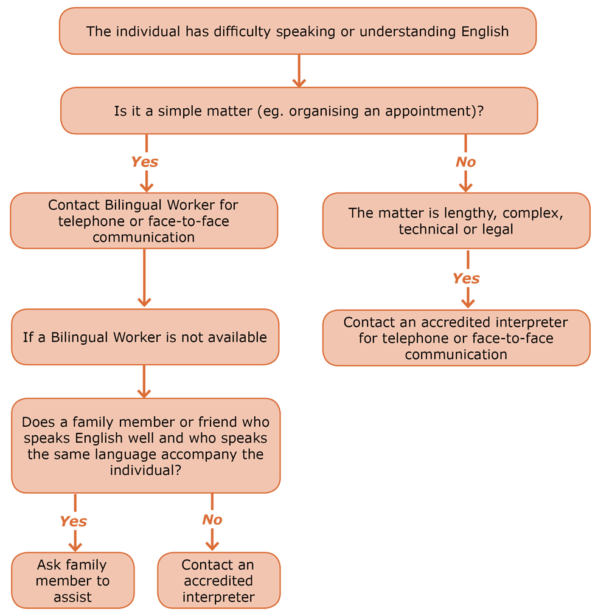
Using an Interpreter or not?

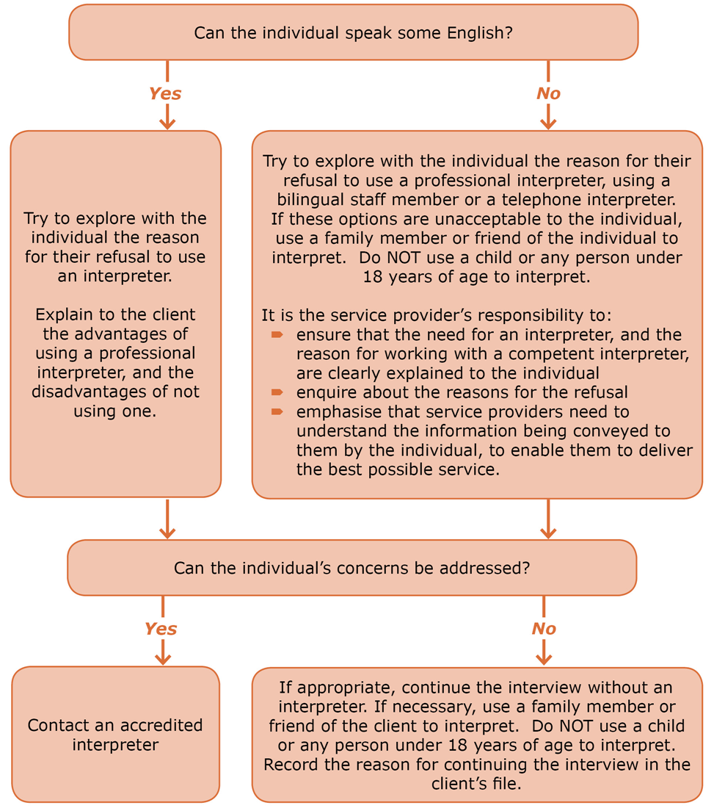
When a person refuses to use an interpreter

Language Allowance Guide

Should we give staff a language allowance?
All people with disability irrespective of their first language preference and cultural, ethnic, linguistic and religious backgrounds, have a right to access information, communicate effectively, and be included in the community.
Organisations wishing to communicate and engage effectively with CALD communities will need to first consider who their clients are, and then identify the best ways to provide support services for individual clients. A key component of support services must include ways to assist people who have little or no ability to communicate in English.
The bilingual skills of staff are an often overlooked, but are a valuable resource that can provide organisations with a direct link into a CALD community and assist with communication. Other staff can also benefit from the bilingual and bicultural skills of their colleagues who can support them to better understand cultural differences when working with a CALD client. In addition bilingual practitioners have the potential to effectively communicate without third party involvement. This is particularly important when confidentiality is a factor.
A small monetary allowance to staff in recognition of their bilingual skills would formally acknowledge the importance of these skills within the organisation.

What should the criteria be?
Consider the following:
- Does the staff member use their language skills to assist people with disability with little or no English language skills regularly?
- Does their work involve direct contact with people with disability with little or no English language skills?
- Do the language skills of your staff reflect the language needs of the local community?
- Is there a demand for these language skills?
- In which situations is it reasonable to use a bilingual worker and in which a professional interpreter?

Where do we start?
You can begin by doing a language audit to identify staff that speak a language other than English. You might do this as an online survey or you may already collect this information about your staff.
- What community languages are represented in your workforce?
- How often does the staff member use their language skills at work?
Collate responses and compare to local area demographics.

How do we know that a staff member speaks a language other than English (LOTE) ‘well enough’?
Currently there are no nationally accepted standards, qualifications or assessment measures for bilingual staff that use a LOTE in their work.
In the absence of formal processes, some organisations, like the Transcultural Mental Health Centre (TCMHC), have developed a number of informal processes to assess the bilingual skills of their staff. These include:
- Using a ‘language expert’ on interview panels
- Buddying new staff with established bilingual staff who can assess their language skills ‘on the job’
- Assessing the quality of bilingual resources developed, and
- Feedback from clients.
Alternatively, if you would like to have confidence in the bilingual skills of your staff, you may elect to have their language skills formally verified by NAATI. For more information check out their website at: www.naati.com.au

What else should we take into consideration?
- Do you have a language allowance policy and procedures in place and what should it include?
- How will you let other staff know about the skills of their co-workers and how can access those skills?
- How will you monitor the use of the language services provided by bilingual staff?
- How often should you review the mix and quality of language skills within your workforce to ensure you have the right ‘mix’ of workers with bilingual skills in your organisation?

This means the person with the disability and/or one or both of their parents were born in a country where English is not the primary language; 2011 ABS Census data; NEDA - http://www.neda.org.au/index.php/reports/item/one-million-people-fact-sheet (Sourced February 2015)
Productivity Commission (2011): Disability Care and Support, page 160
Data consulted include: NDIA- Quarterly Report 2014-15; Australian Institute of Health and Welfare- Disability Support Services Data, 2014; ADHC – MDS data 2013-14 (it has to be noted that ADHC provided services, in contrast to ADHC funded services, appear to be delivering equitable services, with people from CALD backgrounds making up almost 30% of service users); a very limited number of NGO Disability Services Annual Report
ABS (2013): Disability, Aging and Carers, Summary of Findings http://www.abs.gov.au/ausstats/abs@.nsf/mf/4430.0
Productivity Commission (2011) Disability Care and Support, page 160
ABS- Australian Social Trends (2008) 4102.8 How many children have women in Australia had? (http://www.abs.gov.au/AUSSTATS/abs@.nsf/Lookup/4102.0Chapter3202008
NEDA (2010): People from NESB with disability in Australia: What does the data say? http://www.neda.org.au/index.php/statistics
This is one of many Factsheets produced by MDAA. This factsheet and more can be found at http://www.mdaa.org.au/resources/frequently-asked-questions
Centre for Culture, Ethnicity and Health, 2008, Bilingual Staff Research Project Report, CEH, Melbourne

